Evaluation of C++ gRPC

Christopher K. Allen

Available for public release.

October 15, 2023

OSPREYDCS/TM-2023/003

Osprey Distributed Control Systems, LLC

EVALUATION OF C++ GRPC[1]

Author

**Christopher K. Allen**

Date Published:

October 15, 2023

Prepared by

Osprey DCS

304 Blue Heron Court

Ocean City, MD 21842-2452

CONTENTS

CONTENTS iii

Table of Figures v

Table of Tables vi

Executive Summary 1

Background 2

Organization 3

Motivation and Problem Statement 3

(a) The Datastore 4

(b) Real-time Applications 5

(c) Test Stand 5

Article II. Performance Evaluations 7

Section 2.01 RPC Communications Framework via Protobuf 7

Section 2.02 The Test Stand 9

Section 2.03 Results 10

(a) Scenario Payloads 10

(b) Synchronous gRPC Operation with Archiving 12

(c) Asynchronous gRPC Operation with Archiving 15

(d) gRPC Network Transmission (Without Archiving) 17

(e) gRPC Transmission with Compression 18

(f) Message Size and gRPC Transmission 19

Section 2.04 Comparison with Java gRPC 21

Section 2.05 Summary and Conclusions 22

(a) Performance Tuning 23

(b) Best Practices 23

(c) Recommendations 24

Article III. C++ gRPC Resources and Structure 26

Section 3.01 gRPC and Protobuf Structure 26

(a) Protocol Buffers Resources 27

(b) Callback gRPC Resources 28

(c) gRPC Communications APIs 30

(d) gRPC Data Streaming 30

(e) gRPC Communications Resources 30

Section 3.02 gRPC Communications Resources 31

(a) Synchronous API 31

(i) Client-Side Synchronous Streaming 32

(ii) Server-Side Synchronous Streaming 33

(b) Asynchronous API 34

(i) Asynchronous Unary Resources 35

(ii) Client-Side Asynchronous Streaming 36

(iii) Server-Side Asynchronous Streaming 38

(c) Callback API 39

(i) Client-Side Callback Resources 39

(ii) Server-Side Callback Resources 41

Section 3.03 Completion Queues 42

(a) Completion Queues 43

(b) Completion Queue Management 43

(c) Server Completion Queue 45

(d) Server Initialization 46

Article IV. C++ gRPC Development 48

Section 4.01 State Machines 48

(a) Unary State Machine 48

(b) Streaming State Machine 49

Section 4.02 Implementation Strategies 51

(a) Service Implementation 52

(b) Client Implementation 54

Section 4.03 Implementation Designs 56

(a) Synchronous Service Implementation 57

(b) Synchronous Client Implementation 58

(c) Asynchronous Service Implementation 60

(d) Asynchronous Client Implementation 62

REFERENCES 66

APPENDIX A. Synchronous Simulations Results - 1 -

APPENDIX B. Asynchronous Simulation Results - 18 -

Table of Figures

Figure 1: Datastore use cases 4

Figure 2: Datastore system deployment 5

Figure 3: test stand Protobuf RPC definition 7

Figure 4: Scenario architecture and components 9

Figure 5: serialized message size versus transmission rate 20

Figure 6: essential gRPC resources and Protobuf additions 26

Figure 7: Protobuf Stub and Service classes in implementations 27

Figure 8: callback communications resources and structure 29

Figure 9: RPC operation types 31

Figure 10: client-side synchronous streaming gRPC resources 32

Figure 11: server-side synchronous streaming gRPC resources 34

Figure 12: asynchronous unary gRPC resources 35

Figure 13: client-side asynchronous gRPC streaming resources 37

Figure 14: server-side asynchronous gRPC streaming resources 38

Figure 15: client-side callback gRPC resources 40

Figure 16: service-side callback gRPC resources 42

Figure 17: completion queue management patterns 44

Figure 18: server completion queue management and use 45

Figure 19: service initialization and request handler registration 46

Figure 20: asynchronous, unary request state machine 49

Figure 21: asyncrhonous streaming request state machine 50

Figure 22: basic C++ gRPC service activity 52

Figure 23: C++ gRPC service activity diagram 53

Figure 24: basic C++ gRPC client activity 54

Figure 25: C++ gRPC client activity diagram 55

Figure 26: synchronous service implementation 57

Figure 27: synchronous service implementation with gRPC streaming resources 58

Figure 30: synchronous client implementation 59

Figure 28: asynchronous service implementation 61

Figure 29: asynchronous service request handler implementation 62

Figure 31: asynchronous client implementation 63

Figure 32: asynchronous client request executor implementation 64

Table of Tables

Table 1: scenario payload description 12

Table 2: synchronous transmission times and rates (binary archived) 14

Table 3: asynchronous transmission times and rates (binary archived) 16

Table 4: gRPC transmission rate comparisons with and without archiving 17

Table 5: gRPC transmission rates with and without GZIP compression (no archiving) 18

Table 6: gRPC transmission rates (no archiving), GZIP versus DEFLATE compression 19

Table 7: Protobuf serialized message size versus gRPC transmission rates 20

Table 8: Datastore component benchmarking 21

Executive Summary

A test stand utilizing gRPC and Protocol Buffers was implemented in C++ and its performance was evaluated; these evaluations being motivated by C++ gRPC consideration within the Datastore system, and Machine Learning Data Platform (MLDP) in general. The test stand emulates the Datastore Ingestion Service, specifically, the test stand simulates the transport and storage of EPICS NTTable instances with thousands of time-correlated data columns acquired at sampling rates in the kHz range. Various loading conditions and gRPC configurations were investigated and the results presented.

Best C++ gRPC data transmission rates were seen at over 450 Mbps when asynchronous streaming was utilized. Synchronous streaming operations also performed well with data rates beyond 320 Mbps. A simple binary file archiving system was constructed within the test stand, when using a single archiver total data throughput exceeded 200 Mbps for asynchronous streaming and 150 Mbps for synchronous streaming. These results are compared to that found in Datastore benchmarking; there peak Java gRPC transmission rates were seen between 175 – 224 Mbps, and overall data throughput utilizing formal database archiving was found at 90 Mbps. Stated data throughput goals for the MLDP are 32 Mbps.

The use of Java gRPC for Datastore core implementation appears sound. The data transmission rates are significant and provide a 2x overhead compared to the data processing. Due to its development overhead, C++ gRPC should be restricted to applications requiring its exceptional performance capabilities.

The Protocol Buffers serialization mechanism is efficient. It provides about 10% data compression. Thus, with respect to actual message size, the data rates are 10% higher. For example, the asynchronous streaming peak data transmission rates approach 500 Mbps when measuring point to point transmission of the full data messages (rather than the wire rates given above).

An important property of C++ gRPC seen in the evaluations was a significant performance dependency upon transmitted message size; a cutoff maximum size limit of 16 Mbytes was seen for the test stand. Performance also drops when transporting messages with sizes below 1 Mbytes. It is expected that this message size dependency is fundamental to all gRPC implementations.

The asynchronous streaming configuration in C++ gRPC offers extraordinary performance. The datastream processing component of the MLDP (i.e., “plugins”) requires fast real-time response; it may require the exceptional performance offered by C++ gRPC. However, the substantial performance gains also require substantial development effort. To support a potential future development effort, this report includes expanded information on C++ gRPC resources, structure, and design strategies, as available documentation was found to be scarce.

Although not investigated here, C++ gRPC also offers a third communications mechanism, callback communications. It offers mid-level performance characteristics, between that of synchronous and asynchronous gRPC, and is easier to develop than fully asynchronous communication. When a “one size fits all” approach to C++ gRPC is sufficient, it provides a reasonable tradeoff between performance and development. Further investigation of callback communications may be warranted if future gRPC versions improve performance (as documentation implies).

Background

The gRPC system was originally built by Google as a language and platform independent Remote Procedure Call (RPC) framework. It provides a consistent network interface for all programming language implementations while utilizing HTTP2 as the underlying transport mechanism. The framework library has since been open-sourced and is available for download on Github [1]. The gRPC library is implemented explicitly in several different programming languages, including C, Java, Go, Kotlin, and Dart. The C programming language implementation provides a C++ extension for most library resources, which we refer to generally as C++ gRPC. The C language gRPC repository also supplies native language interfaces for Python, Ruby, PHP, Objective-C, and C#. However, any language implementation for a gRPC client or server is interoperable with all other language implementations using the same RPC protocol. All underlying gRPC library resources operate consistently between languages; for example, all credentials, channels, and server objects are interoperable in each language. Online documentation is available here [2], which includes language quick start guides. However, advanced developer documentation is limited; it is generally offered as code examples on Github ( [3] [4] [5], etc.). Unfortunately, for asynchronous C++ gRPC development documentation is particularly scarce. Only two code examples were found that provide a nearly complete demonstration of most asynchronous capabilities [6] [7].

The gRPC framework implements the data transport mechanism for RPC. A support platform, *Protocol Buffers*, provides the RPC message definition and serialization capabilities used by the gRPC framework. Consequently, gRPC and Protocol Buffers are generally used in conjunction and often implicitly assumed when referencing gRPC (although it is possible to use the gRPC library independently). Protocol Buffers, or “Protobuf” in the shorthand, was also developed by Google. It is now open source and available for download on Github [8]. Documentation for Protocol Buffer development is available online [9]. However, language-specific developer documentation is still rather weak.

Protocol Buffers supports language independence by establishing a meta programming language termed “proto”. The proto language is used to define RPC messages and their message-passing interfaces when creating RPC communications frameworks utilizing gRPC as the transport mechanism. The Protocol Buffers compiler, protoc, generates output as standard programming language source code from the proto language source. That is, once the RPC framework is defined in the proto language, it is then “compiled” by protoc creating the RPC communications framework in the programming language of choice. The protoc-generated source code contains all the RPC messages and required interfaces in the native language format using gRPC for the underlying RPC operations. Note that the source code produced by protoc must then, in turn, be built into executable code by a native language compiler, or interpreted for execution if a scripting language is the target.

In addition to defining the RPC communications framework, Protocol Buffers also provides the serialization mechanism for data transmission. The protobuf-generated RPC messages internally provide serialization operations to both 1) serialize the message before transport by gRPC, and 2) for recovery of the message into its original format after transmission by gRPC.

It should be noted that the C++ gRPC implementation utilizes several third-party libraries which must be installed on the host platform, such as zlib, ares, and, most extensively, the Abseil library. The gRPC Github repository contains links to required support libraries and can be included in the repository download using the git clone –-recurse-submodules –depth 1 options as described in the quick start guide. The gRPC and Protobuf codebase are configured for a CMake or Bazel build (the Make build is no longer recommended and not fully supported). Alternative to the download, build, and install procedure, one can use an environment manager such as apt or homebrew to install gRPC with the required dependencies on the local platform. Additionally, when building and linking the final products it is helpful to use a library manager such as autoconf or pkg-config.

Source code for the RPC communications framework used in the evaluations is found in Github repositories maintained by the author [10]. A complete RPC framework description is found in the second chapter containing performance results. The C++ source code implementing the test stand is contained in a similar repository [11]. Comprehensive descriptions of the test stand implementation are presented in the final chapter. Due to the preliminary nature of the current work, code repository access is maintained private; regarding source code availability and repository access please contact the author.

Finally, due to the lack of advanced documentation, a comprehensive description of C++ gRPC development is included in this monograph, within separate chapters. Emphasis is placed on asynchronous streaming implementation. Much information provided here was not found in any formal gRPC documentation.

Organization

The report is divided into four chapters, or “Articles,” which are essentially self-contained. The first chapter, this chapter, is an introduction providing background, references, and the problem statement along with supporting motivation. Article II proceeds immediately to the evaluation results, a brief description of the test stand used for C++ gRPC evaluations is also included. Article II ends with a summary of these results and recommendations supported by the results and other observations. Article III contains a description of the C++ gRPC library and the accompanying Protocol Buffers support package. This chapter can be considered supplemental documentation for C++ gRPC, which is comparatively more complex than gRPC implementations in other programming languages. Finally, Article IV contains design strategies for C++ gRPC development then architectural details for the test stand implementation used in evaluations. Much of the material there was obtained through trial and error, due to the scarcity of available C++ gRPC documentation. Although oriented toward the test stand design and implementation, this chapter further documents C++ gRPC from a developer viewpoint. The test stand may be considered the vehicle by which the ideas are presented.

Some of the text outputs created by the test stand are also included as appendices. Specifically, scenario output files for full data throughput evaluations (including archiving) are included. Appendix A contains output for synchronous communication evaluations and Appendix B contains the output for asynchronous communications. The outputs seen in the appendices are abbreviated; actual output files contain full descriptions of test case scenarios which were abridged.

Motivation and Problem Statement

To establish context for the C++ gRPC evaluations, we present the motivation and problem statement driving it. Performance is the motivation for exploring the C implementation of gRPC and Protocol Buffers. The C compiler produces native machine code which, presumably, facilitates optimal performance on any hosting platform. C is a low-level language providing direct access to the underlying platform systems and hardware, while the C++ facilitates development by supplying the high-level features of modern C++. Moreover, C++ gRPC provides explicit support for asynchronous, multi-threaded client and service implementations exploiting transport and processing concurrency. Here, developers have fine-grained control of request and response threads, although this flexibility comes at the cost of added development effort since C++ gRPC requirements are significantly more complex than for other languages. Thus, one must consider the tradeoff between performance and additional gRPC development efforts.

These investigations are part of an ongoing effort by Osprey DCS to provide full-stack support for Machine Learning (ML), Artificial Intelligence (AI), and general data science applications for large particle accelerator facilities, and, more broadly, large experimental physics facilities in general. The current focus is development of the *Machine Learning Data Platform* (MLDP), supported by the US Department of Energy, Office of Basic Energy Sciences [12]. The MLDP is composed of several sub-systems, which together, provide a standardized platform for data acquisition, transport, archiving, and management, along with broad back-end search and query support orientated towards data science applications. A primary component of the MLDP is the *Datastore*, which is responsible for data ingestion, archive management, and back-end query support. Datastore performance is the focus of this investigation.

### The Datastore

The Datastore system is a MLDP component currently under development by Osprey DCS [12]. The Datastore contains two active subsystems: the *Ingestion Service* and the *Query Service*. The test stand used for these evaluations is a mockup of the Datastore Ingestion Service.

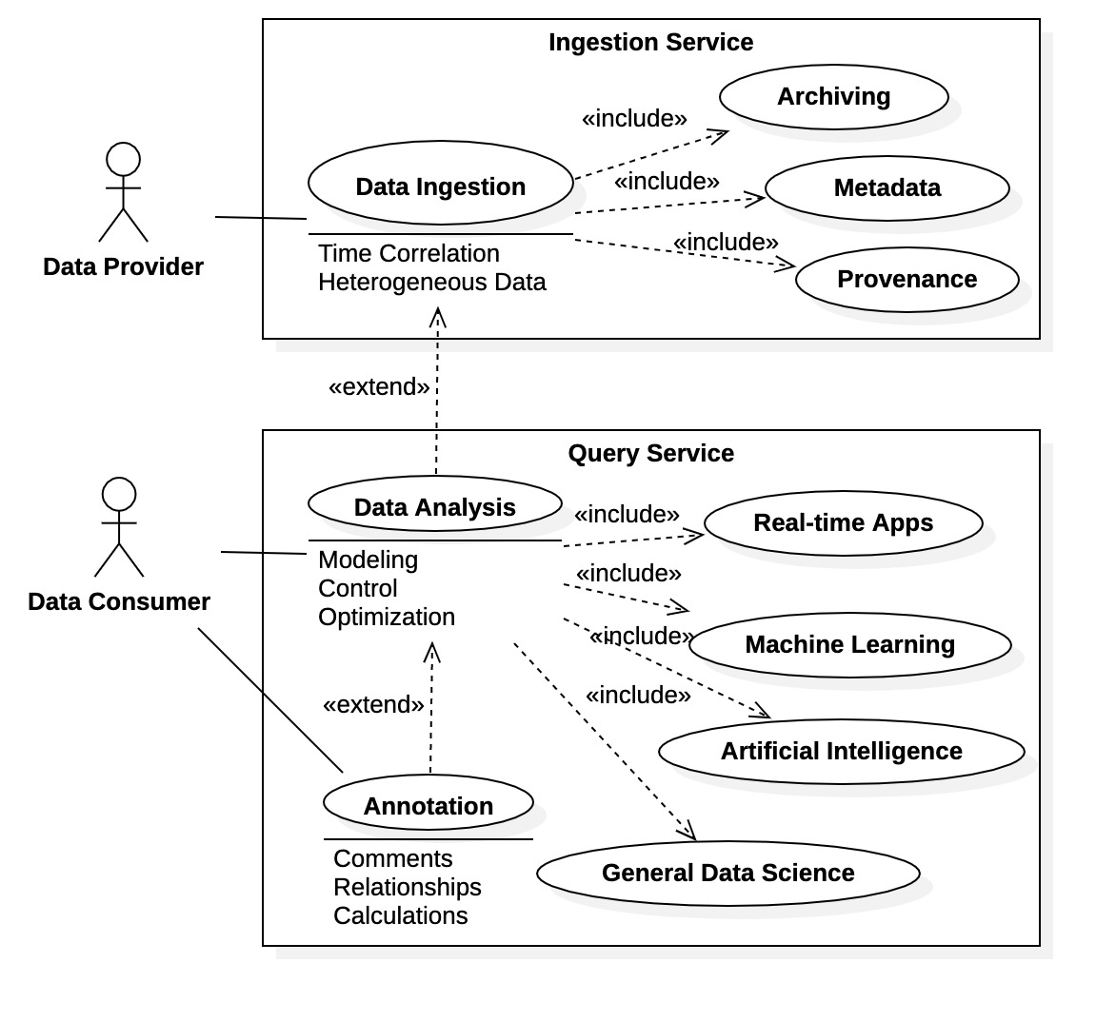

Figure 1: Datastore use cases

To appreciate the function of the Datastore, a use case diagram is included as Figure 1. There are only two actors within the diagram: a Data Provider, and a Data Consumer. Data Providers are producers of time-correlated, heterogeneous data; typically, Data Providers are machine hardware such as detectors, control actuators, remote sensors, and diagnostic equipment. A Data Consumer represents any entity with an interest in data produced by the Data Providers and managed by the Datastore. Typically, Data Consumers are data scientists, engineers, control applications, and other facility personnel. As shown in Figure 1, the Datastore Query Service supports all interaction with Data Consumers; it provides direct support for common use cases in data analysis, including the ML/AI and general data science applications. Within the figure note the “Real-time Applications” use case and its inclusion as a Query Service responsibility. This use case is the target of these investigations. It is an outlier condition and is discussed more fully in Subsection (b).

A typical deployment diagram for the Datastore system is shown in Figure 2. As indicated in the diagram it is possible to deploy the components of the Datastore system on separate server nodes. In fact, for performance reasons it may be desirable to deploy the archive itself on multiple servers supporting multiple write/read access. The important point is that the Datastore supported multi-node deployment. The test stand providing the performance evaluations here was deployed on a single node, the development platform. It is however possible to deploy the testbed across multiple nodes.

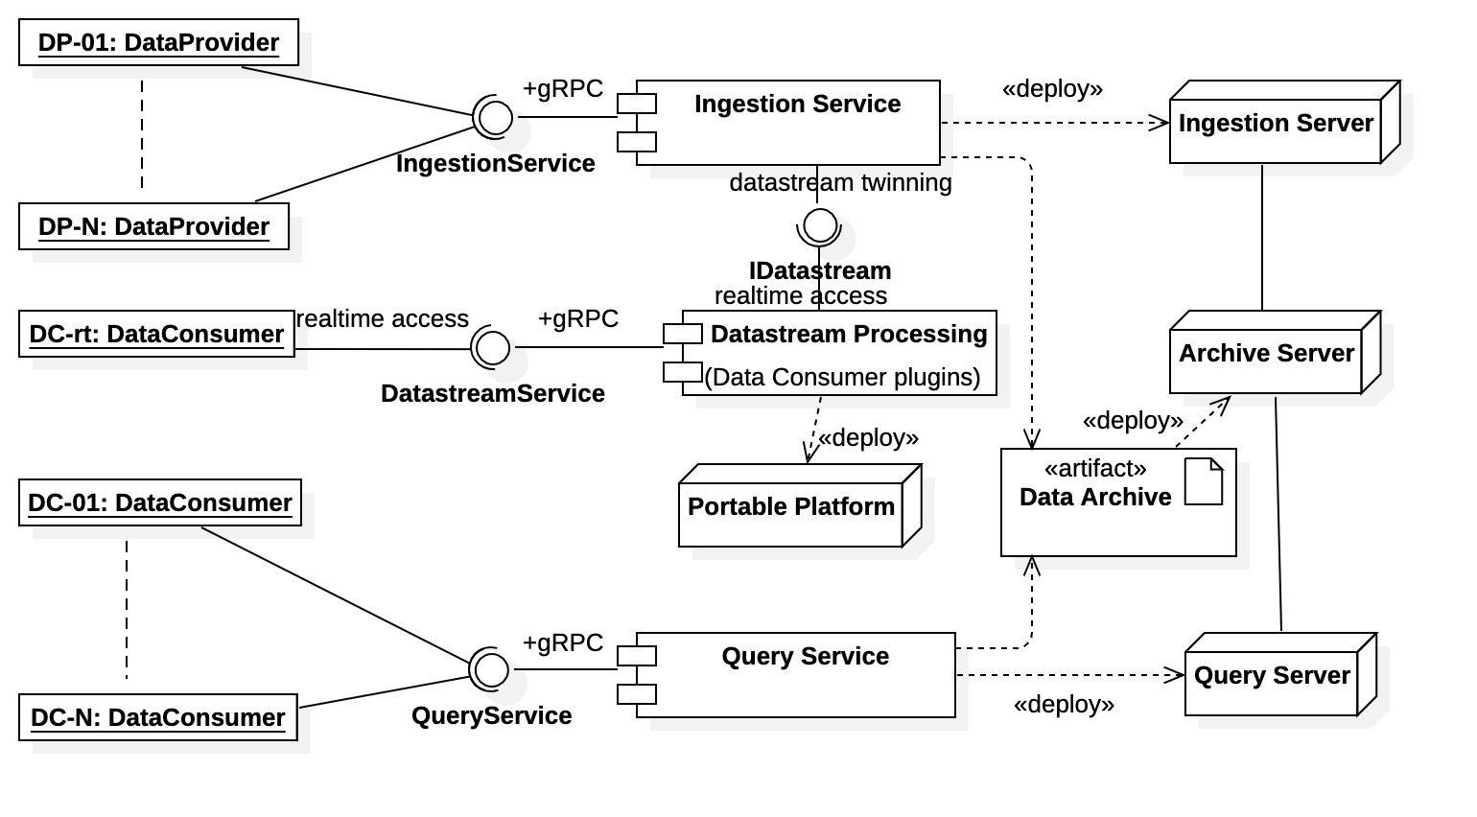

Figure 2: Datastore system deployment

### Real-time Applications

The diagram in Figure 2 also illustrates that the Query Service “Real-time Applications” use case is actually supported by a separate Datastore component, Datastream Processing. This use case is essentially orthogonal to the both the Ingestion Service and Query Service. The “datastream twinning” communication required by the Datastream Processing component is again implemented as a gRPC interface, thus making the component a client of the Ingestion Service, although in the role of a direct service Data Consumer rather than a Data Provider. The diagram shows that the Datastream Processing component formally supports real-time Data Consumers through the DatastreamService interface. However, it is possible for Data Consumers to directly access the IDatastream interface for fastest possible datastream access. Thus, specialized Data Consumers can be built for real-time operations as “plugins.” As shown in the diagrams these plugins can be deployed on their own platform for fast real-time operations.

The most likely application of C++ gRPC is for this use case, where performance is of primary concern. As we find in the next chapter that asynchronous C++ gRPC performance is exceptional. C++ gRPC offers comprehensive control and management of all RPC operations for asynchronous implementation. Thus, implementations can be fine-tuned for optimal performance. Additionally, C++ source compiles into native binary executable of the supporting platform, machine code potentially providing the fastest real-time execution. However, these facts also make C++ gRPC development more challenging. With the performance advantages, the fine-grain control offered by C++ gRPC is also a requirement, necessitating additional effort and detail. Moreover, the native executable code creates portability issues and burdens on platform environments (in both development and deployment).

### Test Stand

The test stand emulates the situation depicted in the top half of Figure 1, specifically the “Archiving” use case. The test stand supports only ingestion and archiving, it does not implement the full functionality of the Ingestion Service. A Data Provider transmits simulated data to Ingestion Service mockup using gRPC, where a rudimentary archiving system is implemented. The Remote Procedure Call (RPC) communication framework is defined with Protocol Buffers; it mimics the transport of EPICS NTTable instances. The performance of this communication framework is the focus of the next chapter. The following chapters presents the underlying C++ gRPC requirements needed to develop such an implementation; specifically, the gRPC resources and basic designs needed by developers.

# Performance Evaluations

This chapter contains three sections. The first two sections present a brief overview of the test stand while the last, the main body, contains all the evaluation results. The first section contains a concise but complete description of the RPC framework used in the evaluations. The RPC framework definition is included as a separate section because it is used throughout the text, including chapters concerning gRPC development; it may be referenced as needed. The second section provides context for the performance evaluations; it describes the test stand and the measurement process. The third section contains the performance results summarized in tabular form. Direct outputs for the synchronous results can be found in Appendix A while asynchronous output are found in Appendix B.

## RPC Communications Framework via Protobuf

For C++ gRPC evaluations, a basic Ingestion Service RPC communications framework was defined in Protocol Buffers proto meta language. The framework is designed to support the network transport of heterogeneous, time-correlated data tables. The data messages and supporting RPC interfaces are defined within two proto source files, CommonMessages.proto and ArchiveService.proto. The proto source code within these files is described concisely in Figure 3. As indicated in the diagram the interface for the Ingestion Service is named ArchiveService and is contained in the C++ namespace com::ospreydcs::archive. (The interface was so named because it supports only the “Archiving” use case of the Datastore Ingestion Service.) The interface contains only 2 operations: 1) sendData() a unary operation transmitting one DataSet message and receiving one Acknowledge message response, and 2 streamData() a gRPC streaming operation that sends a collection of DataSet message while receiving a corresponding Acknowledge message response for each message within the stream.

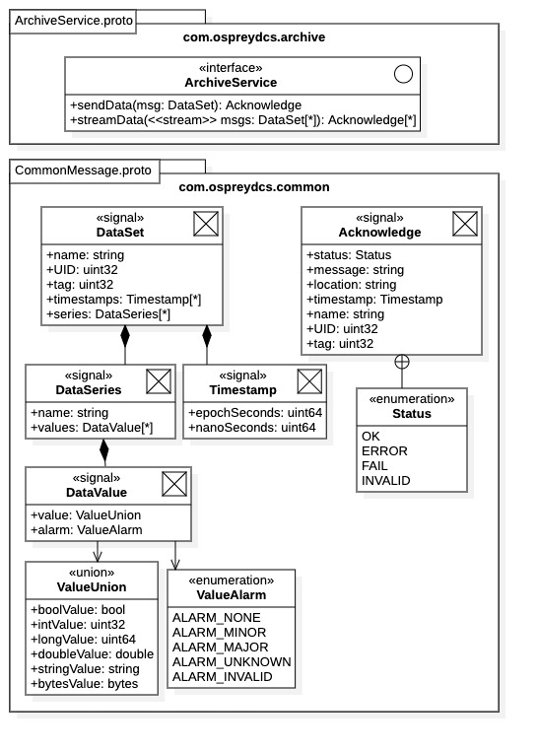

Figure 3: test stand Protobuf RPC definition

Referring to Figure 3, the DataSet message effectively represents heterogeneous table data. Each DataSet is a composition of DataSeries messages comprising the table columns, along with a collection of Timestamp messages containing the acquisition times for each time-correlated table row. The DataSet message also contains some perfunctory identifying information used in archiving: a string name, an integer unique identifier (UID), and an optional tag value (used to identify a DataSet within a gRPC stream). The DataSet message is the basic unit of ingestion and contains the following fields:

1. name – String name identifier for the DataSet message.
2. UID – Unique identifier of DataSet message.
3. tag – Optional tag value of DataSet message (e.g., gRPC stream identification).
4. timestamps – Ordered list of timestamps for table rows.
5. series – Unordered collection of DataSeries messages comprising named table columns.

All data columns contained in the series field must be the same size, specifically, the size of the timestamps field. Otherwise, the service implementation is expected to reject the DataSet, which would be reported as an error in the Acknowledge message response.

Referring to Figure 3, each data column is represented by the DataSeries Protobuf message; it is an ordered composition of DataValue messages, along with a field containing the column name. The DataValue message contains two fields: a value field of type ValueUnion, and an associated alarm of type ValueAlarm. The type ValueUnion is fictitious, it is not seen in the proto source files. It is simply a notation convenience within Figure 3 used to represent the effect of proto keyword “oneof”, which creates anonymous value unions within proto definitions. From the figure, we see that values can be one of the following types: Boolean, int, long, double, string, and a byte array. The associated ValueAlarm is an enumeration specifying some basic alarm conditions. Protobuf enumerations are realized as C++ enums inheriting from a 4-byte wide int primitive type. Thus, for example, when using 8-byte double values, a single DataValue contains 12 bytes of information.

Finally, the Acknowledge message represents the service response from a single DataSet ingestion operation. It contains the following 7 fields:

1. status - Enumeration indicating the transmission, ingestion, and archive operations status.
2. message – String containing any additional status information.
3. location – The archive location in which the DataSet was stored.
4. timestamp – The time at which it was stored (or the first timestamp within the DataSeries).
5. name – String name identifier of the DataSet archived.
6. UID – Unique identifier of DataSet archived.
7. tag – Optional tag value of DataSet archived.

The Acknowledge message is the server response notifying clients of the transmission and archiving status of each DataSet message sent to the service.

Invoking the Protobuf protoc compiler on the proto source files of Figure 3 generates four C++ files. The RPC messages are defined in the header CommonMessage.pb.h and any implementation requirements are in source file CommonMessage.pb.cc. Likewise, the ArchiveService interface is defined in header file ArchiveService.grpc.pb.h and implementations are contained in source file AchiveService.grpc.pb.cc. Note that all data message are contained in the C++ namespace com::ospreydcs::common while the RPC interface has the fully qualified name com::ospreydcs::archive::ArchiveService. The namespaces help isolate the messages and interface from any name collisions within the client and service implementations.

## The Test Stand

The test stand was built to emulate the basic ingestion and archiving function of the Datastore Ingestion Service component within the Machine Learning Data Platform [12]. The test stand was implemented in C++ 17 using the Eclipse IDE for project management and development [13]. The Eclipse CDT Builder plugin was used for development and builds [14]. This plugin automates a signification portion of C++ development by generating supporting make files for project builds. Developers create C++ project configurations; the CDT manages source files and builds projects using local make/gcc command line tools (which must be installed).

Figure 4 is a high-level schematic of the test stand. The test stand is composed of a single active client and single server that communicate over the network ports of the single-node test platform (i.e., network communications operating in “loop-back” mode). All evaluations consisted of a set of client-server “scenarios” where the client delivers a pre-defined payload of DataSet protobuf messages containing table data. The payload consisted of 100 tables of various sizes and dimensions. For streaming operations, the payload may be divided into smaller batches, each batch being sent over a separate gRPC stream.

The test stand is built on the notation of an *execution scenario*. Referring to Figure 4 each scenario is composed of the 4 basic components:

1. DataFactory – creates DataSet payload filled with simulated data of various configurations.
2. Client – gRPC client implementation capable of sending a RequestPayload of DataSet messages.
3. Server – gRPC server operating as an Ingestion Service for the Client.

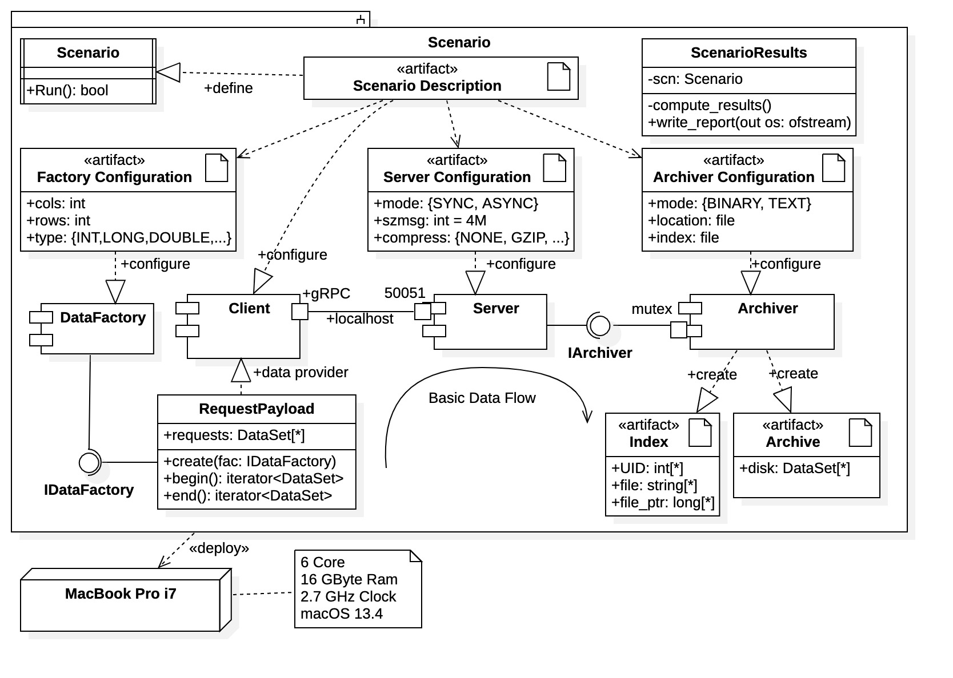

Figure 4: Scenario architecture and components

1. Archiver – Archiving system storing DataSet messages to disk file.

Note that there are also several configuration files involved with a scenario. These are nothing more than standard properties files containing (label = value) pairs specifying various configuration parameters within context. The DataFactory, Server, and Archiver all require a configuration file to parameterize their operation. In addition, there is a “master” scenario definition file which specifies the Client operation and identifies all other configuration files for a scenario. The entire scenario is managed by the Scenario class which performs all the component initializations, gRPC startup operations, data transmission, and measurement operations. An additional class, ScenarioResults, computes all results for a given scenario once completed. It writes a final report as an output file.

Note also that there is no parallelism within the Archiver. There is only one archiver per scenario maintaining a single archive data file. The archiver blocks during a DataSet message archive operation, indicated by the mutex mutual exclusion guard in the diagram. It may be desirable add archiving concurrency for future performance evaluations. (A simple solution would be multiple archivers executing on separate threads creating multiple archive files.) The Archiver can store data in text format (used for debugging) or binary (used for performance). There are also provisions for an HDF5 format, but it has yet to be implemented. The binary mode stores serialized Protobuf message directly to disk using C++ standard library file streams. The Archiver can also be “switched off”, where it generates an Acknowledge message without archiving error, but notifying the client that nothing was archived. This configuration is used to isolate gRPC network transmission performance.

The diagram shows that the archiver maintains an index file recording all archiving activity. The index file is essentially a lookup table containing the location of each archived DataSet message (by UID and timestamp), along with some archive properties (storage time, storage size, etc.). The index file can be used for simple recover operations if so desired.

Figure 4 indicates that the entire scenario is executed on a single platform. All evaluations presented here used a MacBook Pro with 16 GBytes RAM, 500 GBytes SSD hard drive, 2.7 GHz clock, and Intel i7 6 core CPU. The platform was running the MacOS 13.4 Venture operating system.

## Results

All evaluations consisted of a set of client-server scenarios where the client delivers a payload of NTTable-like protobuf messages represented by the DataSet Protobuf message described above. The payload consisted of 100 tables of various sizes and dimensions. For streaming operations, the payload is divided into batches each batch being sent over a separate gRPC data stream.

At the server end, the DataSet request messages are archived to a single binary file. In every scenario a single archiver is used. Thus, for the multi-threaded asynchronous cases it is possible to have competition for the archiver resource. Notably then, better archiving performance could potentially be realized with a test stand employing multiple, independent archivers.

The binary archive format is that of Protocol Buffers. Specifically, DataSet messages are archived in their serialized form in the order presented to the archiver. They can be recovered by reading the archive into DataSet message buffers. It is also possible to archive request messages in text format, which is useful in debugging. However, a text archive is substantially larger (~2x to 5x) and performance there is significantly lower; thus, text archive performance is not considered.

### Scenario Payloads

Table 1 describes the payloads used in performance evaluation scenarios. Scenarios are identified by the tables transmitted, which in turn are identified by their dimensions. The table contains two sections: section **Table** describes each table contained in the payload (i.e., the DataSet message), while section **Total Payload** describes the payload for a scenario. Of particular interest for the Datastore are tables containing thousands of data columns. Thus, table dimensions are specified with column count first.

The “Raw Size” column contains the number of bytes in native C++ required to store all *information* within a table (i.e., data values, data alarms, timestamps, column labels, etc.). Note that information required to identify the table structure is not considered here. The “Doubles” column contains the equivalent number of double values needed to store this information (i.e., if all information was contained as double values). In C++ double values are 8 bytes wide, and this column is simple the raw size of the table divided by 8. The “Serial Size” column is the size of the table after serialization by Protocol Buffers. It is important to note that Protocol Buffers serialization is efficient; it provides about 10% data compression. Thus, the serialized payload is typically 10% smaller (and includes the table structure information) and we typically see a 10% boost in raw information transmission data rates as compared to actual transmission rates.

It is important to note that the default gRPC message size limit is 222 = 4,194,304 bytes, or 4 Mbytes in common convention. Thus, DataSet messages larger than 4 Mbytes require special consideration. If one is to transmit such messages both client and server must be deliberately configured beyond the default gRPC limitation. It is likely that the 4 Mbyte default limit was purposefully chosen by gRPC developers; we see a noticeable, and eventually significant, performance drop when message sizes increase beyond a cutoff. In our case this occurs with message sizes greater than 16 Mbytes. Thus, from Table 1 it is important to recognize the serialized size of the messages used in each scenario.

The gRPC message size limit should be set to a power of 2 (although the author has yet to see documentation as to why). Thus, the message size limits needed to accommodate all scenario evaluations where 4 Mbytes, 8 Mbytes, 16 Mbytes, 32 Mbytes, and 64 Mbytes. Size limits were chosen as the smallest possible to accommodate the DataSet messages being transmitted.

|  |  |  |  |  |  |  |
| --- | --- | --- | --- | --- | --- | --- |
| **Table** (DataSet Message) | | | | **Total Payload** | | |
| **Dimensions (cols x rows)** | **Equivalent Double (millions - x106)** | **Raw Size (Mbytes)** | **Serial Size (Mbytes)** | **Tables** | **Raw Size (Mbytes)** | **Serial Size (Mbytes)** |
| **100x100** | 0.0155 | 0.124 | 0.1126 | 100 | 12.40 | 11.26 |
| **500x500** | 0.3775 | 3.020 | 2.763 | 100 | 302.0 | 276.3 |
| **1000x100** | 0.1532 | 1.226 | 1.113 | 100 | 122.6 | 111.3 |
| **1000x250** | 0.3785 | 3.028 | 2.766 | 100 | 302.8 | 276.6 |
| **1000x350** | 0.5287 | 4.230 | 3.863 | 100 | 423.0 | 386.3 |
| **1000x500** | 0.754 | 6.032 | 5.519 | 100 | 603.2 | 551.9 |
| **1000x1000** | 1.505 | 12.04 | 11.03 | 100 | 1,204.0 | 1,102.6 |
| **2000x100** | 0.3062 | 2.450 | 2.226 | 100 | 245.0 | 222.6 |
| **2000x175** | 0.5314 | 4.251 | 3.877 | 100 | 425.1 | 387.7 |
| **2000x250** | 0.7565 | 6.052 | 5.529 | 100 | 605.2 | 552.9 |
| **2000x500** | 1.507 | 12.06 | 11.03 | 100 | 1,205.6 | 1,103.2 |
| **2000x1000** | 3.008 | 24.06 | 22.04 | 100 | 2,406.4 | 2,203.8 |
| **4000x100** | 0.6122 | 4.898 | 4.452 | 100 | 489.8 | 445.2 |
| **4000x250** | 1.513 | 12.10 | 11.05 | 100 | 1,210.0 | 1,105.5 |
| **4000x500** | 3.013 | 24.10 | 22.06 | 100 | 2,410.4 | 2,205.8 |
| **4000x750** | 4.514 | 36.11 | 33.06 | 100 | 3,610.8 | 3,306.1 |
| **4000x1000** | 6.014 | 48.11 | 44.06 | 100 | 4,811.2 | 4,406.5 |

Table 1: scenario payload description

### Synchronous gRPC Operation with Archiving

Evaluations for gRPC synchronous operations consist of a single synchronous client and a single synchronous server. All server operations are executed on a single thread using a single archiver. The client operations are single threaded for unary operations and utilize two execution threads for streaming operations. In client streaming operations one thread writes requests and the other reads responses. For unary operations, the client transmits the data payload entirely through multiple unary RPC operations (i.e., one operation for each table). For streaming operations, the client invokes multiple streaming operations (i.e., one operation for each request batch) sequentially until the entire request payload is transmitted.

Table 2 presents the data transmission times and rates for all synchronous scenario cases. The table is composed of two categories: one for unary RPC transmissions, and the other for gRPC streaming operations. Test cases are represented by rows and are identified by the tables transmitted by the client (i.e., by table dimensions in the “Table” column). Results are contained in 3 columns within each category:

1. “Time” – The total time required to transmit the full payload.
2. “Raw Rate” – The data transmission rate without Protobuf serialization compression.
3. “True Rate” – The serialized data rate, the actual data rate seen across the wire.

Note that the streaming operations section (i.e., “**Streaming Calls**”) contains an additional column “Stream Size.” This column contains the batch size (i.e., number of DataSet messages) used by the client for each streaming call. Two cases are provided for each table case:

1. Batch size 10: There are 10 streaming calls each with 10 DataSet messages.
2. Batch size 100: 1 streaming call with size 100, sends entire payload over a single data stream.

For the unary operations there are no batches and the two cases presented in Table 2 demonstrate variability in performance. Typically, one row contains results for the best performance seen during testing, while the other contains results chosen at random. Generally best performance is seen when running tests contiguously, presumably because gRPC resources remain in cache memory (there is an observable gRPC startup cost).

|  |  |  |  |  |  |  |  |
| --- | --- | --- | --- | --- | --- | --- | --- |
| **Table** | **Unary Calls** | | | **Streaming Calls** | | | |
| Time (seconds) | Raw Rate (Mbps) | True Rate (Mbps) | Stream Size | Time (seconds) | Raw Rate (Mbps) | True Rate (Mbps) |
| **100x100** | 0.184 | 67.2585 | 61.0718 | 10 | 0.085 | 144.661 | 131.323 |
| 0.214 | 57.9081 | 52.5815 | 100 | 0.075 | 163.527 | 148.486 |
| **500x500** | 4.435 | 68.0906 | 62.2928 | 10 | 2.029 | 148.815 | 136.144 |
| 4.306 | 70.1215 | 64.1503 | 100 | 1.881 | 160.500 | 146.835 |
| **1000x500** | 8.776 | 68.7305 | 62.8836 | 10 | 4.045 | 149.089 | 136.407 |
| 8.818 | 68.4002 | 62.5813 | 100 | 3.579 | 168.519 | 154.183 |
| **1000x1000** | 27.549 | 43.7029 | 40.0213 | 10 | 8.365 | 143.931 | 131.806 |
| 16.514 | 72.9068 | 66.7650 | 100 | 7.706 | 156.239 | 143.077 |
| **2000x250** | 8.829 | 68.5445 | 62.6147 | 10 | 4.162 | 145.393 | 132.815 |
| 8.379 | 72.2237 | 65.9755 | 100 | 3.682 | 164.341 | 150.123 |
| **2000x500** | 22.602 | 53.3392 | 48.8081 | 10 | 9.887 | 121.926 | 111.568 |
| 16.560 | 72.8007 | 66.6164 | 100 | 7.583 | 158.981 | 145.476 |
| **2000x1000** | 55.141 | 43.6406 | 39.9677 | 10 | 22.386 | 107.492 | 98.4451 |
| 43.805 | 54.9336 | 50.3103 | 100 | 23.458 | 102.581 | 93.9473 |
| **4000x100** | 7.260 | 67.4545 | 61.3223 | 10 | 3.436 | 142.518 | 129.562 |
| 7.054 | 69.4245 | 63.1133 | 100 | 3.167 | 154.616 | 140.560 |
| **4000x250** | 22.994 | 52.6204 | 48.0734 | 10 | 10.691 | 112.176 | 103.396 |
| 18.572 | 65.1500 | 59.5203 | 100 | 7.549 | 160.273 | 146.424 |
| **4000x500** | 46.698 | 51.6165 | 47.2349 | 10 | 26.086 | 92.3999 | 84.5562 |
| 44.235 | 54.4900 | 49.8644 | 100 | 23.357 | 103.196 | 94.4358 |
| **4000x1000** | 118.562 | 40.5796 | 37.1660 | 10 | 69.247 | 69.4789 | 63.6342 |
| 111.975 | 42.9667 | 39.3520 | 100 | 63.611 | 75.6340 | 69.2715 |

Table 2: synchronous transmission times and rates (binary archived)

Referring to Table 2 the best performance is seen for the gRPC streaming operation when the entire payload is sent over a single stream. This is true for all scenario cases in Table 2. There, the best true transmission rates are seen around 150 Mbps. These rates are quite consistent so long as the message size is less than 16 Mbytes. There is one exception, that for the 2000x1000 table, where rates are below 100 Mbps. This anomaly was confirmed across multiple test runs; however, the cause is still undetermined.

For unary RPC communication best performance is seen around 65 Mbps, less than half of that seen in the streaming cases. However, note that, unlike its single-streaming counterpart, unary RPC performance is highly variable, sometimes varying over ±10 Mbps for the same case. The same anomalous performance drop for the 2000x1000 case is also seen. Unary RPC performance also drops with message sizes greater than. 16 Mbytes, on par with the streaming gRPC cases.

Other than the 2000x1000 streaming case, table shapes do not seem to factor into C++ gRPC performance. Performance appears to be primarily determined by the communications method (i.e., unary versus streaming) and the transmitted message size. Regardless of communication method, performance sees a marked decline once message sizes pass the 16 Mbyte threshold, regardless of the table dimensions used.

### Asynchronous gRPC Operation with Archiving

The testbed for gRPC asynchronous communications evaluation consisted of a single asynchronous client and a single asynchronous server, however, here both client and server spawned multiple execution threads for RPC transmission management. As before, the server contains a single archiver maintaining a single binary archive file. We would expect a significant performance enhancement for asynchronous gRPC communications if the test stand supported multiple concurrent archivers. This expectation is further justified when isolating gRPC network transmission in Subsection (d) below.

Although only one client was active, a single asynchronous client can spawn multiple execution threads, each independent thread concurrently transmitting data messages. Multiple execution threads were used for both unary RPC calls and streaming RPC calls. It was found that between 3 and 5 threads produced the best performance and those cases are shown in the results. For many cases with small tables, unary RPC communications performed best using 3 threads, while best performing gRPC streaming communications typically required 5 threads (the cause of this incongruity is unknown).

The asynchronous server always maintained 5 service threads for both unary and streaming gRPC calls. This configuration was found to yield best performance (by far) and is consistent with the host platform hardware. As shown in Figure 4 the host platform contained a single Intel i7 processor with 6 cores. Thus, a separate core was available for each of the 5 service threads, plus an additional core for the main execution thread (i.e., that managing the server completion queue). Of course, all cores must be shared with the client threads which are also concurrent.

Table 3 contains the results for the asynchronous gRPC test cases. The table has the same format as Table 2, with the addition of column “Client Threads” containing the number of concurrent transmission threads within the client. For the unary case this value is selected. For the streaming case this value can be affected by the stream size, as described in the paragraph below. When two numbers appear in the “Client Threads” column the first refers to the unary call and the second refers to the streaming call.

In the unary case client threads retrieve individual DataSet request messages from the common payload, transmitting them concurrently until the payload is exhausted. For gRPC streaming operations client threads retrieve DataSet messages in batches according to the “Stream Size” column in Table 3. Two batch sizes were used, 10 messages and 100 messages. A batch size of 10 implies that 10 streaming operations occurred which were shared among the transmission threads. A batch size of 100 requires that the entire payload be sent over a single execution thread maintaining a single data stream. This condition effectively eliminates concurrency and performance is seen to suffer (typically halved). This contrasts with the synchronous case where the performance is best (since there is no concurrency in synchronous gRPC communication, best performance is achieved when transmitting entire payload over a single open data stream). Comparing Table 2 and Table 3 we see that synchronous communications outperforms asynchronous communications in this special case.

Note for asynchronous communications client threads compete for request payload messages. Thus, requests messages typically arrive at the server in different order than found within the original payload container. The archiver is unaware of this condition and simply stores the requests in the order they arrive. However, specific DataSet messages can be recovered according to their UID, as recorded in the index file maintained by the archiver.

|  |  |  |  |  |  |  |  |  |
| --- | --- | --- | --- | --- | --- | --- | --- | --- |
| **Table** |  | **Unary Calls** | | | **Streaming Calls** | | | |
| Client Threads | Time (seconds) | Raw Rate (Mbps) | True Rate (Mbps) | Stream Size | Time (seconds) | Raw Rate (Mbps) | True Rate (Mbps) |
| 100x100 | 3 | 0.116 | 106.910 | 97.0759 | 10 | 0.066 | 185.254 | 168.114 |
| 1 | 0.289 | 42.9058 | 38.9249 | 100 | 0.118 | 104.461 | 94.8528 |
| 500x500 | 3 | 1.896 | 159.263 | 145.700 | 10 | 1.483 | 203.615 | 186.280 |
| 1 | 3.243 | 93.1151 | 85.1863 | 100 | 2.621 | 115.212 | 105.401 |
| 1000x500 | 3, 5 | 3.781 | 159.497 | 145.930 | 10 | 2.659 | 226.821 | 207.525 |
| 1 | 6.328 | 95.3176 | 87.2088 | 100 | 5.276 | 114.314 | 104.589 |
| 1000x1000 | 5 | 7.570 | 159.035 | 145.638 | 10 | 5.507 | 218.593 | 200.179 |
| 1 | 12.448 | 96.7210 | 88.5730 | 100 | 10.502 | 114.645 | 104.987 |
| 2000x250 | 5 | 3.777 | 160.230 | 146.368 | 10 | 2.757 | 219.498 | 200.508 |
| 1 | 6.449 | 93.8358 | 85.7178 | 100 | 6.432 | 94.0847 | 85.9453 |
| 2000x500 | 3, 5 | 7.518 | 160.352 | 146.730 | 10 | 5.338 | 225.850 | 206.665 |
| 1 | 12.743 | 94.6041 | 86.5677 | 100 | 10.259 | 117.508 | 107.526 |
| 2000x1000 | 3, 5 | 18.667 | 128.906 | 118.057 | 10 | 15.428 | 155.972 | 142.846 |
| 1 | 38.661 | 62.2427 | 57.0042 | 100 | 33.028 | 72.8583 | 66.7264 |
| 4000x100 | 5 | 3.448 | 142.004 | 129.095 | 10 | 2.136 | 229.251 | 208.410 |
| 1 | 5.344 | 91.6405 | 83.3096 | 100 | 4.284 | 114.312 | 103.921 |
| 4000x250 | 5 | 7.618 | 158.832 | 145.108 | 10 | 5.628 | 214.991 | 196.413 |
| 1 | 12.605 | 95.9904 | 87.6958 | 100 | 11.012 | 109.877 | 100.382 |
| 4000x500 | 5 | 18.177 | 132.601 | 121.345 | 10 | 14.258 | 168.929 | 154.589 |
| 1 | 39.466 | 61.0752 | 55.8906 | 100 | 31.400 | 76.7628 | 70.2465 |
| 4000x1000 | 5 | 41.346 | 116.362 | 106.573 | 10 | 33.558 | 143.366 | 131.306 |
| 1 | 103.201 | 46.6193 | 42.6976 | 100 | 95.133 | 50.5732 | 46.3188 |

Table 3: asynchronous transmission times and rates (binary archived)

From Table 3 we see that asynchronous gRPC communication always outperformance its synchronous counterpart, so long as concurrency is utilized. Best performance is seen to be over 200 Mbps for the gRPC streaming case when multiple threads are active in both client and server. Even unary transmission significantly outperforms its synchronous counterpart reaching true data rates just under 150 Mbps. Again, we see the fall off in performance when message sizes increase over 16 Mbytes. Note additionally that there appears to be a “sweet spot” for message size and asynchronous performance, somewhere between 1 and 16 Mbytes. When message sizes are less than 1 Mbytes, performance is below peak for both unary and streaming calls.

### gRPC Network Transmission (Without Archiving)

Here we isolate the C++ gRPC network transmission rates. That is, all archiving is turned off and we measure only the data transmission rates over the network. The data rates seen here are indicative of the best possible performance of C++ gRPC transmission for this test stand. We consider the same scenario cases as before, but without any data archiving.

Table 4 below presents a concise comparison of data transmission rates with and without archiving, for both synchronous and asynchronous gRPC. Only the serialized data rates are shown in the table, that is the “True Rate” columns from the previous tables (i.e., “Raw Rate” columns are not shown). Additionally, for conciseness the table includes only best-case results from Table 2 and Table 3 as comparison values.

Table 4 is divided into two major categories, unary calls and streaming calls, each category then divided into two additional subcategories, synchronous transmission rates and asynchronous transmission rates. Asynchronous cases used 3 or 5 client threads as before (i.e., whichever performed best). The asynchronous server again used 5 service threads for both unary and streaming gRPC calls.

|  |  |  |  |  |  |  |  |  |
| --- | --- | --- | --- | --- | --- | --- | --- | --- |
| **Table** | **Unary Calls** | | | | **Streaming Calls** | | | |
| **Synchronous Rate** | | **Asynchronous Rate** | | **Synchronous Rate** | | **Asynchronous Rate** | |
| Archived (Mbps) | None (Mbps) | Archived (Mbps) | None (Mbps) | Archived (Mbps) | None (Mbps) | Archived (Mbps) | None (Mbps) |
| 100x100 | 61.072 | 74.605 | 97.076 | 108.22 | 148.49 | 321.56 | 168.11 | 345.46 |
| 500x500 | 64.150 | 87.867 | 145.70 | 170.95 | 146.84 | 317.38 | 186.28 | 434.45 |
| 1000x500 | 62.884 | 88.455 | 145.93 | 168.50 | 154.183 | 316.10 | 207.53 | 454.57 |
| 1000x1000 | 66.765 | 91.027 | 145.64 | 168.92 | 143.08 | 320.28 | 200.18 | 450.92 |
| 2000x250 | 65.976 | 89.526 | 146.37 | 168.54 | 150.12 | 319.86 | 200.51 | 435.93 |
| 2000x500 | 66.616 | 91.863 | 146.73 | 163.93 | 145.48 | 323.86 | 206.67 | 458.57 |
| 4000x100 | 63.113 | 87.123 | 129.10 | 155.09 | 140.56 | 320.55 | 208.41 | 425.00 |
| 4000x250 | 59.520 | 89.463 | 145.11 | 160.97 | 146.42 | 319.15 | 196.41 | 455.24 |
| 4000x500 | 49.864 | 62.585 | 121.35 | 135.48 | 94.436 | 118.88 | 154.59 | 213.15 |
| 4000x1000 | 39.352 | 45.955 | 106.57 | 110.75 | 69.272 | 74.581 | 131.31 | 158.84 |

Table 4: gRPC transmission rate comparisons with and without archiving

From Table 4, best achieved C++ gRPC transmission rates are 450 Mbps for the asynchronous, streaming case. These rates are quite consistent so long as Protobuf message sizes remain within the performance bandwidth, between 1 Mbytes and 16 Mbytes. The performance for synchronous streaming operations is also exceptional at 320 Mbps. Although synchronous streaming has a 30% performance drop from the asynchronous counterpart, it is much easier to develop (especially on the server side). The ease in development may outweigh the performance drop in some applications. For example, for cases where an application is bound by data processing rather than data transmission.

Synchronous unary calls have peak rates around 90 Mbps while asynchronous unary calls see peak rates up to 170 Mbps. The results in Table 4 suggest that asynchronous unary rates seem to be sensitive to table column width. There we see slightly lower rates for tables with column widths of 2,000 and 4,000 but still within the 16 Mbyte message size cutoff. However, this slight sensitivity is not seen anywhere else and may be anomalous.

The above results establish that the message size performance cutoff of 16 Mbytes is attributable to gRPC, no data processing is involved. We see the characteristic performance drop in all situations, synchronous versus asynchronous and unary versus streaming.

The results of Table 4 also demonstrate that archiving within the test stand creates a noticeable throughput burden. This burden is especially conspicuous in the streaming cases, where transmission rates drop by over half. Thus, although the test stand employs only basic archiving capabilities (without a formal database system), it is still a significant performance bottleneck when gRPC streaming is utilized, for both synchronous and asynchronous communication. Use of multiple write heads for archiving has potential for significant speedup.

### gRPC Transmission with Compression

The gRPC library provides the capability for data compression before network transmission. Currently C++ gRPC provides the GZIP and DEFLATE compression algorithms as library options (note that the GZIP algorithm is based upon DEFLATE). There is suggestion within the C++ gRPC source files (e.g., grpc/impl/compression_types.h) that the SNAPPY compression algorithm will be available in future releases.

Table 5 presents data transmission rates using GZIP compression compared against the uncompressed rates shown previously in Table 4. Data archiving was again turned off, so the data rates are indicative of gRPC network transmission. The results make clear that data compression offers no benefit to performance, the motivation for C++ gRPC. In fact, compression comes with a substantial performance cost, most cases seeing a 5x performance drop. The compression algorithms appear to be CPU bound, severely overwhelming any network gains obtained from the smaller data message sizes.

|  |  |  |  |  |  |  |  |  |
| --- | --- | --- | --- | --- | --- | --- | --- | --- |
| **Table** | **Unary Calls** | | | | **Streaming Calls** | | | |
| **Synchronous Rate** | | **Asynchronous Rate** | | **Synchronous Rate** | | **Asynchronous Rate** | |
| Uncomp. (Mbps) | GZIP (Mbps) | Uncomp. (Mbps) | GZIP (Mbps) | Uncomp. (Mbps) | GZIP (Mbps) | Uncomp. (Mbps) | GZIP (Mbps) |
| 100x100 | 74.605 | 12.783 | 108.22 | 37.291 | 321.56 | 17.170 | 345.46 | 62.165 |
| 500x500 | 87.867 | 18.132 | 170.95 | 51.086 | 317.38 | 21.947 | 434.45 | 87.561 |
| 1000x500 | 88.455 | 17.567 | 168.50 | 48.966 | 316.10 | 21.459 | 454.57 | 87.249 |
| 1000x1000 | 91.027 | 17.003 | 168.92 | 68.782 | 320.28 | 21.314 | 450.92 | 82.440 |
| 2000x250 | 89.526 | 17.143 | 168.54 | 69.759 | 319.86 | 21.180 | 435.93 | 87.459 |
| 2000x500 | 91.863 | 16.801 | 163.93 | 72.865 | 323.86 | 20.620 | 458.57 | 83.353 |
| 4000x100 | 87.123 | 17.575 | 155.09 | 69.603 | 320.55 | 21.618 | 425.00 | 85.830 |
| 4000x250 | 89.463 | 16.398 | 160.97 | 66.423 | 319.15 | 19.858 | 455.24 | 84.080 |
| 4000x500 | 62.585 | 16.549 | 135.48 | 64.718 | 118.88 | 19.031 | 213.15 | 71.972 |
| 4000x1000 | 45.955 | 16.229 | 110.75 | 58.270 | 74.581 | 19.282 | 158.84 | 62.328 |

Table 5: gRPC transmission rates with and without GZIP compression (no archiving)

Table 6 is included as a quick comparison between the two available compression algorithms in C++ gRPC, the GZIP and DEFLATE algorithms. As seen in the table, their performance is essentially identical, which is to be expected. The GZIP algorithm is essentially a later version of the DEFLATE algorithm, both being based upon Huffman encoding.

|  |  |  |  |  |  |  |  |  |
| --- | --- | --- | --- | --- | --- | --- | --- | --- |
| **Table** | **Unary Calls** | | | | **Streaming Calls** | | | |
| **Synchronous Rate** | | **Asynchronous Rate** | | **Synchronous Rate** | | **Asynchronous Rate** | |
| GZIP (Mbps) | Deflate (Mbps) | GZIP (Mbps) | Deflate (Mbps) | GZIP (Mbps) | Deflate (Mbps) | GZIP (Mbps) | Deflate (Mbps) |
| 1000x500 | 17.567 | 17.447 | 48.966 | 48.931 | 21.459 | 21.528 | 87.249 | 87.393 |
| 1000x1000 | 17.003 | 16.988 | 68.782 | 67.412 | 21.314 | 20.884 | 82.440 | 83.317 |
| 4000x100 | 17.575 | 17.482 | 69.603 | 69.917 | 21.618 | 21.808 | 85.830 | 84.917 |
| 4000x250 | 16.398 | 16.924 | 66.423 | 65.172 | 19.858 | 21.160 | 84.080 | 84.748 |

Table 6: gRPC transmission rates (no archiving), GZIP versus DEFLATE compression

In gRPC both client and service must be explicitly configured for compression. Protobuf messages are compressed at the client, transmitted via gRPC, then uncompressed at the server. Thus, the compression algorithm must be specified for the gRPC channel instance at the client, and for the gRPC server instance at the service. (It is also possible to include data compression for individual calls using gRPC ClientContext, ServerContext, and WriteOptions objects.) Data compression options are set in an analogous manner as to that for message size limits.

Note that GZIP and DEFLATE compression algorithms are results based; they aim for maximum possible compression without regard to processing time. On the other hand, the SNAPPY compression algorithm is performance based, aiming for reasonable compression and fast execution. Compression sizes can be twice that obtained for GZIP compression; however, compression rates are quoted between 250 to 500 Mbps for CPUs comparable to that used for hosting the test stand. Thus, if the SNAPPY algorithm is included in future C++ gRPC releases it may offer performance benefits for environments where network traffic is high.

### Message Size and gRPC Transmission

We conclude this section by formally considering the dependency gRPC transmission rates on Protobuf message sizes. Table 7 summarizes the serialized transmission results of Table 3 and Table 4 for comparison against the serialized message size, rather than the table dimensions. The table includes best performance results for all cases both with and without binary archiving. (The **Network Transmission Rate** category contain rates without archiving.) The gRPC preference for message sizes between 1 Mbyte and 16 Mbyte is clearly evident.

|  |  |  |  |  |  |  |  |  |  |
| --- | --- | --- | --- | --- | --- | --- | --- | --- | --- |
| **Message Size** (Mbytes) | **Table** | **Binary Archiving Rate** | | | | **Network Transmission Rate** | | | |
| **Synchronous** | | **Asynchronous** | | **Synchronous** | | **Asynchronous** | |
| Unary | Stream | Unary | Stream | Unary | Stream | Unary | Stream |
| 0.113 | 100x100 | 61.07 | 148.87 | 97.08 | 168.11 | 74.61 | 321.56 | 108.22 | 345.46 |
| 2.763 | 500x500 | 62.29 | 146.84 | 145.70 | 186.28 | 87.87 | 317.38 | 170.95 | 434.45 |
| 4.452 | 4000x100 | 63.11 | 140.46 | 129.10 | 208.41 | 87.12 | 320.55 | 155.09 | 425.00 |
| 5.519 | 1000x500 | 62.88 | 154.18 | 145.93 | 207.53 | 88.87 | 316.10 | 168.50 | 454.57 |
| 11.05 | 4000x250 | 59.52 | 146.42 | 145.12 | 196.41 | 89.463 | 319.15 | 160.97 | 455.24 |
| 22.06 | 4000x500 | 49.86 | 94.44 | 121.35 | 154.59 | 62.59 | 118.88 | 135.48 | 213.15 |
| 44.06 | 4000x1000 | 39.35 | 69.63 | 106.57 | 131.31 | 45.96 | 74.58 | 110.75 | 158.84 |

Table 7: Protobuf serialized message size versus gRPC transmission rates

Figure 5 presents the network transmission rates of Table 7 in graphical form (i.e., for data transmission without archiving). There the peak transmission performance versus message size is clear. Note that the horizontal axis is not scaled, it simply presents the message sizes as they appear in the table. However, the overall presentation is essentially logarithmic in nature.

Figure 5: serialized message size versus transmission rate

Referring to Figure 5 the message performance dependency is strongest for asynchronous streaming, although synchronous streaming also sees a significant role off when message sizes are too large. It should be noted that during evaluations it was seen that asynchronous streaming was by far the most sensitive to parameter tuning. Peak performance was not achieved until test stand parameters were properly “dialed in.” The performance there was particularly sensitive to the number of execution threads concurrently running, for both client and service.

## Comparison with Java gRPC

Operation and performance for the Datastore system and its components was recently evaluated and benchmarked against available technologies [15]. The Datastore system is implemented in the Java programming language. Consequently, it is worthwhile to compare the performances of Java gRPC and C++ gRPC. Note that Java gRPC has a fully independent language implementation; that is, unlike Python, Ruby, and Rust, it uses no native interfaces to the C++ implementation.

Note that the Java language was chosen primarily for its portability, high-level features, standardized (third-party) support, and relatively strong performance criterion. Although Java runs as bytecode on a virtual machine, the technology is mature and highly optimized for most host platforms. As a compiled language with strong typing and wide selection of development environments, it offers a comfortable compromise between performance and ease of development.

Benchmark results are shown in Table 8 below. Data rates for each Datastore component were isolated and measured. The benchmarking contains 3 categories distributed within the table rows:

1. gRPC Network Transmission – Peak overall gRPC network rates without archiving.
2. Data Archiving – Storage rates for specific archiving systems.
3. Metadata Update – Speed of time-series metadata updates.

Table 8 contains single entries for items 1) and 3), the rest is devoted to data archiving.

|  |  |  |
| --- | --- | --- |
| **Benchmark Description** | **Data Rates** | |
| Double Values (vals/sec) | Bytes (bytes/sec) |
| gRPC network transmission | 22M – 33M | 176M – 264M |
| Archiving, structured - HDF5 large | 68M – 77M | 544M – 616M |
| Archiving, structured - JSON files | 38M – 47M | 304M – 376M |
| Archiving, buckets - MongoDB | 7M – 11M | 56M – 88M |
| Archiving, buckets - MariaDB | 4.5M – 5.5M | 36M – 44M |
| Archiving, structured - HDF5 small | 1.3M – 2.4M | 10.4M – 19.2M |
| Archiving, points - InfluxDB | 750K – 940K | 6M – 7.52M |
| Archiving, points - MongoDB | 360K – 410K | 2.88M – 3.28M |
| Archiving, points - MariaDB | 140K – 162K | 1.12M – 1.3M |
| Metadata updates - MongoDB | 11K to 36K updates/sec | - |

Table 8: Datastore component benchmarking

The single value within Table 8 which is immediately comparable to our results is the gRPC network transmission rate, between 176 and 264 Mbps. These are the peak rates seen using asynchronous Java gRPC streaming. It is important to note that these benchmarks were performed using Protobuf message structures that were essentially equivalent to those defined in Figure 3 and used for the C++ gRPC evaluations (i.e., the results are comparable).

The peak Java gRPC network transmission rates are about half that seen for the peak C++ gRPC transmission rate, 450 Mbps. Thus, significant performance improvements can be realized for network transmission, if required. This additional performance is at the cost of substantial development overhead for C++ asynchronous implementations, however. The Java gRPC network performance between 176 and 264 Mbps is adequate to achieve current performance goals of 32 Mbps.

Table 8 is informative in that is isolates data archiving performance from data transmission performance. In particular, the archiving performance is reported for multiple data storage systems and techniques. Four disparate data archiving systems and techniques are considered:

1. System File Archiving – Direct to disk archiving using JSON and HDF5 file formats.
2. MongoDB – A formal NoSQL, document-based database system.
3. MariaDB – A formal relational database.
4. InfluxDB – A formal database system tailored for time-series, measurement data.

From the table we see that file archiving with HDF5 format performs best overall when storing structured data directly to disk. Achieving data rates exceeding 500 Mbps it presents no performance bottleneck in either a C++ or Java gRPC implementation. Thus, a combination of C++ gRPC asynchronous streaming with direct file archiving in HDF5 format would be the choice for service implementation based solely on performance. There are two rows in Table 8 for HDF5 data archiving; a significant performance difference was seen when attempting to store multiple small data files (~ 10 Kbyte each) as opposed to storing larger composite data files (> 1 Mbyte).

From Table 8 MongoDB provides the best performance when utilizing a formal database system for data archiving. The MongoDB database system offers a “bucket” based storage option (opposed to single-value storage). There we see data archiving peaks with rates at 90 Mbps. In this situation the Java gRPC transmission rates > 175 Mbps provide a comfortable overhead and no performance bottleneck.

Within the Java gRPC implementation itself, streaming communications are always asynchronous at the server. It is the responsibility of the service implementation to explicitly exploit concurrency through multi-thread execution. However, ultimately it is the determination of the client whether data is transmitted synchronously or asynchronously through the selection of Protobuf communication Stubs (i.e., either blocking or non-blocking stubs, respectively). During benchmarking it was found that 2 concurrent service threads produced best performance in Java gRPC. It is suspected that, internally, the Java gRPC implementation follows a similar pattern to that for callback communications C++ gRPC implementation.

## Summary and Conclusions

The best performance was seen for asynchronous gRPC streaming operations. There, true data rates of over 200 Mbps were seen for asynchronous transmission when binary archiving, and over 450 Mbps rates were seen for network transmission alone (i.e., without archiving). Asynchronous communications always outperformed synchronous communications so long as concurrency was utilized. For synchronous communications the best performance was achieved when transmitting the entire client payload over a single data stream. There, data rates approached asynchronous rates, achieving 150 Mbps data transmission rates with archiving and over 320 Mbps without archiving. However, synchronous communication is limited in practicality, only one client request can be serviced at any instance.

C++ gRPC performance is strongly dependent upon the Protobuf message size being transmitted. (It is probable that this is the case for all gRPC implementations.) For message sizes less than 1 Mbyte transmission rates are below peaks in all cases considered here, although synchronous unary RPC operations are the least affected. For the testbed and host platform used in these evaluations, the transmission rates always decreased from peaks for message sizes greater than 16 Mbytes. This performance drop becomes especially significant past the 32 Mbyte limit, typically half that of peak performance. It is worth noting that the 16 Mbyte performance cutoff is 4 times larger than the gRPC default limit of 4 Mbytes.

Transmission rates do not appear to be dependent upon the data table dimensions, so long as the overall message size is below the 16 Mbyte cutoff. That is, transmission rates for tables with thousands of data columns appears to be the same as tables with hundreds of columns whenever message sizes are equivalent. There was one anomalous case for 2,000x1,000 sized data tables, and the drop in performance was consistent throughout repeated testing. However, the cause for this drop is undetermined.

The Protocol Buffers serialization mechanism is efficient. In fact, it typically provides about 10% data size compression for the RPC data messages. Thus, with respect to information content, the data rates in their raw form are 10% higher. For example, the asynchronous streaming peak network transmission rates approach 500 Mbps when measuring point to point transmission of the full data messages.

In the current C++ gRPC release data compression provides no benefit. Conversely, invoking any gRPC data compression creates significant performance degradation. The current compression algorithms appear to be CPU bound and overwhelm any network performance gains. A future release of C++ gRPC may include the SNAPPY compression algorithm, which is performance based rather than the currently available size-based compression algorithms. Use of this algorithm may be warranted in cases where network traffic is excessive.

### Performance Tuning

The author wishes to note that the asynchronous peak data rates seen here were not achieved until the server was properly tuned to the host platform. Performance was tightly coupled to the number of active service threads, which appeared to coincide with the number of available processor cores. When the number of service threads differed from the number of platform cores, asynchronous performance was significantly below that for synchronous communications. Thus, it is expected that asynchronous gRPC data transmission rates can be improved with better hardware, specifically with host platforms containing large core counts.

Additionally, the performance dependence on Protobuf message size is likely coupled to the network environment. That is, message size limits probably require tuning for specific host platforms and network deployment. Since a single platform hosted both client and server in the test evaluations, the performance cutoff message size of 16 Mbytes is likely smaller for data transmission across physical networks containing additional hardware (i.e., ethernet cables, switches, and routers, etc.).

Synchronous communications were least sensitive to parameter tuning overall. Thus, although data transmission rates for asynchronous implementations excel when properly tuned, synchronous communication is reliable and robust. It is also the most straightforward to develop; it is similar to the Java implementation.

### Best Practices

Several “best practices” observations were found during the evaluations. These observations were more-or-less consistent with general recommendation offered by gRPC developers [16]. Specifics regarding the Datastore operation are given here. Additionally, no direct discussion of transmitted message sizes and performance was found in the gRPC documentation.

Because of the message size performance cutoff, large data tables should be binned into smaller messages accommodating in the performance bandwidth (on our case between 1 Mbytes and 16 Mbytes). For example, rather than transmitting a single 4000x1000 table, transmission performance can be increased up to 300% by sending it as four 4000x250 sub-tables. The performance cutoff message size limit and, thus, the number of bins required for large tables, likely depends upon the network environment and would require determination in situ.

When performance is priority, the asynchronous streaming configuration offered by C++ gRPC should be selected. However, this implementation requires substantial development overhead. When network performance is not the absolute bottleneck, synchronous streaming operations is still exceptional within C++ gRPC, and it is significantly easier to develop.

When using asynchronous C++ gRPC operations, it is best to match the number of concurrently executing threads with the number of processor cores. The best match appears to be two threads per core. Thus, on the single platform hosting the testbed, best performance was found when both the number of concurrent client threads and concurrent service threads equaled the number of processor cores.

When using synchronous communication, it is best to send all client data over a single data stream. Again, data should be binned, and message sizes should be limited by the performance cutoff value (i.e., 16 Mbytes). For example, transmitting a 4000x1000 tables as four 4000x250 tables over a synchronous streaming increases data rates from 45 Mbps to 320 Mbps, a speedup of over 700%. Again, the exact gains and bin sizes would be a property of the local network and would require investigation.

### Recommendations

The selection of Java gRPC for the Datastore core implementation appears sound. As seen in the use cases of Figure 1, core functions require sophisticated data management for data science applications. Thus, the utilization of a formal database system is a natural choice (e.g., MongoDB). As seen in Table 8 the database throughput of ~90 Mbps determines the overall performance, the Java gRPC transmission rates greater than 175 Mbps provides a comfortable overhead. The current data throughput objective of the Datastore is 32 Mbps. Thus, the current configuration utilizing Java gRPC and a MongoDB database system fulfills this requirement.

The asynchronous C++ streaming gRPC implementation offers the fasted data transmission seen so far. However, due to its complexity, C++ gRPC implementation should be used only when network transport performance dictates. The likely situation being the data stream processing component of the Machine Learning Data Platform, where processing must occur in real time. Unfortunately, asynchronous C++ gRPC is also the most complicated to develop; it is detail oriented and has a unique architecture, it differs significantly from that seen in other programming languages. Since the datastream processing component of the MLDP is essentially self-contained, a C++ implementation with C++ gRPC is a feasible option.

Synchronous C++ gRPC streaming operation may be a viable alternative to asynchronous streaming for performance focused applications. The peak data rates of 320 Mbps there are still exceptional. The major advantage is ease of implementation, its development is essentially analogous to the Java implementation (no completion queues are required). The major disadvantage is the lack of concurrency, only one client can be serviced at any instant. This disadvantage may be overcome using “horizontal scaling.” For example, a pool of synchronous services would be available to clients. A service manager would then provide a prospective client with a dedicated server instance (from the pool) monitoring a dedicated port address. Note, however, that this additional development requirement essentially mimics the asynchronous situation, where a server completion queue manager provides a handler for client asynchronous request.

It is worth noting that by defining the communications interfaces using gRPC we are offered the option of multi-language implementations. Thus, we are free to utilize Java when the performance is sufficient while employing C++ when performance dictates. No upgrades or modifications to the RPC communications definition are required.

# C++ gRPC Resources and Structure

Here we cover the fundamental gRPC and Protobuf resources required for C++ gRPC development. We also provide an overview of the gRPC and Protobuf architecture of which a basic understanding is required for robust development. C++ gRPC implementations can be quite involved and differ appreciably from those seen in other languages, especially for asynchronous communications. As an added complication, available documentation for C++ gRPC development is scarce. The material provided here is offered as an attempt to fill that void and provide C++ gRPC developers a self-contained documentation resource.

Admittedly, the gRPC presentation favors Datastore developers. The test stand implementation is used as an ongoing application example through the presentation, the test stand being a mockup of the Datastore Ingestion Service. With this perspective we can more easily demonstrate the fundamental operation and structure of C++ gRPC, along with the interoperability of Protocol Buffers. When specific references are made to Protobuf generated C++ code, the test stand communications framework is used. When specific client or service implementations are presented, the test stand is used consistently to aid in illustration. Thus, a familiarity with Section 2.01 and Section 2.02 of the previous chapter is helpful. More broadly, familiarity with the Datastore and its objectives is advantageous, although not required.

## gRPC and Protobuf Structure

The basic architectural layout of the C++ gRPC framework and corresponding Protobuf relationships is depicted in Figure 6. The figure shows the essential resources required for a client/server RPC communications realization in C++ gRPC when using Protocol Buffers to define the available messages and RPC operations. All gRPC resources and entities are identified with <<grpc>> stereotypes while Protocol Buffers entities are identified with the stereotype <<protobuf>>. All Protobuf entities within the figure are generated by the protoc compiler from the proto source shown in Figure 3. Thus, the specifics of the Protocol Buffers representations shown in the diagram are particular to the test stand implementation.

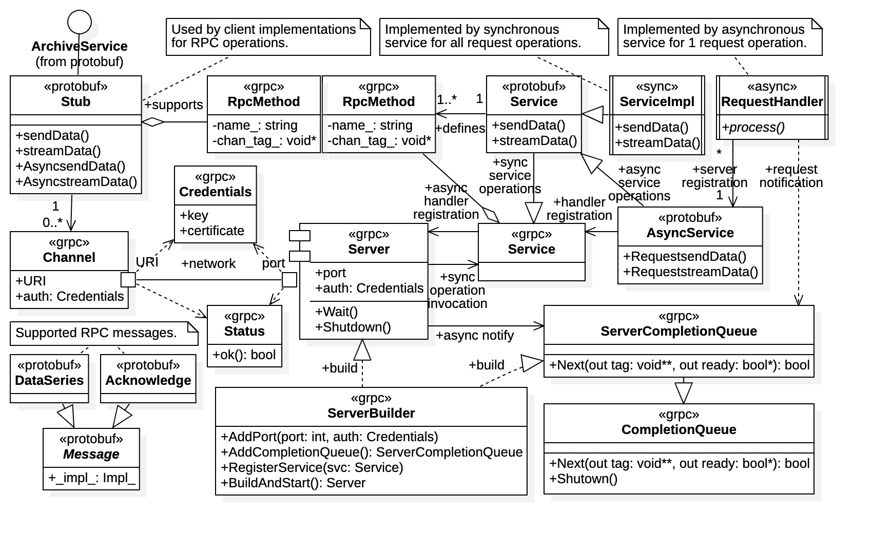

Figure 6: essential gRPC resources and Protobuf additions

The only two entities within Figure 6 not belonging to gRPC or Protobuf are ServiceImpl and RequestHandler; these classes are part of the synchronous and asynchronous service implementations, respectively (note that identifiers ServiceImpl and RequestHandler are general terms used to identify the roles of the entities, they are not requirements of Protobuf or gRPC). The client implementation is not shown; it would access the ArchiveService Protobuf RPC interface at the top left-hand corner.

The primary communications gRPC resources within Figure 6 are the Channel class for client-side network communications, and the Server component (implemented as a class) for service-side network communications. All other gRPC resources are required to support the function and operations for those components. Protobuf generates the communications end points used by both client and service implementations. However, it is necessary for both client and service implementations to directly interact with C++ gRPC resources, within the diagram the Channel class for clients, and the Server and ServerBuilder classes for services. A ServerBuilder instance is required to create a gRPC Server instance hosting any service implementation. Shown in Figure 6, the ServerBuilder.RegisterService() function is used to register services with the gRPC server before creation.

Note the presence of the CompletionQueue and ServerCompletionQueue classes within Figure 6. These are essential resources for asynchronous C++ gRPC communication (they are not required for synchronous RPC operations). Completion queues are used to coordinate execution between multiple execution threads, for both clients and services. Server completion queues are used to notify services of incoming client requests, they must be created with the ServerBuilder.AddCompletionQueue() function. This topic is complex and covered in detail within **Error! Reference source not found.**.

Not shown in the diagram are the gRPC communications resources needed for interaction between client and service. These resources are covered in detail within (c).

### Protocol Buffers Resources

Figure 7 isolates the Protobuf resources in the context of client and service implementations. Within the figure client implementations are shown in the left-hand side and service implementations are shown on the right-hand side. For client RPC communications Protobuf generates the Stub class, which is actually an enclosed class of the ArchiveService interface (shown in Figure 7). The Stub class contains all the RPC operations defined the proto interface description, both synchronous and asynchronous RPC operations. Thus, client implementations focus on development of individual RPC operations contained in the communications stub, whether synchronous or asynchronous.

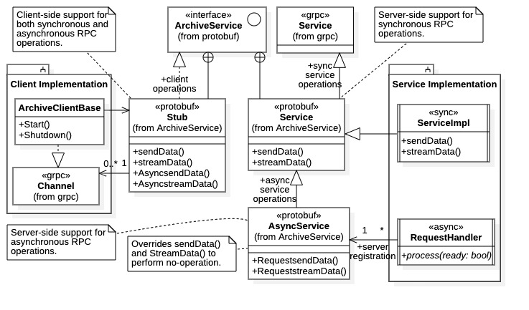

Figure 7: Protobuf Stub and Service classes in implementations

For the service-side communications Protobuf generates the Service and AsyncService classes, which are also enclosed classes of the ArchiveService interface (also shown in Figure 7). Note that protobuf::Service class inherits from the grpc::Service class so that all derived classes may be recognized by the gRPC ServerBuilder component. Any protobuf::Service derived instance must be first registered with the ServerBuilder instance for recognition by the created gRPC Server instance.

Synchronous services are implemented by inheriting from the protobuf::Service class, indicated in the figure with class ServiceImpl. The derived class implements RPC operations by overriding virtual functions provided in the protobuf::Service class. The service implementation becomes active after registering with the ServerBuilder instance (i.e., once the server is built and started). Asynchronous services, on the other hand, are quite different.

Asynchronous services are implemented by building individual request handlers for each asynchronous RPC operation (implied in Figure 7 with the * multiplicity on RequestHandler). Rather than by inheritance, asynchronous request handlers register themselves with the gRPC server instance using the Protobuf generated AsyncService class. The class provides a registration function for each asynchronous RPC operation. (In our case, the RequestsendData() and RequeststreamData() functions register the sendData() and streamData() handlers, respectively.) For valid request handler registration, the AsyncService instance must be registered with the ServerBuilder instance before server creation. A ServerCompletionQueue instance must also be created to receive client notifications for the request handlers.

Thus, the focus of a C++ gRPC synchronous service development is the creation of a Service child class implementing all RPC operations as virtual function overrides. Synchronous service implementations register themselves with the ServerBuilder instance creating the gRPC server, they receive client notifications directly as virtual function calls. On the other hand, the focus of a C++ gRPC asynchronous service development is the creation of individual request handlers implementing each RPC operation. Asynchronous request handlers must register with an AsyncService instance which is first registered with the ServerBuilder instance. Client notifications appear within a separate ServerCompletionQueue instance created by the same ServerBuilder.

### Callback gRPC Resources

Although not investigated, we present a brief overview of the gRPC “callback API” since it is asynchronous in nature. Because performance is the priority for MLDP datastream processing, the focus is on asynchronous C++ gRPC communications. However, further investigation of callback communications may be warranted, especially if future versions of C++ gRPC improve performance there (as documentation implies).

The C++ gRPC library contains a *callback communications* API, a hybrid between synchronous and asynchronous communications. Callback communications appears to be a later addition to the gRPC library and is now recommended as the preferred API. Callback communications offer mid-level performance without the development difficulties of fully asynchronous communications. As stated in gRPC documentation, its performance is significantly greater than that for synchronous but slower than fully asynchronous communication [16]. It is suspected that callback performance is comparable to that for Java gRPC when multi-threading is utilized. The two APIs follow a similar pattern, although Java development is somewhat more straightforward.

The callback mechanism is essentially asynchronous since it is nonblocking. It does not rely on low-level completion queues needed for fully asynchronous communications. Instead, notifications of RPC completions are provided using *reactors*, which are essentially a collection of formalized callback classes covered in Section 3.02(c). RPC actions and event notifications are recovered within reactor-derived classes, in which implementations override reactor virtual functions defining events. Services receive client connections by implementing a child class of Protobuf-generated base class CallbackService; the mechanism resembles that for synchronous communications but without blocking.

Figure 8 lists the fundamental gRPC and Protocol Buffers resources needed for callback communications. Client-side access to RPC operations is through the Protobuf-generated Stub::async class, enclosed within the primary communications stub (for our example the namespace location is ArchiveService::Stub::async). Access to this stub is through the Stub.async() function. The diagram includes the full function signatures for the callback RPC operations within Stub::async, showing dependence upon the reactor gRPC communication resources. Within the client implementation, the bidirectional streaming actions for the streamData() operation are realized with virtual function overrides of the ClientBidiReactor class (i.e., within derived class ClientStreamData). As implied in Figure 8, unary callback operations can be implemented without inheritance (for both client and service). However, it may be necessary in some applications to use inheritance to capture unary events. It is also just good practice, enhancing robustness.

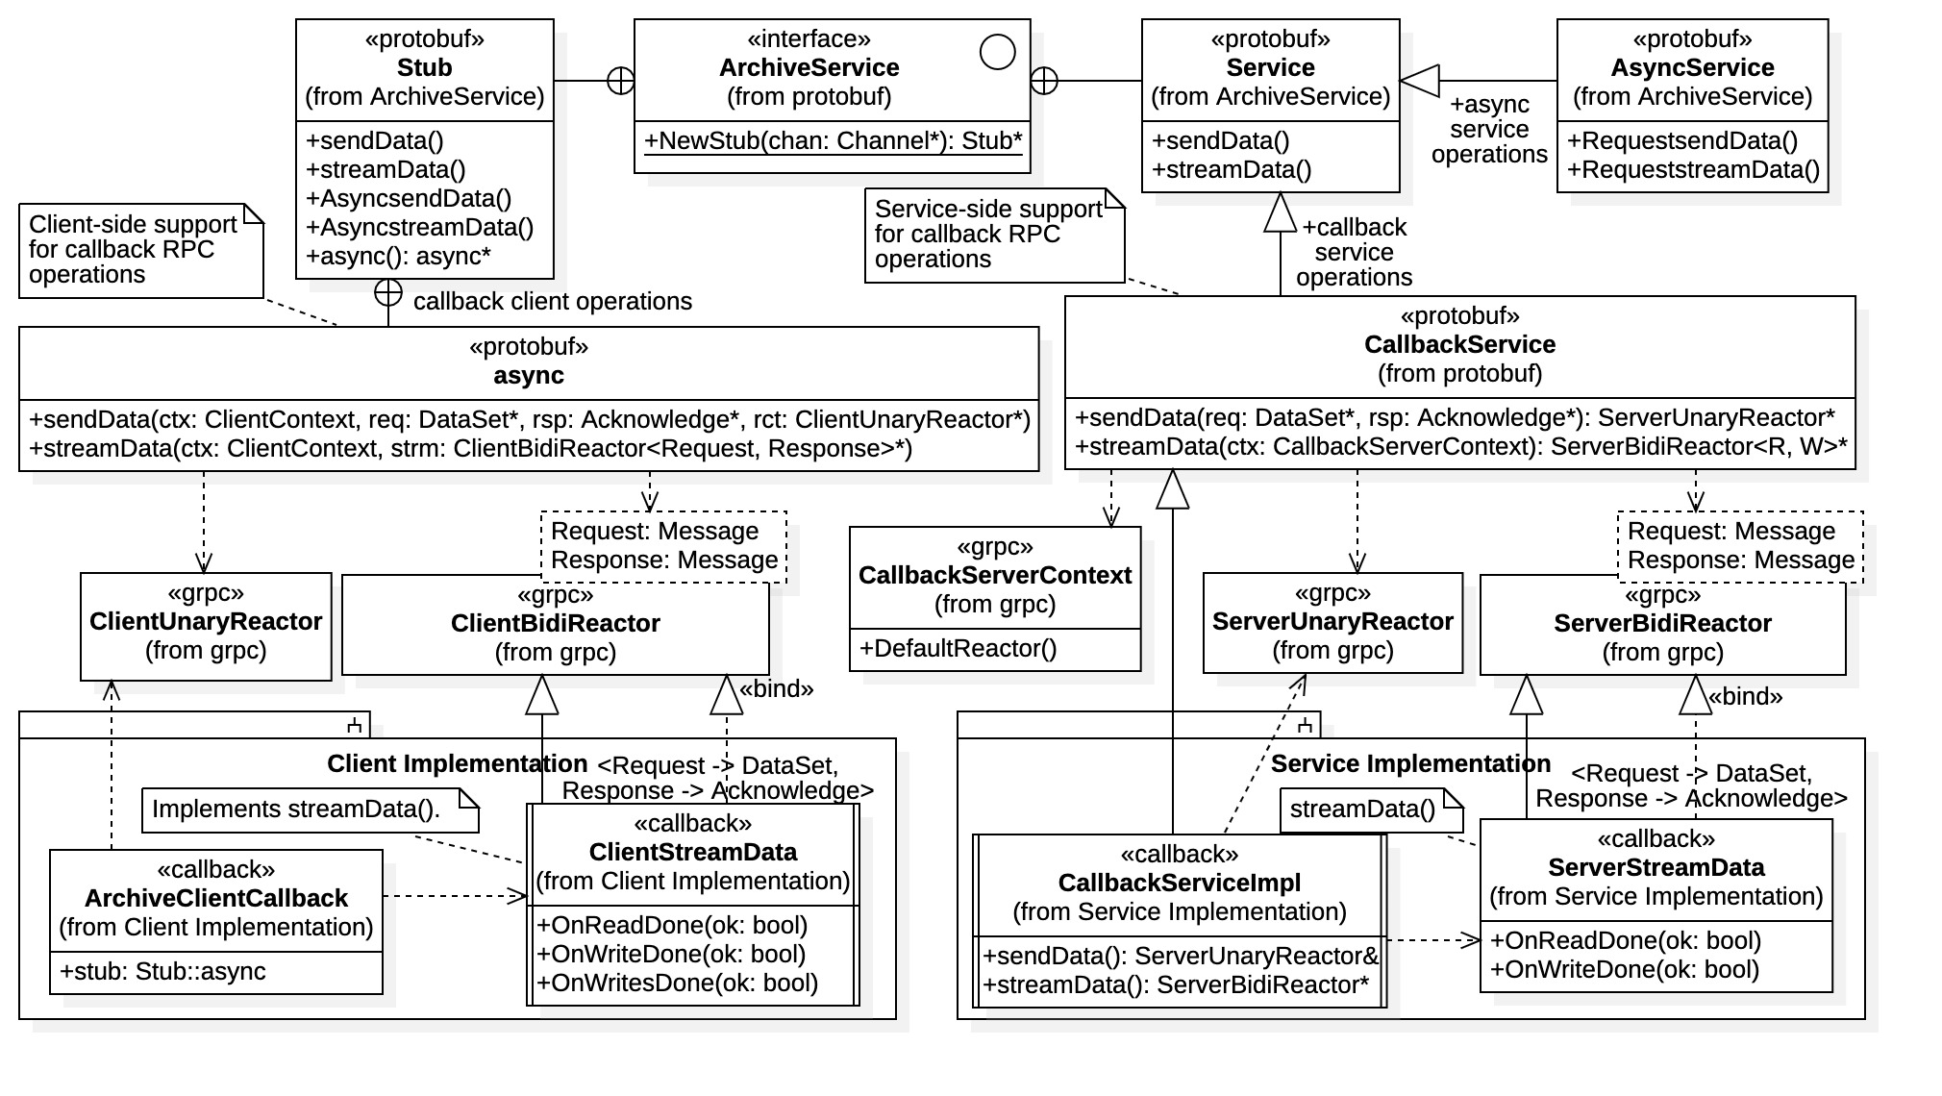

Figure 8: callback communications resources and structure

The server-side access to the RPC operations is through the Protobuf-generated CallbackService class. Like synchronous development, service-side implementations inherit from this service interface to intercept RPC operations. Unique to callback communications, however, is that implementations must also inherit from streaming reactors to realize RPC actions. (This is the situation for both clients and services.) As shown in Figure 8, the service implementation realizes the streamData() bidirectional streaming operation by inheriting from the ServerBidiReactor gRPC resource (its virtual functions are overridden by class ServerStreamData).

Development of callback communication is not as involved as that for fully asynchronous communications, which requires low-level completion queues. However, it does require more development effort than for synchronous communications. When a “one size fits all” approach to C++ gRPC is sufficient, it is the recommended implementation, providing a reasonable tradeoff between performance and development.

### gRPC Communications APIs

The C++ gRPC library offers 3 different communications categories: 1) *synchronous communications*, 2) *asynchronous communications*, and 3) *callback communications*. Resources within these communications categories are referred to as *communications* *APIs* in the gRPC documentation. Synchronous communications are single-threaded, blocking RPC operations, while asynchronous communications are fully multi-threaded, non-blocking RPC operations. Callback communications are somewhat of a hybrid protocol, they are essentially asynchronous in nature being non-blocking operations. However, special resources are needed to notify implementation of RPC completion. Implementations can employ multi-threading to increase performance (i.e., by engaging in orthogonal activities while waiting for completions).

Synchronous communications are the slowest but most straightforward to implement. Asynchronous communications are fastest, but most difficult to implement (thread synchronization is done at a relatively low level). The callback communications library provides a compromise; it requires additional development beyond synchronous communications but offers mid-level performance. Callback communications appear to be the latest additional to the C++ gRPC communications library due to its structure and nomenclature.

### gRPC Data Streaming

All gRPC language implementations support the capability for *data streaming*. Data streaming is where an open communications channel is maintained between client and server to exchange multiple data messages within the channel, or *stream*. This is contrary to standard *unary* RPC calls which are essentially atomic operations; single data messages are exchanged between client and server. Data streaming may be *client* *unidirectional* from client to service, *server* *unidirectional* from service to client, or *bidirectional* between client and service. In all cases streaming operations requires specialized communications resources within the gRPC library.

### gRPC Communications Resources

*Communications resources* are the entities within the gRPC library that clients and services use to exchange messages. Within each communications API, there are explicit resources required for each type of RPC operation. Thus, a familiarity with all RPC operation types is required for development using a particular communications API.

Recall the RpcMethod class first seen in Figure 6. Referring to Figure 9 we see that the RpcMethod class contains an internal enumeration RpcType of all possible RPC situations. There are 4 RpcType enumeration constants identifying 4 situations:

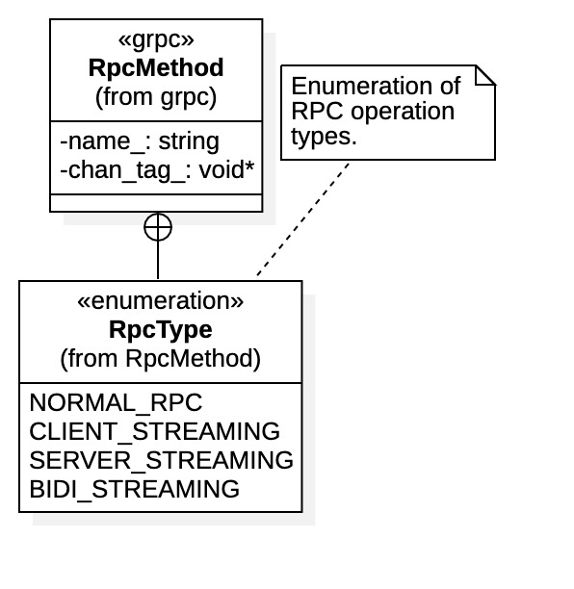

Figure 9: RPC operation types

1. NORMAL_RPC – Indicates a unary data exchange between client and server.
2. CLIENT_STREAMING – Indicates a unidirectional data stream *from* client *to* server.
3. SERVER_STREAMING – Indicates a unidirectional data stream *from* server *to* client.
4. BIDI_STREAMING – Indicates a fully bidirectional data stream between both client and server.

The C++ gRPC library provides explicit support for each type of RPC operation. In the diagrams to follow the RPC operation type supported by each communication resource is identified using the appropriate RpcType enumeration constant.

Support for RPC operations within C++ gRPC is compounded by the low-level, highly typed nature of C++. Library resources are provided on a case-by-case basis, and we refer to these resources collectively as gRPC communications resources. Within the library each possible RPC operation type and streaming protocol is explicitly addressed (i.e., unary, unidirectional, and bidirectional). Additionally, separate gRPC library resources are required for clients and services. Separate resources and usages are also required for synchronous, callback, and asynchronous communications. Thus, there in an abundance of C++ communications resources and use cases. All cases are considered fully in Section 3.02.

## gRPC Communications Resources

We catalogue the gRPC communications resources using UML structure diagrams. Resources are groups according to the communications API in which they belong, and then further by client or service support. Within diagrams resources are identified by the RPC operation type.

Most gRPC communications resources are defined in C++ header files, which are listed under subsection headings. The UML diagrams contained in this section are abridged representations of the C++ resources defined in these files, showing relationships and structures.

Note the continued use of the UML interface entity within diagrams. While C++ has no direct language support for interfaces per se, interface definitions are made in context. They refer to classes supplying only pure virtual functions, or whose intent is clearly that of a software interface.

### Synchronous API

Synchronous communications resources are found in grcpp/support/sync_stream.h.

Synchronous RPC operations are blocking operations, and RPC actions do not return until completed (at which time the status is known). Actions for synchronous RPC operations generally return a Boolean value, indicating the success or failure of the action. The Finish() action recovers a gRPC Status value upon completion, indicating the status of the overall RPC operation.

#### Client-Side Synchronous Streaming

Figure 10 shows the gRPC client-side support for synchronous streaming (due to its nature, synchronous unary operations require no communication resource support). Note that the client-side streaming resources are entirely analogous to the server-side resources shown in Figure 11. Here all client-side streaming interfaces and classes all inherit from base class *ClientStreamingInterface*, which is used primarily to identify such resources. The interface does also stipulates the requirement for a Finish() operation, which is used to terminate the data stream and receive the final status of the stream. Thus, for synchronous streaming the client initiates all stream terminations.

The type of streaming operations supported, specifically *reading* and/or *writing*, is identified through C++ polymorphism and the generic interface *ReaderInterface* and *WriterInterface*. The latter interfaces are shared among both synchronous clients and servers, although their roles are switched regarding the message bindings.

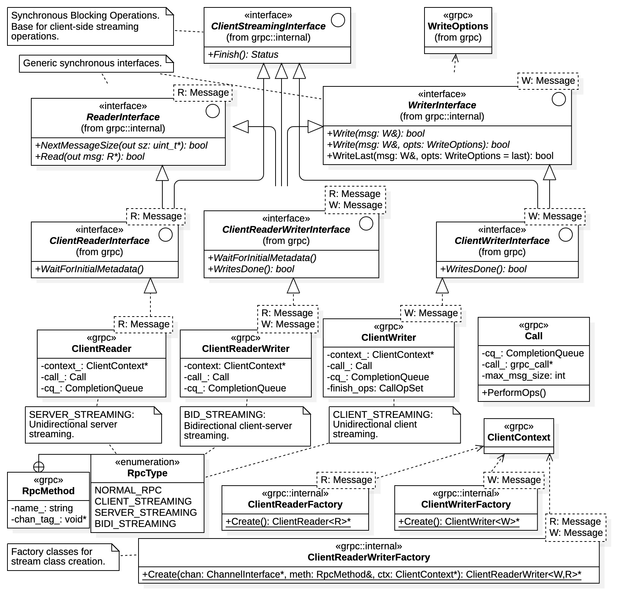

Figure 10: client-side synchronous streaming gRPC resources

While C++ has no direct language support for interfaces per se, class definitions are made in that context, supplying only pure virtual functions. The ReaderInterface and WriterInterface C++ classes identify the operations that derived classes must support. They also contain the template parameters R and W identifying the Protobuf messages that are to be read or written, respectively. Note that WriterInterface includes the WriteLast() operation which, in server case, is used to explicitly signal the client that there are no remaining messages in the stream.

The *ClientReaderWriterInterface* and *ClientWriterInterface* interfaces include the addition of the WritesDone() operation. This operation can be invoked (without arguments) to signal the server that the client has no more messages to send. This is an optional protocol which can be used to signal a client-side stream completion without closing the data stream. Presumably the client would then wait for a pre-determined action from the service (say a final Read() operation) before terminating the stream with a Finish() operation.

We see from Figure 10 that roles for the concrete streaming classes are indicated by the RpcType enumeration constants. Specially, for unidirectional server streaming indicated by the SERVER_STREAMING enumeration, a ClientReader class is required by the client (a ServerWriter class is required by the service seen in Figure 11). For unidirectional client streaming indicated by the CLIENT_STREAMING enumeration, a ClientWriter class is used (a ServerReader class is required by the service). Finally, for bidirectional streaming (i.e., BIDI_STREAMING) clients and services use the ClientReaderWriter and ServerReaderWriter classes, respectively.

Figure 10 also includes the creation factories for concrete stream classes. In general client implementations do not need to create stream instances, they are created by the operations within the Protobuf Stub class. However, the factory classes are available if desired. Note that factory classes utilize ClientContext instances to specify general parameters for newly created streams. Again, the WriteOptions class is optionally available for tailoring parameters to individual write operations. A ClientContext instance should be used only once, reusing instances can cause unpredictable behavior.

#### Server-Side Synchronous Streaming

Figure 11 shows the gRPC resources required for synchronous, server-side streaming. All server-side streaming support is derived from the base interface *ServerStreamingInterface*. Note that the sendInitialMetadata() operation is included the diagram. All gRPC communications APIs support the exchange of metadata between client and service prior to actual data transmission. Metadata is optional information supporting the data exchange, such as authentication tokens or stream parameters, its context is determined by client and service.

The server streaming resources again include the interfaces ReaderInterface and WriterInterface supplying the read and write actions, respectively. The next set of interfaces in the hierarchy, ServerReaderInterface, ServerReaderWriterInterface, and ServerWriterInterface inherit polymorphically indicating that derived classes support server-side streaming and the intended read and/or write operations. The final level of the hierarchy, ServerReader, ServerReaderWriter, and ServerWriter, are the concrete template classes used by service implementations for streaming operations. Their function is identified by the RpcType enumeration constant as shown in Figure 11. The diagram also includes additional gRPC resources such as WriteOptions which is used to specify tailored parameters for individual streaming write operations, and ServerContext which is used to specify general parameters for all server-side streaming operations.

Note that there are no constructors within the streaming template classes. Generally, service implementations are not required to create these classes, but are instead supplied by the Protobuf resources. However, as with the client resources there are factory template classes available within the gRPC library for streaming class creation if needed (not shown in Figure 11).

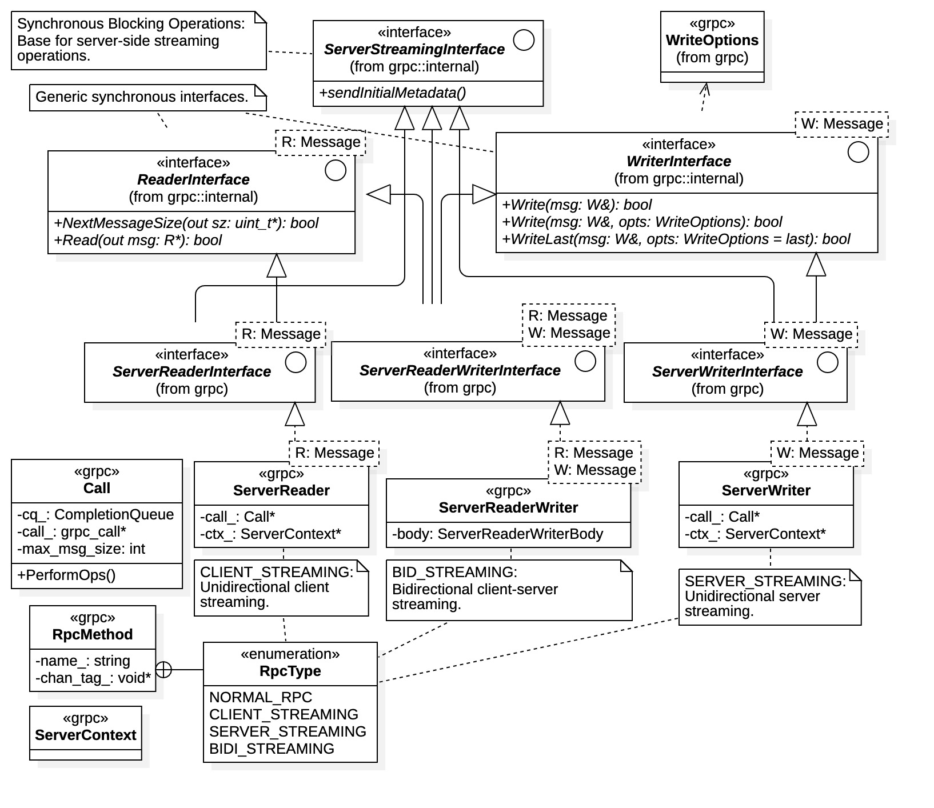

Figure 11: server-side synchronous streaming gRPC resources

### Asynchronous API

Asynchronous communications resources are defined in grpcpp/support/async_stream.h.

Asynchronous RPC operations do not block. RPC actions return immediately, before the results of the action are known. Completion queues are needed to determine actions results. Consequently, there are 2 immediately identifiable characteristics within asynchronous RPC operations:

1. RPC actions do not return a value. The action result can be recovered from the completion queue as the ready parameter within the Next(void** tag, bool* ready) function. A completion queue Next() call unblocks when the pending RPC action completes.
2. RPC actions require the additional argument tag, of type void*. The common argument tag is used as an identification parameter for the RPC action. Its value is recovered within the completion queue and the implementation interprets its value according to its assigned role.

The tag argument only has context within the implementation. It can identify a specific streaming action (e.g., read, write, done, etc.), the source of the operation (the calling request handler), the state at invocation time (e.g., error, termination, etc.), or any other characteristic that has context. The tag parameter has a C void* type and can thus represent anything within the implementation, it is the responsibility of the implementation to utilize the tag value appropriately. Use of the tag parameter is covered further in **Error! Reference source not found.** concerning completion queues. Strategies for completion queue management are covered in the in that section.

#### Asynchronous Unary Resources

Asynchronous unary operations require communication resources, they also require completion queues to coordinate communication between client and server. However, unlike streaming operations the unary operation has a well-defined communications protocol: a client initiates the connection, sends a single message, then the service sends a single response while terminating the operation. Both client and service must block on completion queues while waiting for their respective operations to complete.

Figure 12 shows the C++ gRPC asynchronous communications resources required for both client and service. Only one level of inheritance is used to define roles from which concrete template classes are directly derived. The base interface *ClientAsyncResponseReaderInterface* defines all client unary actions while the *ServerStreamingInterface* interface identifies the server-side role. Note that *ServerStreamingInterface* is also used to identify the server-side asynchronous streaming role and is used here again for the unary case. Thus, all request handlers register themselves using a communications resource derived from this interface class. *ClientAsyncResponseReaderInterface* is unique to gRPC unary clients.

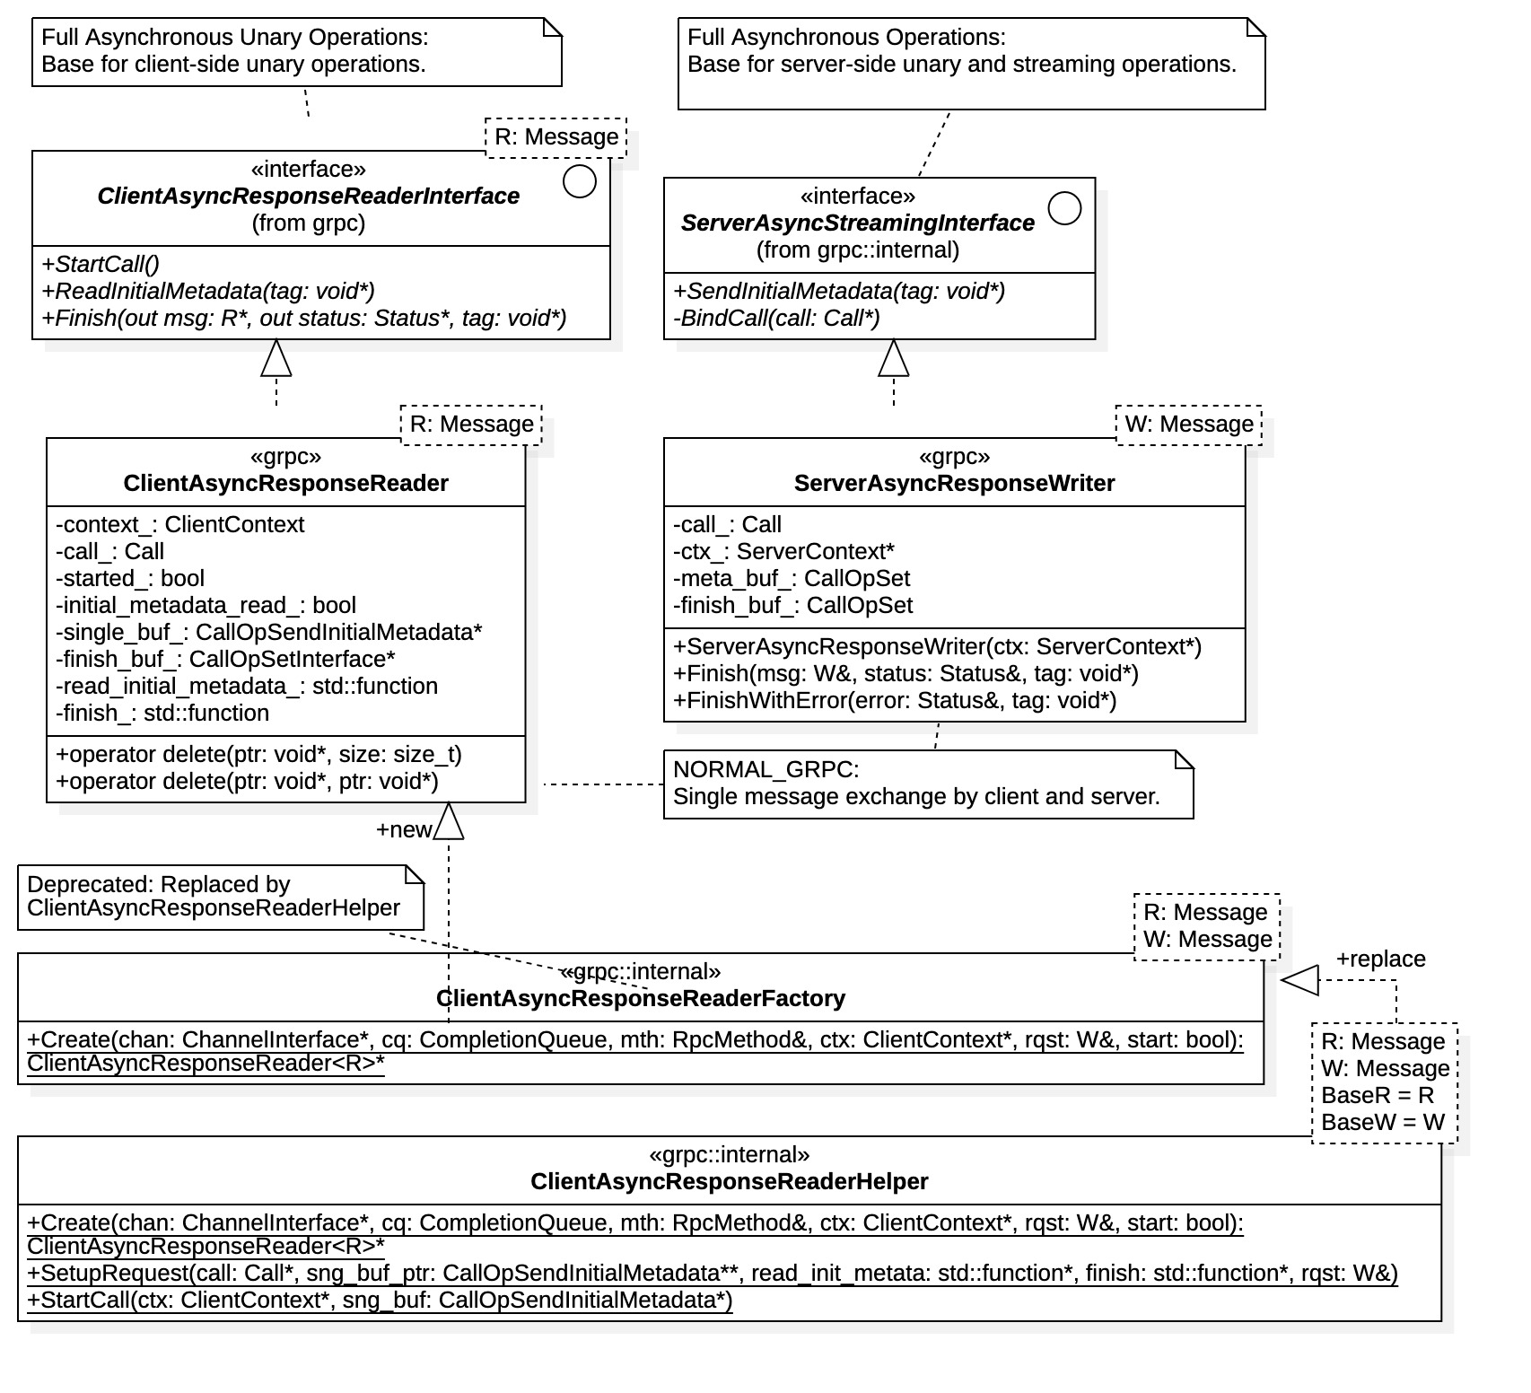

Figure 12: asynchronous unary gRPC resources

The concrete asynchronous unary resources are the template classes ClientAsyncResponseReader and ServerAsyncResponseWriter. Both template classes have a single template parameter identifying the Protobuf message type of the response (in our case the Acknowledge message). For clients, template parameter R is the message type *read* as the server response. For services, the message type is template parameter W indicating to be *written* to the client. The client request message is passed directly to the Stub RPC operation as an argument.

As mentioned above, unary RPC operations are well defined. A unary RPC operation is always initiated by the client. Both client and service require waits involving a completion queue.

The request message (i.e., the DataSet message) is always provided by the client upon initiation of the unary RPC operation. (In our example case, this is the AsyncsendData() operation within the Stub class, or, alternatively, the PreparesendData() operation followed by a StartCall() operation on the ClientResponseReader unary resource.). Once the initial Stub operation returns, the client can recover the response using the Finish(R* msg, Status* status, void* tag) action, after which it must again wait on the completion queue. Once the client completion releases the RPC operation is complete, the response and RPC status are available in the buffers msg and status (provided by the client).

After registering itself with AsyncService (i.e. using the RequestsendData() function), a unary request handler blocks on the ServerCompletionQueue instance until a client initiates a request connection. At registration time the handler provides both a ServerAsyncResponseWriter instance for client communication, and a message buffer to receive the request (i.e., a DataSet* message buffer). Once the completion queue unblocks the connection is established and the message buffer is available for reading. The request handler writes its response and the RPC operation status using the Finish(W& msg, Status& status, void* tag) function which terminates the connection. However, it must again block on a completion queue to wait for the action to complete.

An initializing constructor is available within the ServerAsyncResponseWriter class, since an instance is required for unary request handler registration. For clients it is generally not necessary to create a ClientAsyncResponseReader instance, they are provided by the Stub RPC operation. However, it is possible to create instances using the factory classes shown in Figure 12.

Again, the protocol for asynchronous unary communications is fully prescribed and detailed above. Both client and service must block on their respective completion queues. This situation differs from the streaming operations where considerable latitude is given to the method of data exchange and the internal protocols expected between client and service. This is especially true for bidirectional streaming where client and service must have an established sequence of exchanges understood by both parties.

#### Client-Side Asynchronous Streaming

Client-side asynchronous streaming resources are shown in Figure 13. All client synchronous streaming resources inherit from the *ClientAsyncStreamingInterface* interface. Unlike the synchronous cases, this interface includes the function StartCall(void* tag). This is an optional action used to initiate the stream, unlike synchronous streams which are created active. The StartCall() action is valid only when invoking the PreparesendData() or PreparestreamData() functions within the Protobuf Stub class (these are optional operation that can be used in lieu of the AsyncsendData() and AsyncstreamData() functions). Note that the StartCall() function includes the tag parameter used to identify initial client connection within its completion queue.

Other than the StartCall() function, the asynchronous client-side streaming structure is analogous to that for the synchronous case. Of course, the streaming operations do not return values, the success or failure of the operation is recovered in the completion queue as with asynchronous server-side streaming. The client-side streaming template classes at the end of the inheritance hierarchy also have initializing constructors. In general, however, it is unnecessary for client implementations to create stream classes themselves, a stream instance is provided by the asynchronous RPC operation within the Protobuf-generated Stub class.

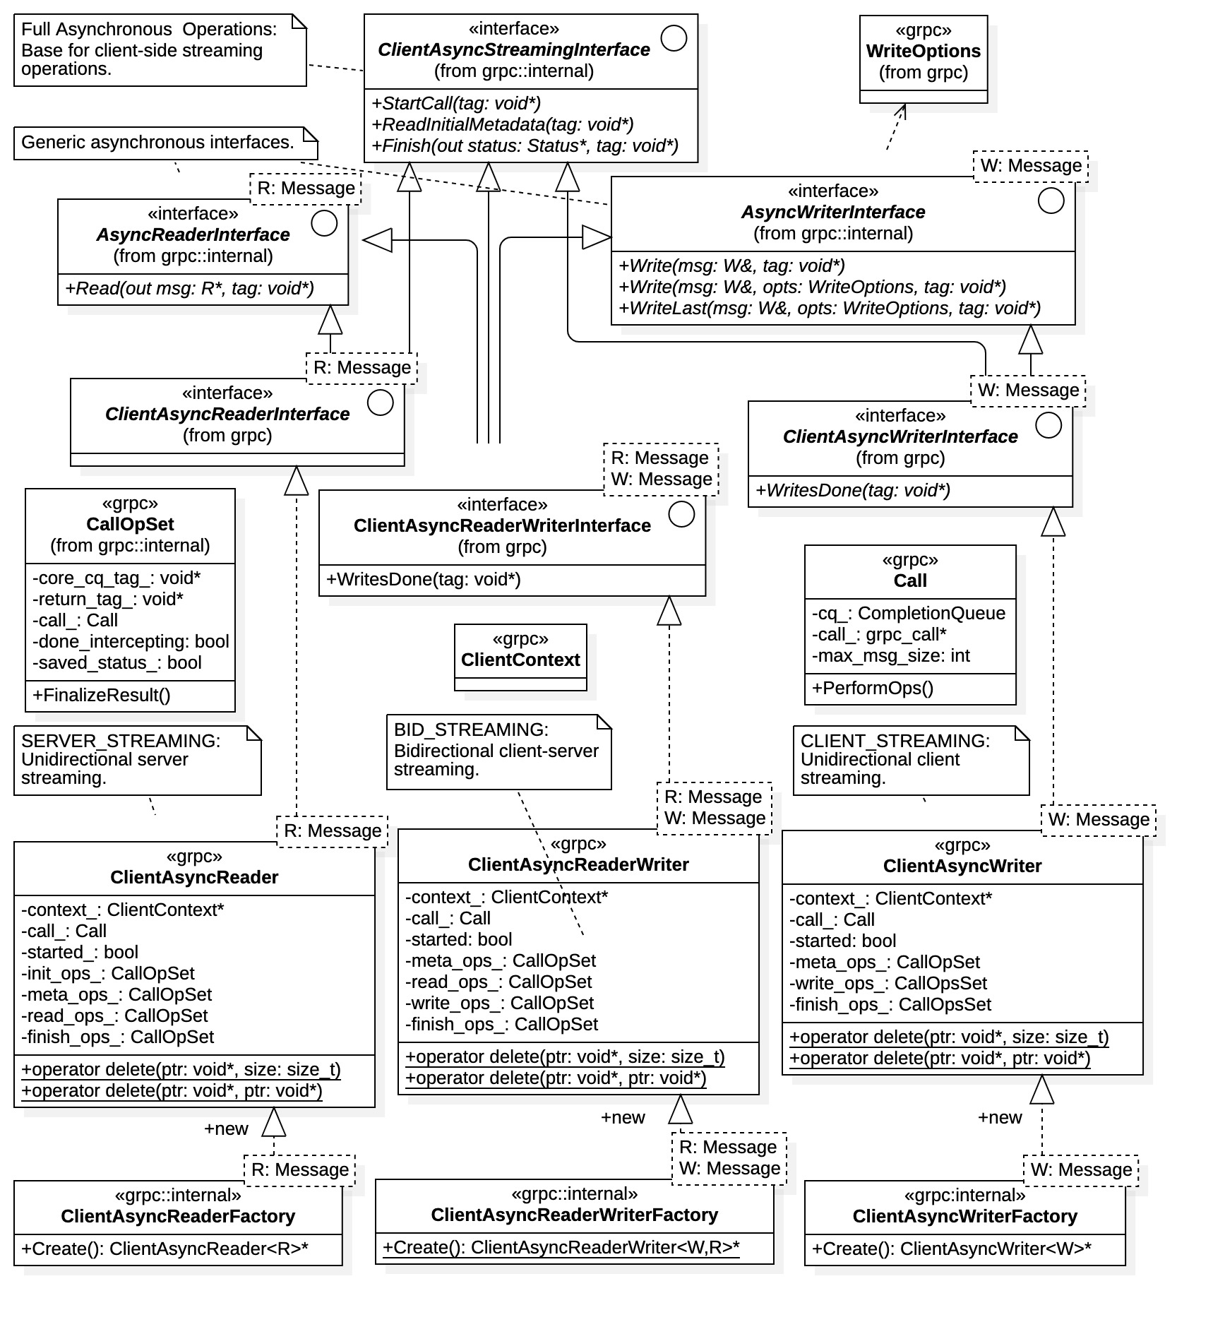

Figure 13: client-side asynchronous gRPC streaming resources

#### Server-Side Asynchronous Streaming

The server-side asynchronous gRPC streaming resources are shown in Figure 14. The asynchronous streaming resources have a similar structure to the synchronous case, but with noticeable differences. First note that all asynchronous server resources inherit from base interface *ServerAsyncStreamingInterface* identifying them as such; the *AsyncReaderInterface* and *AsyncWriterInterface* interfaces have roles analogous to the *ReaderInterface* and *WriterInterface* interfaces for the synchronous case.

Like the synchronous case, the next level of interfaces within the inheritance hierarchy utilizes C++ polymorphism to define their function as a streaming resource, that is, unidirectional client streaming, bidirectional client/server streaming, or unidirectional server streaming. Note that all interfaces supply a form (or forms) of the Finish() operation, used to terminate a data stream. Thus, unlike the synchronous situation, in asynchronous communications the service can initiate a data stream termination.

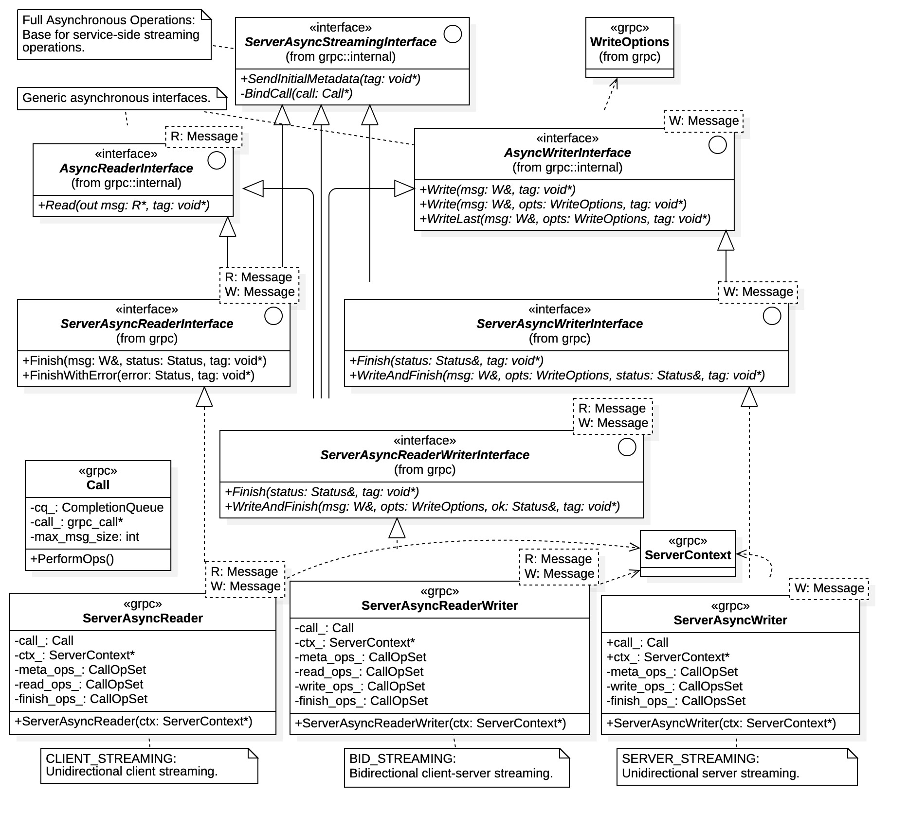

Figure 14: server-side asynchronous gRPC streaming resources

The final level of inheritance are the streaming classes themselves, ServerAsyncReader, ServerAsyncReaderWriter, and ServerAsyncWriter. These are concrete template classes bound to the Protobuf messages that they exchange with the client. An anomalous feature here is that the ServerAsyncReader template class has the additional parameter W, which is used to bind the final Finish(W&, Status, void*) operation terminating the stream while writing the response. This action is used to send a single response message upon termination of a client unidirectional streaming process.

Note that all server streaming template classes contain explicit initializing constructors. Service implementations must first construct an appropriate streaming class which is required for request handler registration. Specifically, when registering a request handler, one must identify the streaming resource, the completion queues receiving notifications, and the tag value used to identify the initial client connection. Request handler registration is discussed more in Section 3.03(d).

A ServerContext instance is used in streaming class construction to specify general parameters for the ensuing data stream (compression, message size, credentials, etc.). As with ClientContext instances, ServerContext instances should be used only once. Multiple use of a ServerContext instance can cause unpredictable behavior.

### Callback API

The hybrid callback communications API is contained in two files: grpcpp/support/client_callback.h for client-side resources, and grpcpp/support/server_callback.h for service-side resources.

C++ gRPC callback communication resources are generally referred to as *reactors*. As the name implies, they react to RPC actions and events, without blocking. Here, RPC activities are signaled to reactor virtual functions, which implementations then override to capture the events. This condition contrasts with the synchronous and asynchronous APIs where communications resources are used as provided.

Thus, development is different for callback communications, requiring direct inheritance from the reactor communications resources. This holds for both client and service implementation. Recall that virtual functions (abstract methods) are identified using *italicized* font within UML. Thus, in the following diagrams all italicized functions are available for implementation overrides.

As seen in the diagrams to follow, reactors have a simpler external structure as compared with their synchronous and asynchronous counterparts. Internally, however, they are more complex. Knowledge of reactor internal structure is not needed for development, however.

#### Client-Side Callback Resources

Figure 15 shows the gRPC resources necessary for client-side callback RPC operations. Callback communications resources (i.e., reactors) have a significantly simpler structure than that for their synchronous and asynchronous counterparts. There is no polymorphism, no abstract classes (interfaces for gRPC recognition), and there is only one level of inheritance. All client-side callback communications resources inherit from the single base class ClientReactor. Note that both unary and streaming resources inherit from this class.

Base class ClientReactor has the virtual function OnDone() which is called by gRPC at the completion of all callback RPC operations. After this function call, all gRPC are released and the reactor is no longer active. Client implementations override this function to recover the completion event and the status of the operation.

All client reactors contain a StartCall() function. A reactor becomes active upon StartCall() invocation and inactive after the OnDone() event. It is the responsibility of the client to maintain data message buffers until the OnDone() event occurs.

Unary callback operations are supported by the ClientUnaryReactor class. These operations only require a StartCall() invocation with an optional OnDone() RPC event capture. Note that the ClientUnaryReactor class can be used concretely (i.e., without override) if the client does not require the OnDone() event.

Streaming RPC operations are more involved. All streaming resources contain the AddHold() and RemoveHold() functions. “Holds” are references placed upon resources to prevent their destruction (i.e., invocation of the OnDone() operation by gRPC). Holds must be placed before invoking StartCall() and removed in equal multiplicity (i.e., the number of removes must match the number of holds to allow destruction). Holds are atypical in normal streaming operations but sometimes required when the resources are accessed externally. For example, when message buffers used for reading or writing actions are accessed external to any derived reactor implementation.

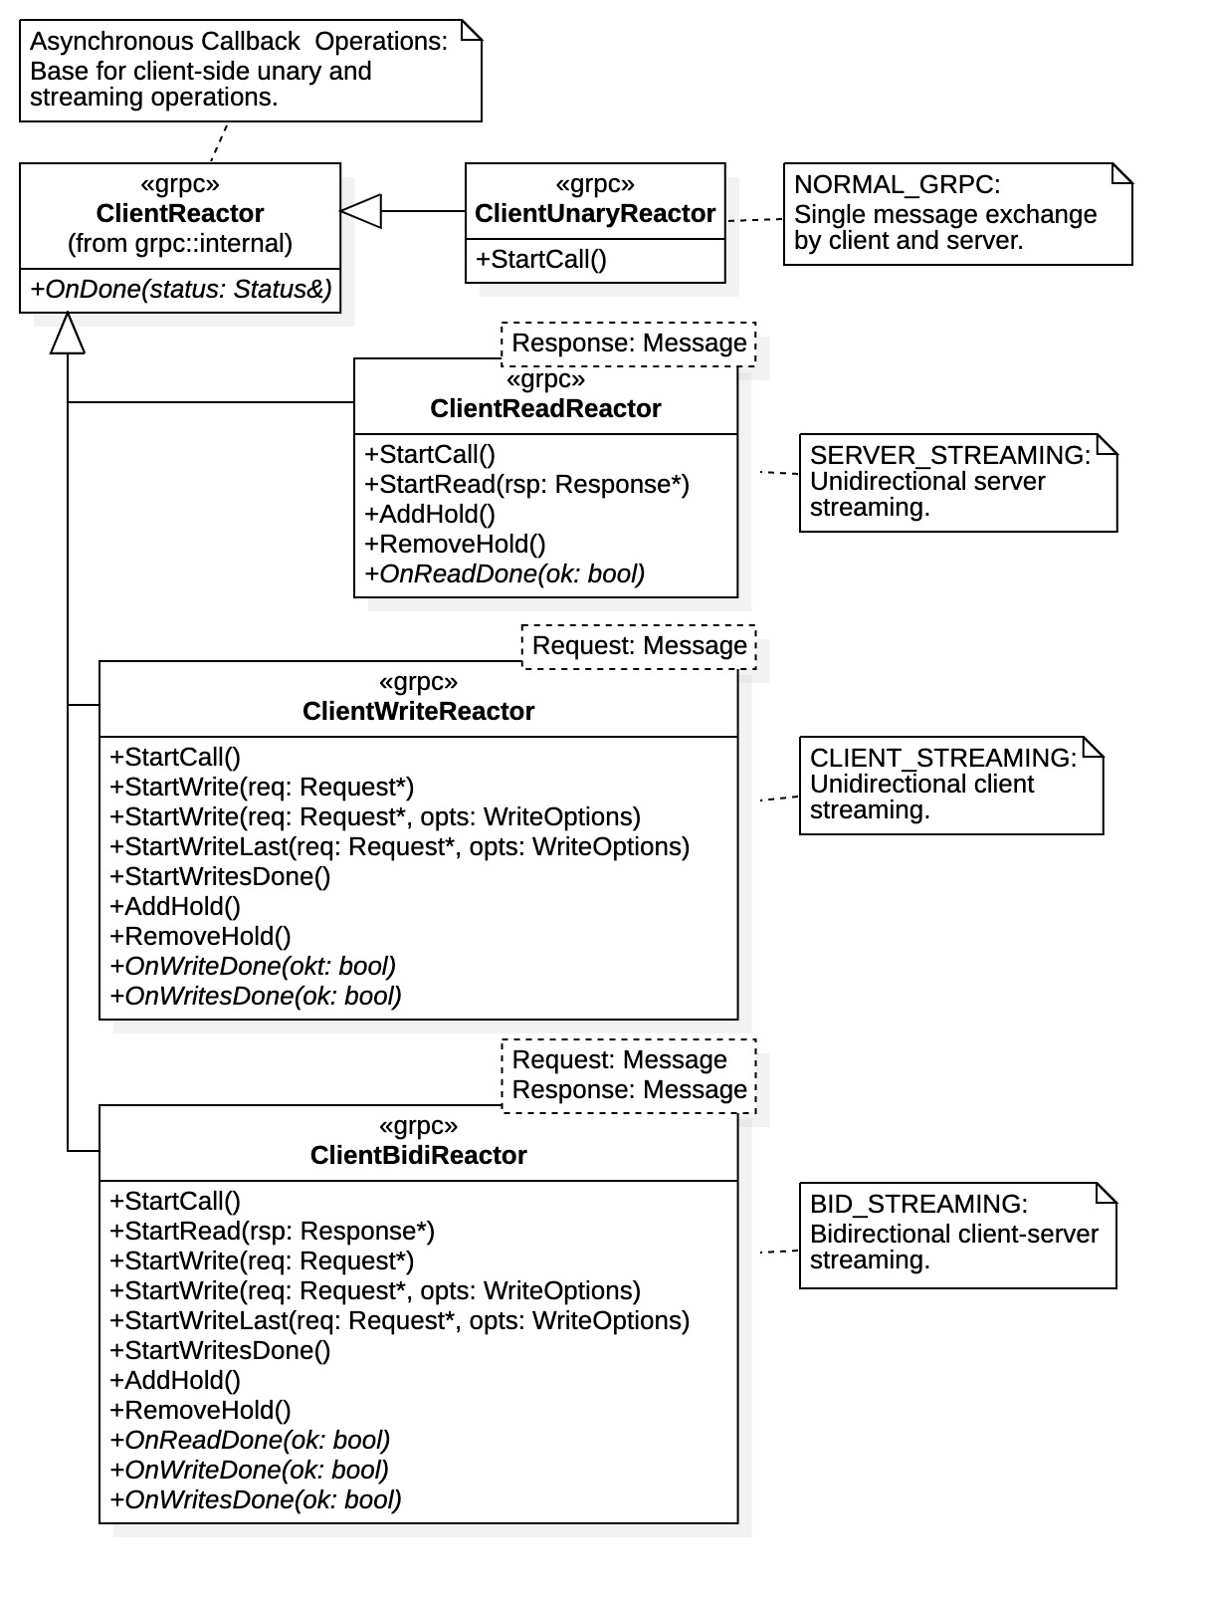

Figure 15: client-side callback gRPC resources

Unidirectional server streaming RPC operations are supported with the ClientReadReactor class. The single template parameter Response is the message type for the multiple responses sent by the service (e.g., in our case the Acknowledge message). An RPC read action is initiated with the StartRead() function and the read completion event is recovered by overriding the OnReadDone(bool ok) virtual function. Note that the parameter ok is used for signaling gRPC that the action was successful. If a false value is supplied the stream will terminate and an OnDone() signal will be issued.

Unidirectional client streaming RPC operations are supported with the ClientWriteReactor class, template parameter Request being the message type for the client stream to the service (e.g., in our case the DataSet message). The write action is initiated by a StartWrite() function and the completed event is recovered by overriding the OnWriteDone() function. The client signals the final request with the StartWriteLast() function. Alternatively, the client can invoke the StartWritesDone() action after writing the last request. In either case, the stream completed signal is recovered with a OnWritesDone(bool ok) override. The stream is completed at that time and an OnDone(Status status) signal is later expected once the service finishes.

The bidirectional streaming RPC operation is supported by the ClientBidiReactor class. It has two template parameters: Request for the client request message type (e.g., DataSet), and Response for the service response message type (e.g., Acknowledge). The functions within ClientBidiReactor are the amalgamation of those within the ClientReadReactor and ClientWriteReactor classes, and their use and behavior are identical. Streaming is fully supported in either direction with a protocol prescribed by client and service.

#### Server-Side Callback Resources

Reactors for service-side callback communications are shown in Figure 16. The structure and hierarchy of service-side reactors is directly analogous to that for the client. Function behavior within each service reactor is essentially equivalent to that for client reactors. Their roles, however, are reversed; service reactors read requests and write responses.

All server-side callback resources inherit from the base class ServerReactor. It too has the virtual function OnDone(), which is called by gRPC at the completion of an RPC operation. It also includes the additional event OnCancel(), a notification by the client that an RPC action failed (e.g., through client invocation of an OnReadDone(false) or OnWriteDone(false) function). If either event occurs the RPC operation has been terminated and the gRPC resources have been released (i.e., the reactor is destroyed and no longer active). Implementations override these functions to capture the terminating events.

Note that all reactors within Figure 16 have default constructors. Thus, it is possible to use server reactors without inheritance (i.e., if notifications are not required). The StartSendInitialMetadata() functions are also include the diagram, along with the virtual function OnSendInitialMetadataDone(bool) notification. All gRPC communications APIs support the exchange of metadata between client and service prior to actual data transmission. Metadata is optional information supporting the data exchange, such as authentication tokens or stream parameters, its context is determined by client and service.

In callback communications RPC operations are started by the client and finished by the service. Clients use the reactor StartCall() function to initiate the connection. It is the responsibility of the service to terminate all RPC operations, thus the appearance of the Finish() operation.

Unary service operations are supported by class ServerUnaryReactor. All that is required of the service is to invoke the Finish() operation. However, services must not destroy response message buffers supplied for the RPC operation until the OnDone() event occurs.

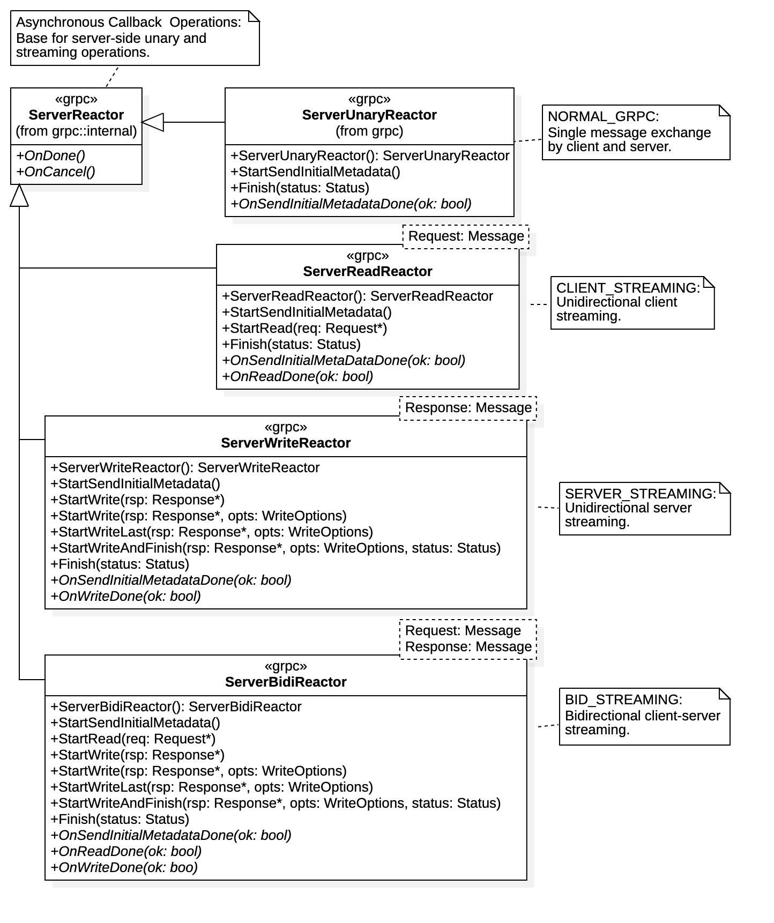

Figure 16: service-side callback gRPC resources

Unidirectional client and server streaming operations are supported by the ServerReadReactor and ServerWriteReactor classes, respectively. Bidirectional streaming is supported by the ServerBidiReactor class. Class functions have similar behavior with their client reactor counterparts, with the streaming directions reversed.

## Completion Queues

Fully asynchronous RPC operations are handled uniquely in C++ gRPC. Compared to RPC operations in other gRPC languages seen so far, C++ asynchronous operations are far more complex. Other programming language implementations typically follow the pattern like that for callback C++ RPC operation.

Asynchronous communications require additional structure coordinating communications between client and service using multiple processing threads. The C++ gRPC library provides additional resources for communication synchronization between client and service, beyond that of communications resources. In addition to the specialized asynchronous communications interfaces of the previous section, *completion queues* are the unique mechanism for gRPC communication synchronization.

Completion queues are low-level objects used to notify implementations when RPC actions have completed. They involve the general purpose “tag” parameter used to identify RPC actions and/or execution threads. Completion queues requires a concerted development effort to contend with their low-level nature. Although developmentally complex, gRPC asynchronous communication provides the fastest performance characteristics.

### Completion Queues

Asynchronous communications in C++ gRPC requires the use of *completion queues*, for both clients and services, and for both unary and streaming operations. Completion queues, as the name implies, notify waiting threads that an asynchronous RPC activity has completed. The specific activity or event is identified by the notification “tag”, whose value is left to interpretation by the implementation.

As shown in Figure 6, completion queues are represented by class CompletionQueue. In general RPC operation, execution threads block on the Next(void** tag, bool* ready) function of a completion queue where “tags” identify the completed event. Tags are arbitrary, being C void pointers, thus they can represent anything and have context only within the implementation. Typically, CompleteQueue objects are used to notify threads when asynchronous streaming actions have completed, for example, connections, reads, or write actions identified by the recovered tag value. However, they are also required in asynchronous unary RPC operations.

From a high-level perspective, completion queues are where execution threads wait for asynchronous actions to complete. That is, threads enter the queue waiting for notification of an activity completion. (Threads are, of course, able to perform other processing activities while waiting for a completion notification). Proper utilization of a CompletionQueue instance, or instances, requires careful design consideration.

All asynchronous RPC thread management is external to completion queues. That is, completion queues to not explicitly recognize execution threads or threading operations. They simply provide notification of asynchronous RPC events by unblocking the Next() function. The thread management mechanism must poll the completion queue with repeated calls to Next() then respond according to the recovered tag value. Thus, thread managers must spawn, re-activate, or terminate threads by proper interpretation of the tag value. Strategies for thread management using completion queues are presented below. Common designs include the use of *state machines* when tags identify execution threads, or action *mediators* when tags identify activities or operations.

### Completion Queue Management

There are 2 common forms of completion queue management, both of which are illustrated in Figure 17.

1. A completion queue is assigned to a single RPC operation. The tag parameter identifies an RPC action within the operation (e.g., connect, read, write, etc.). The design pattern used here is typically an action mediator.
2. A completion queue is assigned to a thread pool of independent RPC operations. The tag parameter identifies the thread to be activated (i.e., whose RPC action has completed). Execution threads typically utilize an internal state machine to manage specific RPC actions.

The two management approaches address very different situations. However, in both cases a completion queue manager executes as an independent thread and responds to queue events asynchronous. Typically the completion queue is polled indefinitely using a continuous loop that invokes the blocking Next(void** tag, bool* ready) function. The response to an unblocking event then depends on the interpretation of the tag value, as shown in the diagram.

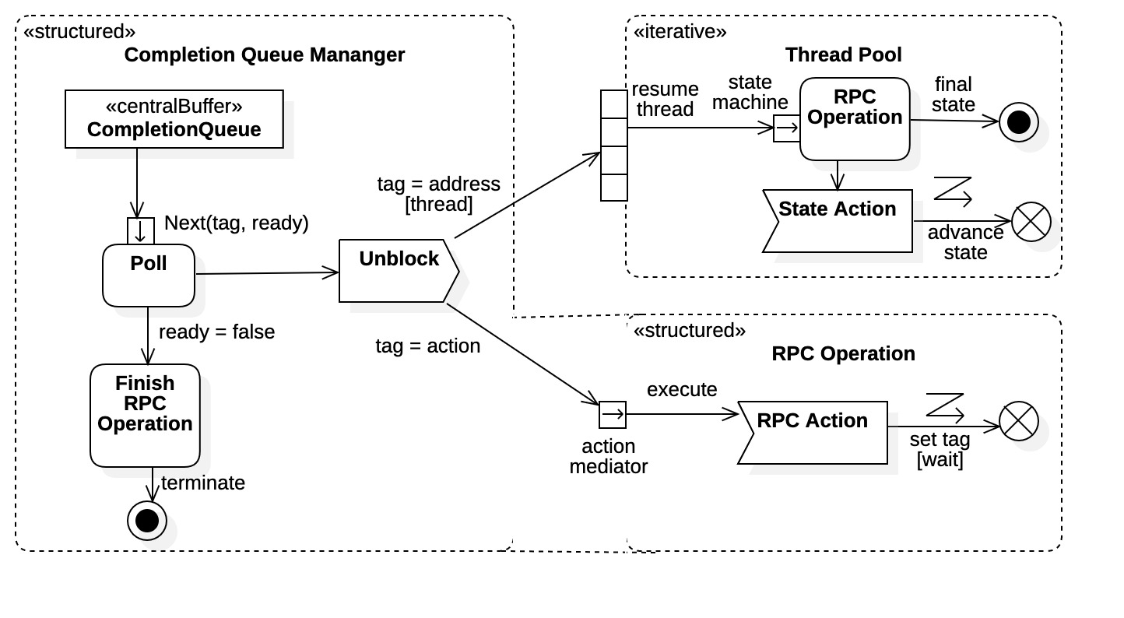

Figure 17: completion queue management patterns

In the first case the tag parameter is interpreted as an RPC action, shown in the bottom of Figure 17. Thus, a completion queue unblock event signals the completion of an RPC action identified by the tag value. An action mediator (typically within the manager thread) then determines the appropriate RPC Action needed to advance the overall RPC Operation. Once the activity is completed, the RPC Action relinquishes control of the CPU. Each RPC action can be executed on an independent thread, allowing concurrency within a single RPC operation. However, this may be unwarranted if communication protocols are inherently sequential (as pre-determined by both client and service).

Referring to Section 3.02(b), recall that all asynchronous streaming and unary resources require a tag argument for RPC functions (e.g., Read(), Write(), Finish(), etc.). The RPC Action sets this tag value identifying the RPC activity currently pending. It is recovered by the Completion Queue Manager when unblocking and passed to the action mediator.

In the second case, where the tag value identifies a currently paused execution thread, the requirements of the completion queue manager are comparatively straightforward. The manager simply translates the tag value as an execution address (i.e., a C function pointer) then spawns a thread for that address. All the complexity for an RPC operation is handled within the execution thread itself. As indicated in Figure 17, here the RPC Operation is commonly controlled by an internal state machine.

Within the top right-hand corner of Figure 17 we see a thread pool of RPC Operations. Each thread within the pool can be in various stages of the underly RPC operation, determined by its current state. Threads can be currently executing or paused waiting for an RPC action to complete. When awakened by the completion queue manager, a thread advances the RPC Operation according to the State Action prescribed by the state machine. Once the State Action is complete the thread state is advanced, and it then relinquishes the CPU. The thread terminates itself when awakened in its final state (after performing any final actions).

Completion queues require significant gRPC resources and should be managed carefully. It has been indicated within developers’ forums that use of multiple completion queues can affect performance; a gRPC developer recommend use of a single completion queue, a ServerCompletionQueue instance, for best performing asynchronous service implementations [17]. This is also implied in the general gRPC “best practices” recommendations [16]. However, there are also recommendations as to when multiple completion queues are warranted; most notably it simplifies development in some situations. We find that to be case for bidirectional streaming operations requiring sophisticated state machines.

Finally, all completion queues should be shut down and “drained” after they are no longer needed. Specifically, after shutdown, all pending queue notifications should be recovered and discarded with repeated calls to the Next() function until a false value is returned. Failing to do so creates a noticeable and potentially significant performance burden. This was observed for service performance in the evaluations.

The above discussion applies to both client and service implementations. There is one case of completion queue management that requires specific attention, however. A special completion queue, the server completion queue, is central to all service implementations. All client RPC connections originate there, and use of server completion queues is unique within asynchronous C++ gRPC communication.

### Server Completion Queue

Of particular importance in asynchronous C++ gRPC server-side communications is the server completion queue, represented by the ServerCompletionQueue class in Figure 6. These objects are the initial points of interaction between the service implementation and the gRPC Server instance. It is used to notify services that a client request is incoming, signaling the initial client-connection event. It may also be used for all client-service interactions if so desired. In any event, services block on the Next() operation of the ServerCompletionQueue in order to wait for initial client requests and, potentially, any forthcoming RPC actions. Unblocking presumably activates a handler thread to process a request action.

The service application should implement a separate execution thread for managing the ServerCompletionQueue instance, as demonstrated with MainThread in the interaction diagram of Figure 18. Generally this thread executes a continuous loop blocking on the Next() operation, which then reacts according to the tag interpretation when unblocked (seen as sequence 1 in Figure 18). For this reason, handler threads typically register with their executable address as tag values. As shown in sequence 2 of Figure 18, the ServerHandler main thread interprets the tag value as the request handler address which it spawns on a separate execution thread. For our example, the tag value would be the address of the process() function within the RequestHandler class.

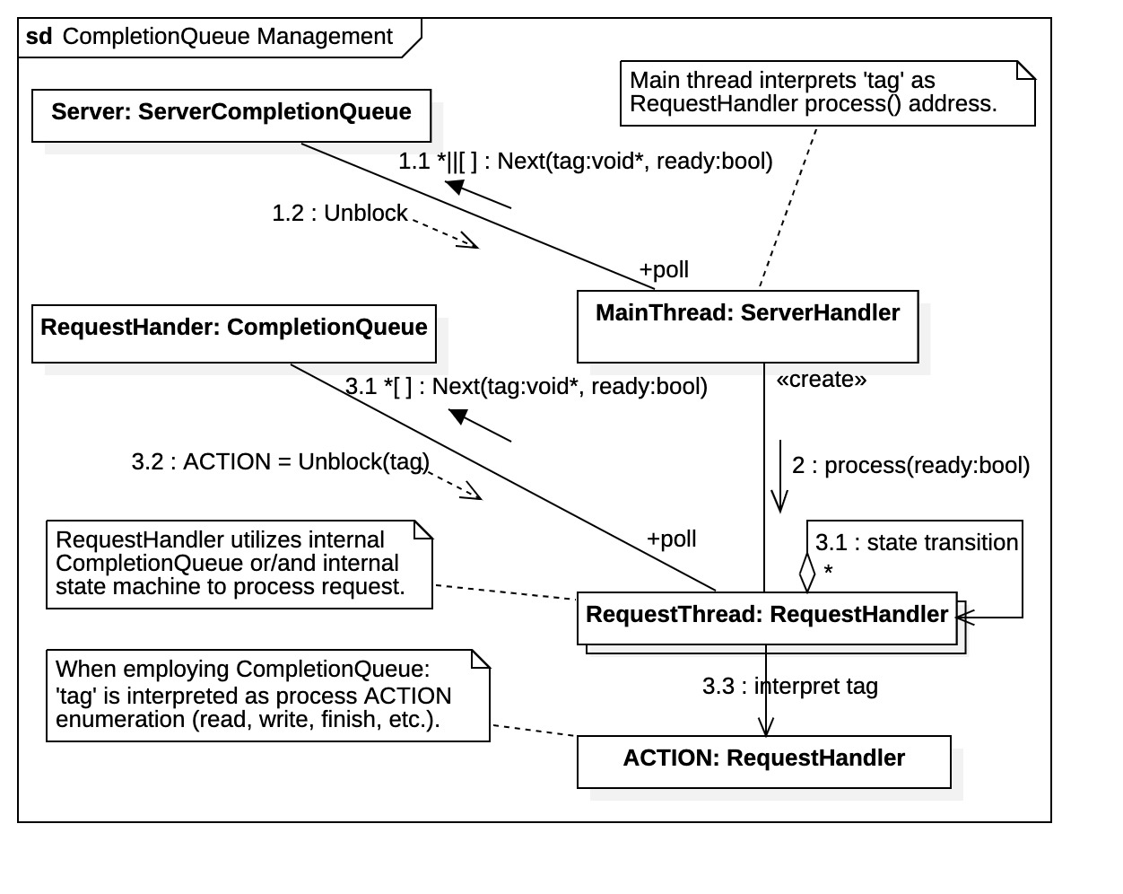

Figure 18: server completion queue management and use

After the initial connection, handler threads may move to an independent CompletionQueue instance to manage all forthcoming RPC actions. That is, a request handler may maintain its own CompleteQueue instance to receive action complete notifications. There the tag value is interpreted by the handler itself (i.e., rather than by the ServerHandler main thread). This approach is shown in Figure 18 as the sequence 3.1, 3.2, and 3.3. It provides greater code legibility since tags can be assigned according to the context of the specific RPC operation and its required actions. For example (and as shown in Figure 18), tags can be assigned enumeration values corresponding to the streaming actions such as read, write, and finish. Here the handler blocks itself on its internal completion queue and, upon activation, reacts according to its own self-defined tag values.

### Server Initialization

To initiate the activities shown in Figure 17 and Figure 18, and asynchronous servers in general, a variety of related gRPC resource must be created and initialized. The server completion queue must be created, a gRPC server instance must be created and started, asynchronous gRPC communications resources must be created, and ultimately request handlers must register themselves with the active gRPC server instance. The gRPC ServerBuilder object is the primary resource behind all these activities.

Figure 19 is a structural diagram listing all the resources required for service initialization. The entire process begins at a ServerBuilder instance. Note that the ServerBuilder class contains a default constructor for creating ServerBuilder instances. It also contains a function for creating a ServerCompletionQueue instance coupled to the Server object ultimately created (not shown). Note also that the ArchiveService interface class has a default constructor. It too must be created and registered with the ServerBuilder before server creation.

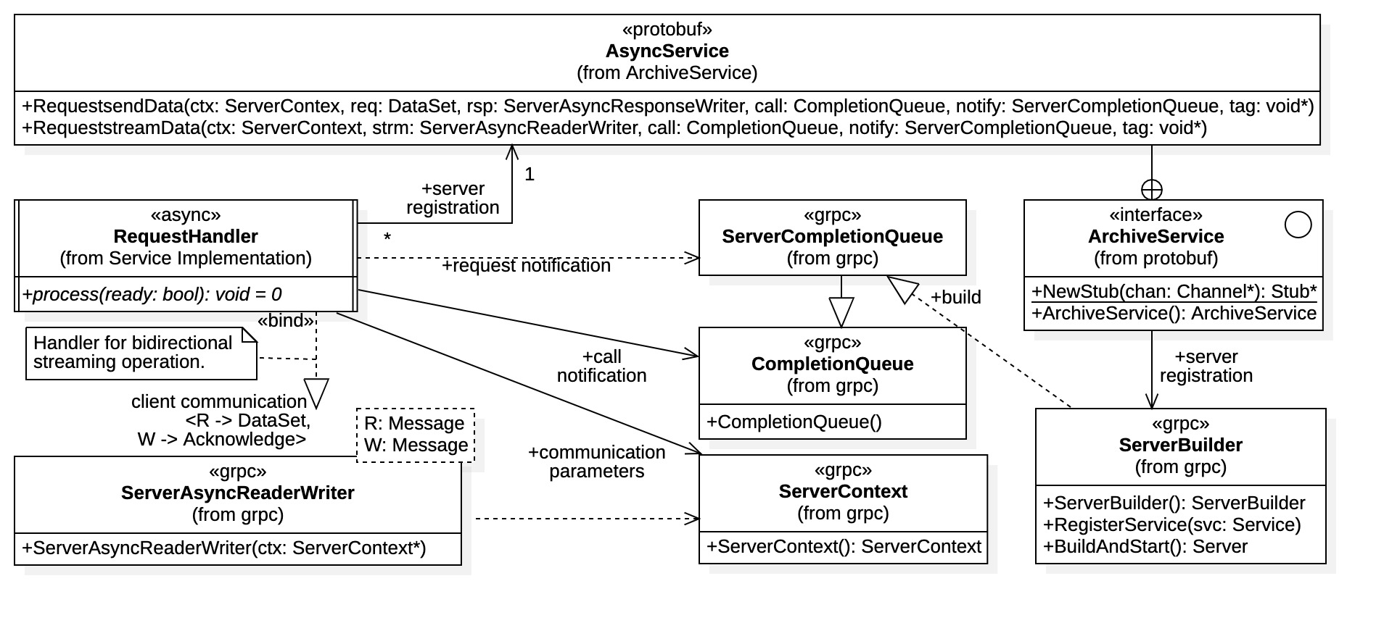

Figure 19: service initialization and request handler registration

As mentioned previously, request handler registration is accomplished through a Protobuf generated AsyncService interface (ArchiveService::AsyncService in our example). However, an ArchiveService interface must first register itself with the ServerBuilder instance before becoming a viable registrar of request handlers.

The diagram shows the full signatures for RequestsendData() and RequeststreamData() within the AsyncService interface. These functions are used for request handler registration. The function signatures identify all the gRPC resources required for registration. A request handler must provide its communication resource (for client communications) and all completion queues used. In particular, the request handler must supply the server completion queue used to recover client connection requests (i.e., “request notifications”). It may also specify general communications parameters for the client connection using the required ServerContext argument. The same ServerContext instance should be used for both communication resource creation (i.e., ServerAsyncReaderWriter in the diagram) and request handler registration. In this context, however, the ServerContext instances *should be used only once*, otherwise unpredictable behavior is possible. A default constructed ServerContext instance can be supplied when using default communications parameters.

Request handlers may use the server completion queue to receive the RPC events, or optionally provide an additional completion queue to receive RPC call notifications. Using the server completion queue to recover both request notifications and call notifications is reported to yield best performance results [17]. However, it also requires sophisticated request handler development for streaming operations (especially for bidirectional streaming). This topic is covered more fully in the next chapter.

*It is important to note* that the tag value provided in request handler registration is the value seen in the ServerCompletionQueue.Next(void** tag, bool* ready) operation upon initial client connection. If a second completion queue is specified in handler registration, *this is the only notification received* within the server completion queue. All further RPC action events (i.e., “call notifications”) will appear in the second completion queue.

# C++ gRPC Development

Here we consider C++ gRPC development in detail. Due to the complexity and distinctiveness of C++ gRPC multiple design approaches are possible, especially for the asynchronous case. We provide an extensive treatment for the asynchronous situation which is unique to the other programming language gRPC implementations seen so far. It is the general focus of the presentation since it provides the best performance properties. Development for synchronous implementations follows the standard pattern seen in other languages such as Java and Python. Likewise for the C++ gRPC callback communications API.

The chapter begins with an expanded treatment of state machines, which are needed for request handler development in asynchronous communication. The next section contains general implementation strategies for C++ implementation considering the gRPC library resources and architecture. The last section contains structural designs for C++ gRPC service and client implementations, specific examples are for the test stand implementation presented in Article II. However, the principles are applicable to general development.

## State Machines

State machines are typically used to implement request handlers when asynchronous services utilize a single completion queue, the ServerCompletionQueue instance. The gRPC authors have indicated that this approach generally provides the best performance. However, it also creates added complexity for all but the most basic service functionality. State machines are used to manage this complexity.

Here, the ServerCompletionQueue managing thread must accommodate all client connection events and RPC operations concurrently. Tags must not only identify the handler to be notified, but the RPC action that has completed. To relieve burden on the ServerCompletionQueue managing thread, it is best practice to maintain an internal state machine within each request handler. Thus, each handler remembers its previous RPC action as a state value and determines its next action according to state transitions. It moves through its prescribed state values considering the actions seen by the communications resource it maintains, and the ready parameter obtained from the ServerCompletionQueue.Next(void** tag, bool* ready) function. That is, the state transition depends not only on the current state, but the results obtained from the communications resource used and the server completion queue.

In the following state machines, it is assumed that request handlers manage their own lifetimes. That is, there is no external handler pool management. Thus, request handlers replace themselves by cloning and delete themselves when the RPC operation is complete.

### Unary State Machine

A typical state machine used by an asynchronous unary request handler is shown in Figure 20. As seen in the diagram the unary operation has only 3 states: CONNECT, FINISH, and TERMINATE. There are only 2 entries into the request handler, the initial connection activation and a second activation leading to hander termination. Thus, the use of the final state TERMINATE is somewhat artificial, but it does serve as an explicit internal condition indicating the end of the RPC operation.

Unary operations exchange a single DataSet message request for a single Acknowledge message response. In synchronous communications this operation is accomplished atomically with the single function call sendData() within the Stub class. However, for asynchronous communications the operation is more complex requiring a completion queue, and thus the need for a unary request handler state machine. The service must first register a unary request handler for the RPC operation, which the Server maintains in the ServerCompletionQueue. There the request handler remains in the CONNECT state waiting for the initial client connection to complete. Once the unary request handler is activated it must process the request then respond with an Acknowledge message, along with the status of the request operation (i.e., with a Finish() action). Since the communications is asynchronous, the handler must then wait again for a signal that the finish action has indeed completed.

When a client invokes an asynchronous unary request (i.e., using the AsyncsendData() function), the Server then unblocks the ServerCompletionQueue.Next() function with the address tag of a registered handler. This action represents the “Initial Unblock” entry into the request handler in the CONNECT state. As seen in Figure 20, there the unary request handler performs most of its function. It first creates and registers a new unary request handler to replace itself, thus ensuring that the same number of request handlers are always available within the server completion queue. It then validates the DataSet message composing the request, archives the message (with validation), creates the appropriate Acknowledge message response, and finally sends (i.e., a gRPC “Finish()” operation) that responds through the gRPC unary responder interface. The request handler then exits the execution thread while transitioning to the FINISH state. Note that the handler also maintains a composite state “gRPC Status” which is required for the eventual gRPC Finish() operation.

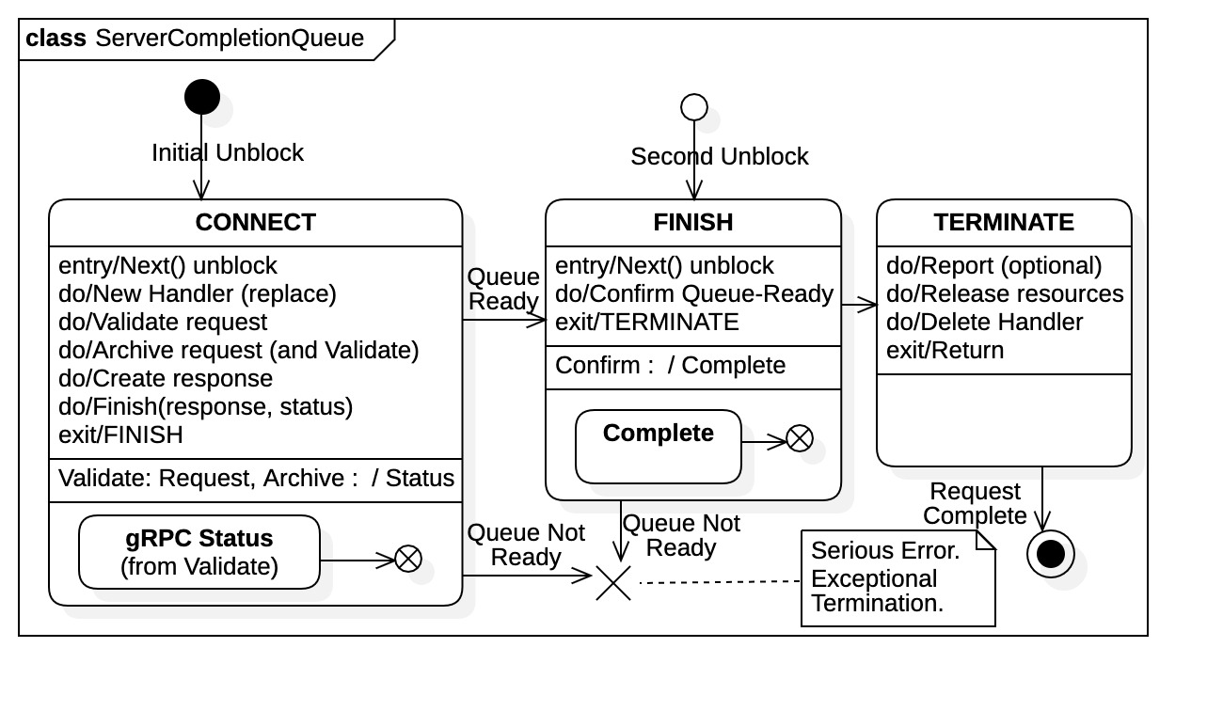

Figure 20: asynchronous, unary request state machine

After the client receives and accepts the Acknowledge message response the ServerCompletionQueue.Next() operation unblocks again within the main thread. (As shown in Figure 18) the main thread spawns another execution thread for the unary request handler (identified by its address tag). When activated it finds itself in the FINISH state. There it simply validates that the response has been correctly received then moves immediately into the TERMINATE state where it deletes itself. At that point the request operation is completed, either successfully or unsuccessfully. Note that the additional internal “Complete” state within the handler which is reached if the request operation has successfully completed. This state is optionally used by the service implementation to log and/or record interactions with clients.

Note that the states CONNECT and FINISH states refer to the *completion* of a pending RPC action. The request handler remains dormant in the CONNECT state until a gRPC client connection has completed, at which point it is awakened by the main thread to process the request. The request handler services the request up to and including the gRPC Finish() operation. It then remains dormant in the FINISH state waiting for the Finish() operation to complete. Once completed, the main thread activates it for the second and final time to complete the request.

### Streaming State Machine

For a streaming request the state machine approach is significantly more complex, especially for the bidirectional stream considered here. Figure 21 shows a viable state machine diagram for an asynchronous bidirectional streaming request. There we see that 6 primary states are used: CONNECT, READ, WRITE, DONE, FINISH, and TERMINATE. There are 5 potential entry points into the request handler. The TERMINATE state is again used as an explicit internal condition to mark the handler deletion; it is not entered externally. And again, there is a composite state machine, “gRPC Status”, that is used to maintain the stream status value (and message) which is returned in the final Finish(status) gRPC streaming action. Unlike the unary request, this composite state is distributed across several primary states and is available for the thread exit point occurring at stream termination. Note that here the number of total entries into the request handler is unknown a priori; the stream remains active until the client signals a half-close event (using its Finish() or WriteDone() stream action).

Referring to Figure 21 we see that the initial entry into the streaming request handler occurs in the CONNECT state as before. There the handler initializes itself, then starts the streaming operation with the initial Read(request) gRPC action. It then exits the execution thread while transitioning into the READ state. Once the Read(request) operation completes, the ServerCompletionQueue.Next(ready) function unblocks, the main thread captures the tag value (and ready value), translates it into the handler address, then spawns an execution thread for the handler. The request handler enters in the READ state where one of the following transitions are possible:

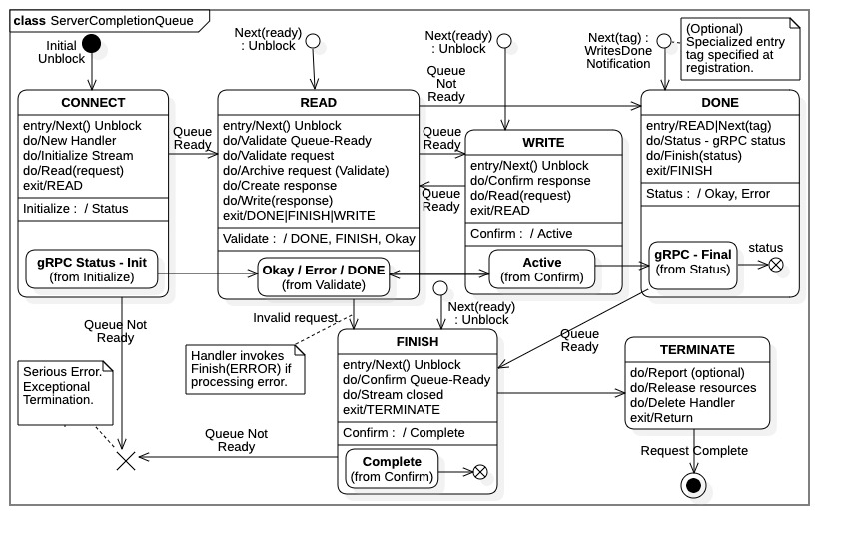

Figure 21: asyncrhonous streaming request state machine

1. DONE: The queue ready value is false indicating the client has terminated the stream or a gRPC error has occurred; in any event there are no more requests to be processed. This condition could be normal operation or an unexpected termination; the condition is determined by the current “gRPC Status” state. The handler moves directly to the DONE state, entering the DONE activity without exiting the thread.
2. WRITE: The queue ready value is true indicating the Read(request) operation was successful and the request (i.e., the DataSet message) is available. The handler archives the request, creates the appropriate response message (i.e., an Acknowledge message), then invokes the gRPC Write(response) operation. Concurrently it transitions the internal “gRPC Status” state to the appropriate value (and metadata) according to the results of the request processing. The handler exits the execution thread in the WRITE state.
3. FINISH: This is the consequence of a request processing error. The specific error condition (and message) is captured in the composite “gRPC Status” state transition and metadata. The state activity issues a gRPC Finish(status) action directly, thus notifying the client of the error and closing the stream. The handler moves to the FINISH state while exiting the thread.

As described above and seen in Figure 21, most of the request processing is done in the READ state activity. The remaining state activities are needed primarily for stream management. While the stream is active, the request handler will transition between the READ and WRITE states, the WRITE state activity simply initiating the next gRPC Read(request) action then exiting the execution thread while transitioning back to the READ state. If a queue ‘not ready’ flag is encountered while entering the READ state, the likely condition is that the client terminated the stream (a “half-close” action). The request handler proceeds under that assumption unless there is an explicit error condition. Specifically, the request handler chooses the DONE state path out of the streaming READ/WRITE transitions, without exiting the thread. Within the DONE state activity, the gRPC Finish(status) operation is invoked notifying the client that the service had closed the stream at its end. The request handler then exits the thread while transitioning to the FINISH state.

Once the gRPC Finish() action has completed, the main thread spawns another execution thread reentering the request handler for the final time. Upon entry in the FINAL state the handler performs any final checks on the stream and the conditions within the handler. Referring to Figure 21 we again see an optional “Complete” composite state which is used to record the history and status of the streaming request operation (e.g., number of reads, writes, errors, etc.). Again this sub-state is optional, available to the service implementation for logging and/or recording these client interactions. The handler then moves directly to the TERMINATE state activity without exiting the thread. There the stream activity is optionally recorded with the service implementation, the handler resources are released, then the request handler itself is deleted, completing the request.

Referring to the DONE state within Figure 21, it is important to note that there exists another specialized, but optional, entry into the request handler. During request handler server registration it is possible to instruct that a client gRPC WritesDone() notification be identified with a special tag value. (Technically, this is accomplished through function call ServerContext.AsyncNotifyWhenDone(tag) on the ServerContext instance provided to the AsyncService.RequeststreamData() registration function[2].) Typically, a separate handler entry address is provided as the tag value, one that the main thread can correctly recognize and translate. For example, the request handler may have a child class override the process(ready) function entry point, which would then have a different address. This is handler entry point is only then activated if the client does, indeed, invoke the WriteDone() signaling operation; it must be part of the agreed client/service protocol. It is also important to note that when completed, the final Read(request) operation will still unblock from the ServerCompletionQueue with a “queue not ready” flag. It will be recovered by the main thread and used to spawn a thread entry into the request handler. The handler must anticipate this “not ready” entry and ignore it if the DONE state has been previously activated. Thus, when using this protocol, the DONE event *must be recorded*. One of the composite state machines “gRPC Status” or “Complete” can be used to acknowledge the DONE event, as shown in the diagram.

## Implementation Strategies

We offer general design strategies and patterns for implementing C++ gRPC clients and services. Activity diagrams showing general management of client requests and server responses are provided to that end. These diagrams identify the basic actions and resources required within C++ gRPC, and the control flow between them. Specific references regard the test stand, but the process is essentially general. More specific structural designs are provided in the next section. There we produce architectural diagrams that realize the activities and control flow shown in this section.

### Service Implementation

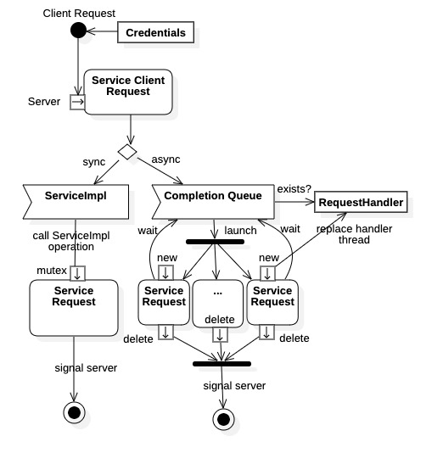

Figure 22: basic C++ gRPC service activity

The basic activity for a C++ gRPC service is shown in Figure 22. The entry point for the incoming client request is the gRPC Server instance. For synchronous requests the activity follows the left-hand side of the diagram while asynchronous requests follow the right-hand side. Synchronous RPC operations are handled completely by the ServiceImpl derived class of the Protobuf Service base. Asynchronous RPC operations must pass through a completion queue (i.e., a ServerCompletionQueue instance) to an appropriate request handler. Request handlers may execute concurrently, synchronizing their operations using a completion queue. (Callback implementations follow the same flow as the synchronous case, but without the mutual exclusion guard.)

Asynchronous requests explicitly provide for concurrency at all levels, a single gRPC server can accommodate multiple clients. Once an asynchronous connection is initiated, a single request handler is assigned to the incoming request. Thus, each request handler is dedicated to a single client request and remains active on independent execution threads until the request is completed. One the other hand, synchronous requests are mutually exclusive, blocking in a server queue guarding the RPC operations implemented in ServiceImpl. Consequently, synchronous gRPC servers can service only one client at a time, competing clients wait until the current request operation is fully completed.

As shown in Figure 22, request handlers manage their own lifetimes; this condition is an open design decision. To maintain a constant number of available request handlers, each handler clones itself upon initial connection. Handlers then delete themselves once the request is completed. Note that an alternative design approach is to have an explicit pool of request handlers for each RPC operation. There, request handlers would reenter the pool when requests are completed. They would be cleared and re-initialized upon handler pool reentry. The former approach is presented here because it is easier (C++ offers no direct thread pool support). However, the additional development required to re-initialize request handlers may yield performance benefits since some gRPC resource would not require recreation (specifically, completion queues).

The specific asynchronous service implementation used for the test stand was a hybrid approach. Specifically, the streaming request handlers maintain their own completion queues while the unary request handlers use a state machine. Unary requests handlers require only two entry points and, as seen in Figure 20, their state machines are relatively simple. However, as shown in Figure 21, a bidirectional streaming request requires sophisticated state machines with significant composite structure. The code complexity to implement such a state machine and state activities is substantial; it was decided to avoid this effort and accept the performance tradeoff of added gRPC resources, the additional completion queues. Note that for the hybrid approach a streaming request handler sees the server completion queue only once. For unidirectional streaming, a state-machine based request handler implementation would be more viable, the state machine burden is less significant.

The hybrid implementation choice produces the more detailed activity diagram seen in Figure 23. The left-hand side of the figure again includes the activity for the synchronous service, which is relatively straightforward. There the server simply calls the appropriate function override for the ServiceImpl class to process the request, either the sendData() or the streamData() function. It is, however, important to note the presence of the mutual exclusion semaphore mutex guarding entry into the ServiceImpl class, this is an internal entity supplied by gRPC for any synchronous service. It signifies that only one client is actively serviced at any one time, all other clients are blocked until the request operation completes. Thus, a greedy client can capture the service with an extended streaming operation, blocking all other clients for the duration. It is wise to implement some type of monitoring for synchronous RPC operations to avoid service capture.

The asynchronous service is represented on the right-hand side of Figure 23. There we see that a pool of request handlers is maintained for both unary and streaming requests. Clients do not block so long as there is a handler available for the desired request. Requests are serviced in the order they appear in the server completion queue, first-in-first-out. The Main Thread always interprets the tag value as a request handler entry address. Both unary and streaming requests inherit from a common base class, RequestHandler, which has the pure virtual function process(bool ready). The function is overridden to perform the operations specific to the RPC request type. Thus, the Main Thread simply casts the tag value to the type &RequestHandler::process then invokes the function pointer (with ready argument) within a separate execution thread. This action spawns the request handler which then activates in its current state.

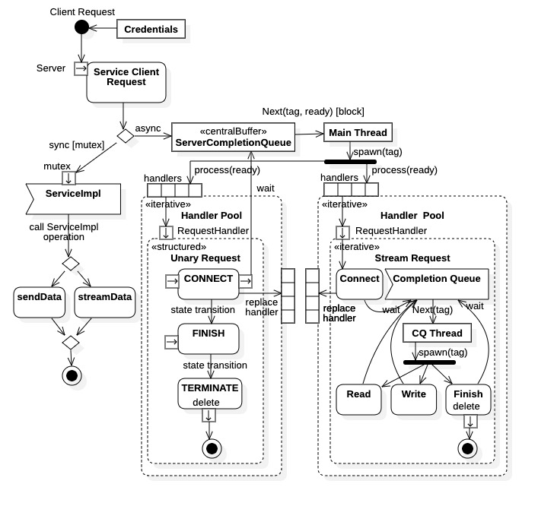

Figure 23: C++ gRPC service activity diagram

Because request handlers manage their own lifetime, external management of the request handler pools is not required. With this design pattern request handlers register themselves upon creation. Initiating the handler pool is done simply by creating the required number of request handlers at server startup. A request handler clones itself during a connection event (registration is automatic) maintaining the same number of available handlers within the pool. The same number of request handlers is always available, the number assigned at server startup.

For the unary request handlers, the activities within Figure 23 represent the states CONNECT, FINISH, and TERMINATE as presented by state diagram Figure 20. For the streaming request handlers the activities Connect, Read, Write, and Finish represent the completions of the AsyncstreamData() client operation, the Read(request) gRPC action, the Write(response) gRPC action, and the Finish(status) gRPC action, respectively. These entry points are called directly by the independent completion queue managing thread CQ Thread running within the request handler. The CQ Thread translates the tag values obtained from the CompleteQueue.Next(tag, ready) function into enumeration constants identifying the specific gRPC action completed. It then defers to the handler function responsible for that operation (i.e., a proxy design pattern). The implementation is more modular and legible then a state machine implementation, however, at the cost of maintaining an additional gRPC CompletionQueue within the handler.

The streaming request handler internal completion queue is identified at handler registration, along with the handler’s starting execution address (i.e., the process() function pointer). The registration process is detailed in Article III Section 3.03(d) and Figure 19. After creation and registration at server startup, the handler remains inactive until spawned on an execution thread by the Main Thread managing the server completion queue. Upon initial entry, the process() function acknowledges the client connection, starts the streaming operation with the initial Read() action, then defers to the internal completion queue manager thread CQ Thread.

### Client Implementation

Developing C++ gRPC client implementations is generally less involved than service development. Most client design patterns follow directly from the C++ gRPC requirements. However, asynchronous client operations always require the use of a completion queue, whether unary or streaming. Also, concurrency must be explicitly implemented for asynchronous clients.

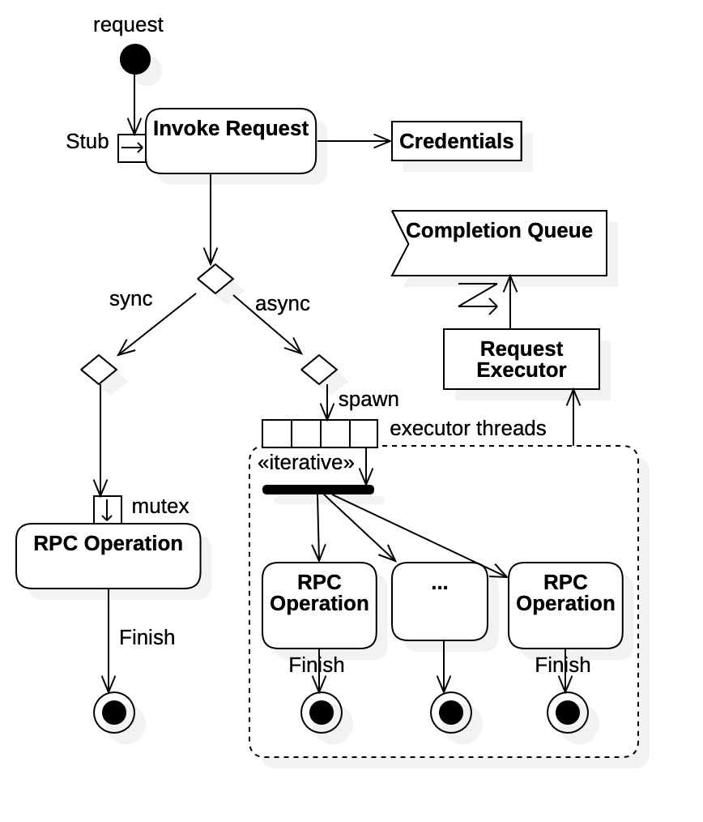

Figure 24: basic C++ gRPC client activity

A basic activity diagram for C++ gRPC clients is shown in Figure 24. The entry for any client RPC operation is through the Protobuf communication stub instance. The left-hand side shows the synchronous communications decision path while the right-hand side shows the asynchronous path. Synchronous RPC operations are inherently sequential, as implied with the mutex mutual exclusion guard. Within a client all synchronous RPC operations block until completed, whether unary or streaming. On the other hand, asynchronous RPC operations allow for concurrency. It is the responsibility of the client implementation to exploit any concurrency. In Figure 24 a design pattern is used to facilitate concurrency by implementing “request executors” which perform RPC operations on independent threads. Request executors manage an internal completion queue which is needed to coordinate all asynchronous RPC action. Thus, a single asynchronous client can support multiple, concurrent data exchanges with a compatible asynchronous gRPC server. Typically, a client receives notification of a completed asynchronous RPC operation through the gRPC Finish() action. It provides a gRPC Status instance, containing the final status of the operation (e.g., success, failure, error messages).

Figure 25 shows a more detailed activity diagram for C++ gRPC clients. The diagram is detailed in that it includes all possible request types, synchronous, asynchronous, unary, and streaming. Again, the entry point is the Protobuf Stub instance exposing all RPC operations, synchronous and asynchronous. And again, the left-hand side shows the synchronous communications decision path while the right-hand side shows the asynchronous path.

Synchronous unary client requests are straightforward, the RPC call is invoked directly on the communications stub (i.e., the Stub.sendData() operation) which writes the request message. The call does not return until the response is returned within the provided buffer (i.e., an Acknowledge* pointer). For synchronous streaming operations an appropriate gRPC streaming resource is required, which is returned by the communications stub. Client synchronous streaming operations may benefit from multi-threading, as shown in the diagram. The only significant design decision for the synchronous situation is the use of multiple threads for streaming operations, specifically for bidirectional streaming. As shown in the diagram, separate execution threads can be spawned to independently write requests and read responses. Both threads share the same streaming interface, which exposes the blocking gRPC actions. With two active threads there is no cross-blocking, the independent threads block only on their respective actions. Specifically, the writer thread freely transmits all requests within its payload (without waiting for server responses) then joins with the reader thread; the reader thread simply reads response messages until the stream terminates.

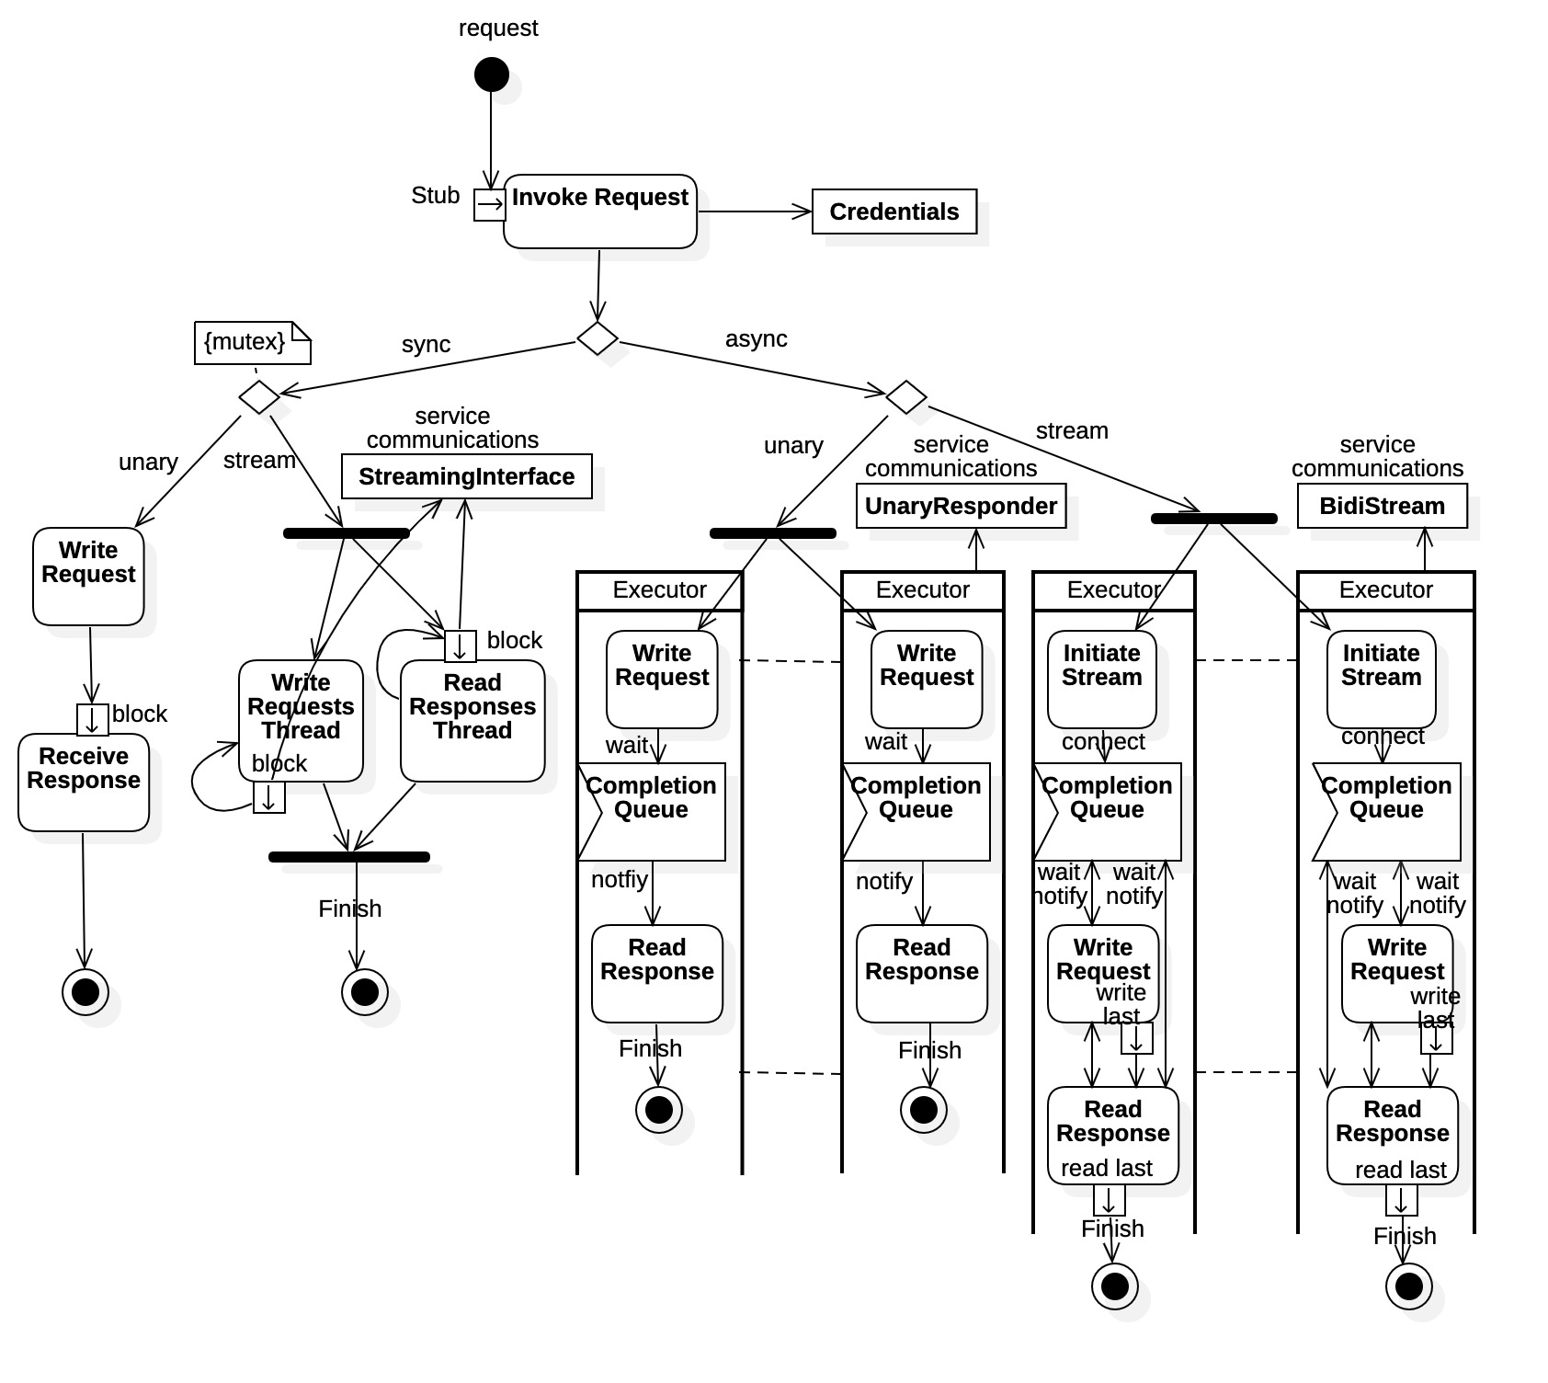

Figure 25: C++ gRPC client activity diagram

Within Figure 25 all asynchronous client request operations are executed on independent threads, identified by swimming lanes. Asynchronous unary operations execute straight through, though they must block once on a completion queue before recovering the server response. As indicated in the diagram, a gRPC unary response reader resource is needed to receive the server response. Flow control within an asynchronous streaming operation is more involved, especially for the bidirectional case shown in the diagram. It is sound design to implement some type of completion management as outlined in Figure 18.

For streaming RPC operations, the request executor must first initiate the stream using the proper RPC operation within the Protobuf communication stub. It then blocks on the completion queue waiting for a server connection establishing the stream. Once the stream is established the request executor moves between the Write Request and Read Response activities, always blocking on the completion queue for completed notifications. This process continues until the request payload is exhausted, that is the last request message is written. At that time the thread optionally issues a WritesDone() notification (or, optionally, a WriteLast() action) to the server using the stream interface. Once the last response message is read, the executor thread signals with the Finish() stream action, blocks on the completion queue until completed, then terminates. The client thread must internally monitor the Read Response activity to determine when the last server response is recovered.

## Implementation Designs

Here we present specific designs for C++ gRPC clients and services based upon the above strategies. These designs illustrate fundamental C++ gRPC development. They are particular to the test stand example, but extrapolation to the general case is straightforward. For performance reasons our focus has been asynchronous communications, however, here we include designs for the synchronous situation. Synchronous communications were implemented for the evaluations and their inclusion helps contrast the additional development effort required for asynchronous C++ gRPC development.

### Synchronous Service Implementation

The basic structure for a synchronous service implementation is shown in Figure 26. All RPC operations are implemented within the ServiceImpl class derived from protobuf::Service. It inherits from the Protobuf generated protobuf::Service class and overrides the supplied virtual functions to handle RPC operations. The virtual functions within the Service class are the service end points for the synchronous RPC operations. The RPC operations are fully implemented within the class ServiceImpl base class function overrides. A ServiceImpl instance is registered with the ServerBuilder before gRPC server creation and startup. After startup the gRPC Server object invokes these virtual functions when receiving any synchronous RPC request operations from a client. Thus, it is relatively straightforward to create a synchronous C++ gRPC service implementation. Note from the diagram that the ServiceImpl class implements the archiving operation archive() which is guarded by the class-owned mutual exclusion semaphore MtxArchiver.

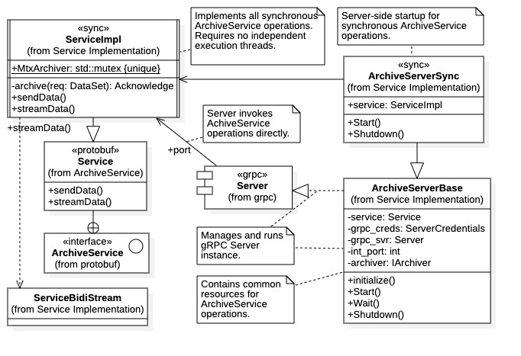

Figure 26: synchronous service implementation

As shown in Figure 26 the service implementation is attached to a gRPC server port. The Server instance directs all incoming synchronous port requests to the appropriate ServiceImpl virtual function override. We see that the Server instance is managed by class ArchiveServerBase within the service implementation. Since both synchronous and asynchronous implementations were built during the evaluations, it was expedient to supply a base class that manages all common gRPC server resources and handles all common server operations. The ArchiveServerBase class also handles all archiving operations for the test stand.

The synchronous implementation supplies the derived class ArchiveServerSync to implement server startup behavior specific to synchronous communication. Note that ArchiveServerBase maintains the attribute service containing the protobuf::Service class instance registered with the server. The child class ArchiveServerSync recasts the service attribute to type ServiceImpl particular to the synchronous implementation.

For streaming operations both client and service must utilize the appropriate gRPC streaming resources for communications. Figure 26 identifies the type ServiceBidiStream for handling bidirectional streaming required by the streamData() operation. This type is actually a binding of the DataSet and Acknowledge Protobuf messages to a communications resource within the C++ gRPC library. The library provides template classes realizing the various streaming action for exchanging data with the appropriate Protobuf RPC messages as discussed in Article III, Section 3.02(a). Unlike callback communications, synchronous gRPC communication requires no additional implementation support; the streaming templates directly support all streaming protocols.

More details for the synchronous service implementation are shown in Figure 27, in particular the requirements for the synchronous streaming operation streamData(). Figure 27 provides an alternative perspective of the synchronous service implementation, with emphasis on the streaming resources required from the gRPC library. The diagram demonstrates communication through the Server instance using the gRPC streaming interfaces and templates. The class ServiceBidiStream is bound to the template class ServerReaderWriter so that it reads DataSet messages and writes Acknowledge messages. A protocol is defined within the implementation where one Acknowledge response is written to the client for every DataSet request read.

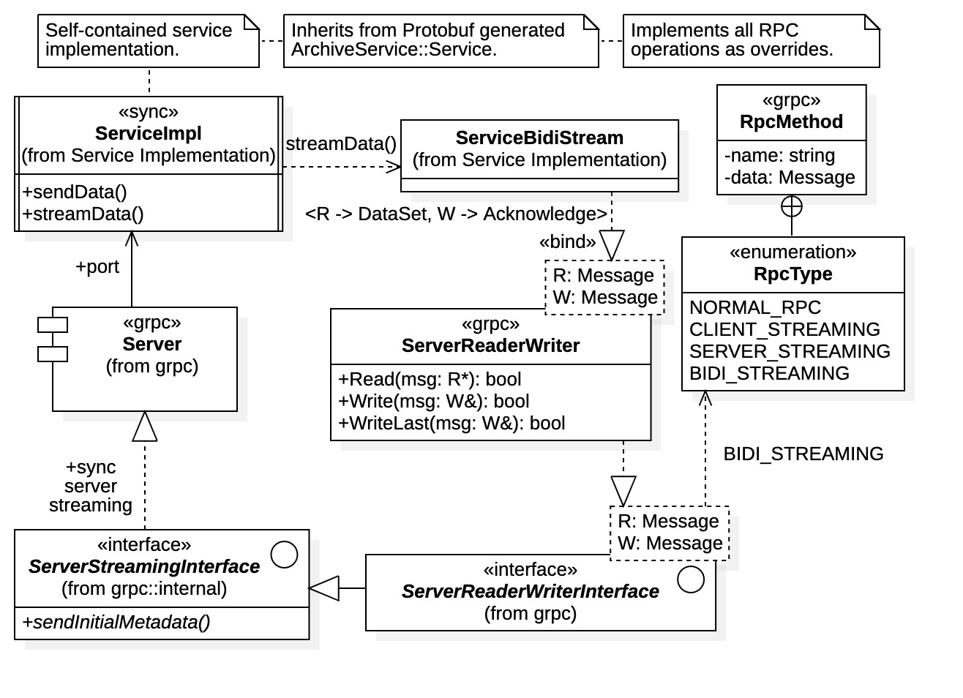

Figure 27: synchronous service implementation with gRPC streaming resources

It is important to note the presence of a mutual exclusion regarding synchronous operations. Thus, while a synchronous service is occupied with a client request it is unavailable to all other clients. This property can create serious issues for multi-client operations where a “greedy client” is present. A synchronous service can be captured by an active client with an extended streaming operation. Thus, it is prudent for synchronous services to monitor client calls in multi-client situations to prevent capture (e.g., by specifying predetermined time limits for client requests).

### Synchronous Client Implementation

Client-side C++ gRPC implementations are generally more straightforward than the service-side counterpart. All RPC operations are directly available through the Protobuf-generated Stub class. Clients are required to create at least one gRPC Channel instance to acquire Stub instances, specifically, Protobuf Stubs require a Channel instance specifying the service address and properties. However, streaming operations require some detail.

Figure 28 shows the possible design for a synchronous client implementing the ArchiveService interface. Analogous with the service implementation, a base class ArchiveClientBase is provided to maintain the gRPC resources and functions that are common to both synchronous and asynchronous client implementations. This class maintains attributes for the Protobuf Stub, the gRPC Channel, and any required channel credentials, as well as provided operations Start() and Shutdown() for client startup and shutdown, respectively. The derived class ArchiveClientSync exposes and implements the actual synchronous RPC operations within the Stub class.

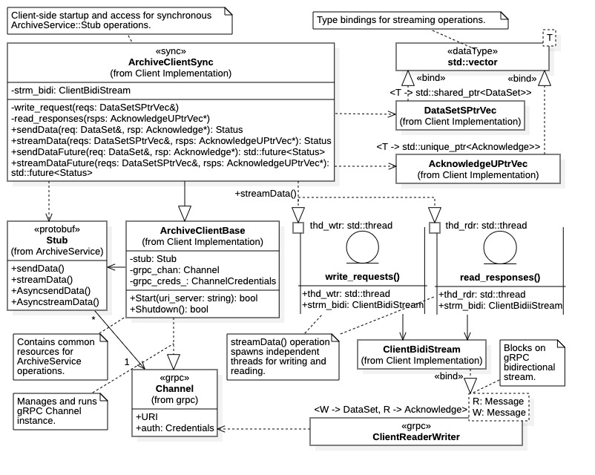

Figure 28: synchronous client implementation

Note from the diagram that all RPC operations supported by ArchiveClientSync return a grpc::Status instance indicating the status of the operation (i.e., success or failure). It also provides two versions of each RPC operation, a blocking version, and a non-blocking version identified with the suffix “Future”. This is a design decision provided to offer synchronous clients a non-blocking option. However, within gRPC all RPC operations are synchronous and sequential. The non-blocking operations sendDataFuture() and streamDataFuture() both return a std::future<Status> instance whose value becomes available when the RPC operation completes.

Figure 28 explicitly indicates template bindings to the C++ standard library container class std::vector<T>. The C++ vector template binding DataSetSPtrVec is used to pass multiple DataSet request messages (as shared pointers) to the streaming operations in a single payload. The C++ vector template binding AcknowledgeUPtrVec used to recover the corresponding Acknowledge message responses (as unique pointers) produced by the service. Note that both request and response messages are allocated from the heap and stored as std::shared_ptr<DataSet> and std::unique_ptr<Acknowledge> pointer instances, respectively. The heap allocation is a requirement for proper gRPC streaming operations.

The sendData() and sendDataFuture() are straightforward implementations, they simply call the sendData() unary operation within the Stub class (the latter is executed asynchronously on a std::async thread). However, the streaming operations streamData() and streamDataFuture() utilize two separate execution threads (in addition to the main execution thread). Each thread maintains the bound reference ClientBidiStream to the bidirectional streaming gRPC resource ClientReaderWriter used to communicate with the service. One thread, executed on the write_requets() function, is responsible for writing the DataSet message payload within the DataSetSPtrVec container argument. The other thread, executed on the read_responses() function, is responsible for reading the Acknowledge message responses as they appear then populating the AcknowledgeUPtrVec container argument. Utilizing two separate execution threads for writing and reading allows for better performance between client and service, as each thread blocks only on its assigned stream activity. Specifically, the writer thread does not wait to receive a response, it simply supplies DataSet request messages as fast as the service accepts them.

### Asynchronous Service Implementation

For asynchronous service implementation the situation is very different from the synchronous case. A service interface AsyncService is again generated by Protobuf; it is derived from the synchronous protobuf::Service interface. However, in this case the inheritance structure exits primarily to provide recognition to the gRPC Server instance for registration as an asynchronous service port. Direct inheritance from the AsyncService interface is possible, however, it is not recommended for most applications. Instead, the interface is used to register request handlers with the Server. It contains the functions RequestsendData() and RequeststreamData() to register handlers and signal that a handler is available for the specific RPC operations (i.e., the sendData() or streamData() operations, respectively). Additionally, multiple request handlers can be assigned to the same operation, facilitating concurrent, asynchronous operations between multiple clients, or the same client with multiple concurrent requests.

Figure 29 depicts the basic structure for an asynchronous implementation where, central to the diagram, is the request handler. Rather than producing a Service interface implementation that handles all RPC operations, in asynchronous communications a separate request handler must be implemented for RPC operation. These request handlers, identified generically as the RequestHandler active class in Figure 29, are spawned as independent execution threads within gRPC (i.e., once they are registered through AsyncService). Thus, for asynchronous operations the service must manage a collection of independent request handlers for all incoming client requests.

Figure 29 also shows the necessity of completion queues within the asynchronous implementation. Completion queues are used to synchronize RPC operations, for active clients and all executing request handlers. Thus, completion queue management, and thread synchronization in general, can be quite involved in asynchronous communication. It is possible to use a single completion queue for all thread management, the ServerCompletionQueue instance, or distribute the synchronization process among multiple CompletionQueue instances. In the latter case, as shown in Figure 29, the ServerCompletionQueue instance is used to signal incoming client request notifications while separate CompletionQueue instances owned by the request handlers are used to synchronize unary and streaming RPC operations. Figure 29 also depicts the gRPC resources used in unary and bidirectional streaming communications, as require by the test stand example. The subject of asynchronous C++ gRPC communication operations using completion queues is discussed more fully in Article III, Section 3.03. Here we consider a more detailed examination of the request handler implementation.

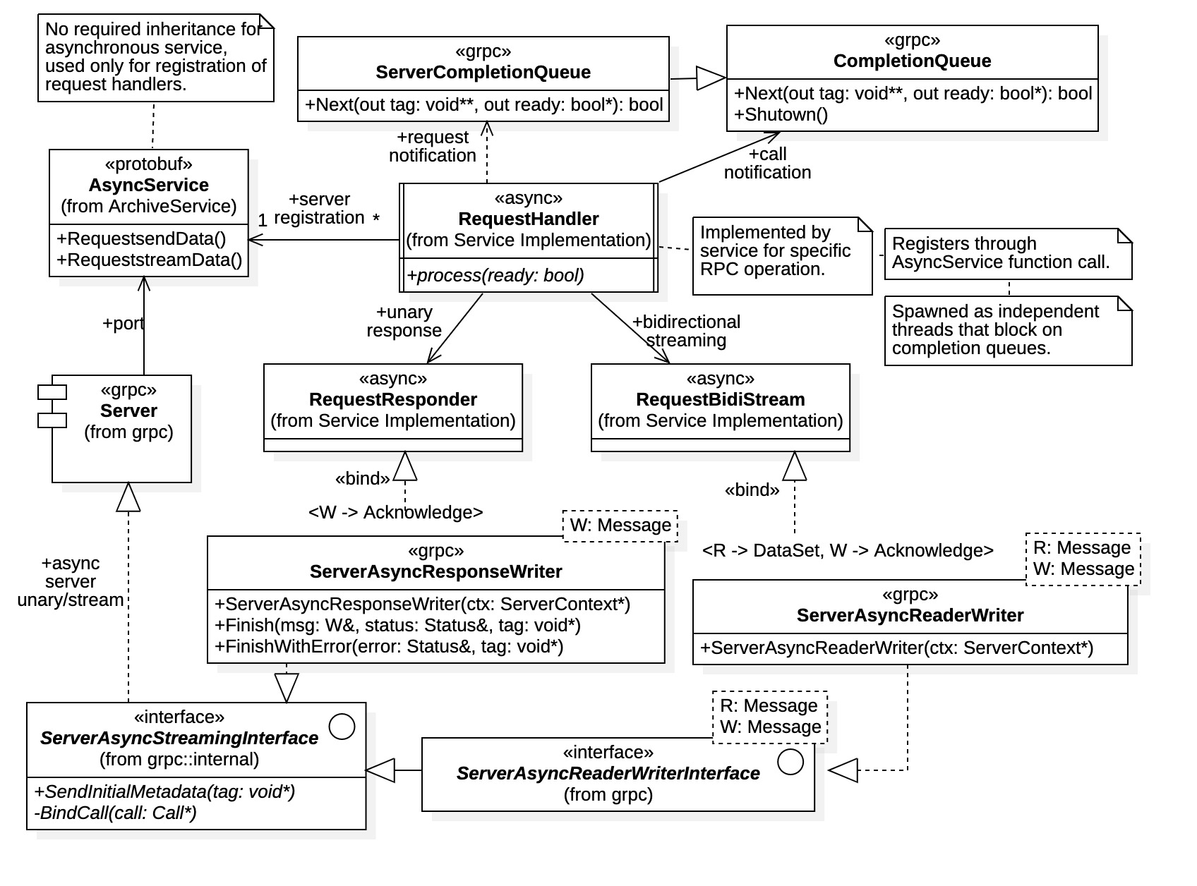

Figure 29: asynchronous service implementation

Figure 30 provides a prospective request handler architecture for the test stand example containing two asynchronous operations, AsyncsendData() and Asyncstream() (this is the design used for the evaluations). The overall architecture contains a top-level class ArchiveServerAsync which maintains a single ServerCompletionQueue and manages the gRPC Server instance (i.e., through the base class ArchiveServerBase as with the synchronous implementation). All request handlers are initiated by the single server completion manager, SCQManager, which responds to client requests by spawning an appropriate request handler thread.

There are two request handler implementations, SendDataHandler and StreamDataHandler, one for each RPC operation. Both inherit from the common base class RequestHandler and are required to implement the process() pure virtual function, which is the entry into all request handler classes. The RequestHandler base class contains the static function SpawnHandler(void* tag, bool ready) which spawns request handlers on separate threads executing the process() function. It converts the tag argument recovered from the ServerCompletionQueue.Next(void* tag, bool* ready) operation into a RequestHandler.process() function pointer then creates the execution thread (the ready argument is passed to the process(bool ready) function).

The SendDataHandler processes the unary request of the sendData() RPC operation. Its implementation is based upon an internal state machine whose states are listed in the enclosed enumeration STATE. The internal state is advanced by repeated invocations of the process() function, of which there are only two for the unary case. On the other hand, the StreamDataHandler, implementing the RPC operation streamData(), maintains its own CompletionQueue instance to manage the bidirectional streaming between client and service. There, streaming operations are the focus of the implementation, where specific operations are identified by the enclosed OPERATION enumeration. The process() function is invoked only once, upon client request notification and connection. Henceforth all streaming operations are synchronized by the internal completion queue manager (i.e., CQManager) instance which assumes control within the request handler thread. Thus, unlike the unary case, the original execution thread remains active until the request is fully processed. Within that thread, additional threads are spawned to handle each streaming RPC action. The online documentation indicates that use of multiple completion queues may create a performance cost. However, implementation of bidirectional streaming using a single server completion queue requires a sophisticated state machine to manage operations.

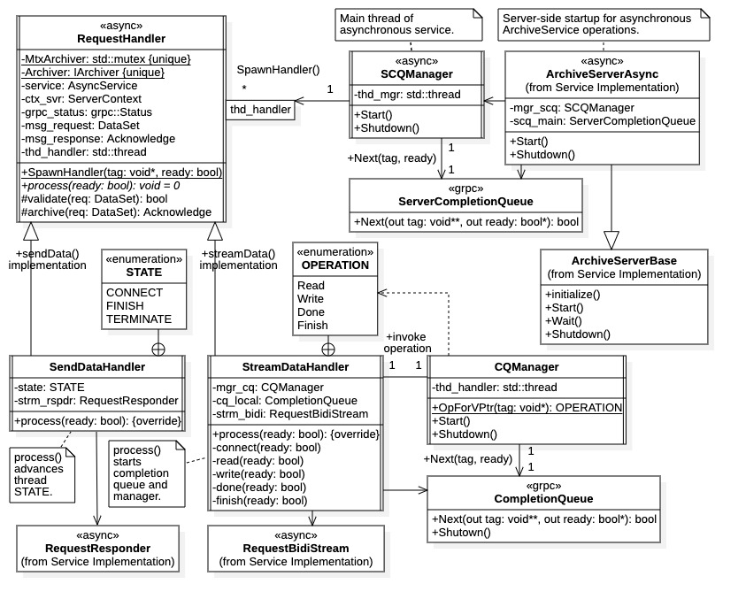

Figure 30: asynchronous service request handler implementation

### Asynchronous Client Implementation

An asynchronous client implementation is shown in Figure 31. There we see that the asynchronous operations are exposed by the ArchiveClientAsync class. As in the synchronous case, the top-level class inherits from base class ArchiveClientBase to manage all common gRPC resources and server operations. And again, there are two implementations for each RPC operation, a blocking version and a non-blocking version, each operation returns a grpc::Status instances. However, for the asynchronous case use of the non-blocking operations creates a true multi-threaded execution scenario; both client and server can have multiple shared connections each concurrently exchanging data (e.g., multiple, concurrent, data streams). In fact, an asynchronous service can concurrently support multiple asynchronous clients, each with multiple data streams. This is not possible in the synchronous case where a server can process only one client request at a time.

Referring to the design in Figure 31, all RPC operations are performed on separate execution threads formally represented as RequestExecutor instances. Asynchronous clients require completion queues for synchronizing communications with the server; thus, each RequestExecutor execution thread must maintain a completion queue to wait for service actions, even for the unary case. In the diagram all RPC operations are implemented as child classes of RequestExecutor and must supply an implementation for the pure virtual function execute(), which is the entry point for the request operation. The derived class AsyncsendDataExecutor performs the AsyncsendData() and AsyncsendDataFuture() operations, while the AsyncstreamDataExecutor performs the AsyncstreamData() and AsyncstreamDataFuture() operations. Figure 31 also includes the gRPC communications resources ClientAsyncResponseReader for unary operations, and ClientAsyncReaderWriter for bidirectional streaming (the respective template bindings ClientUnaryResponse and ClientBidiStream are also shown). In both the unary and streaming cases, a completion queue is required for use of these resources.

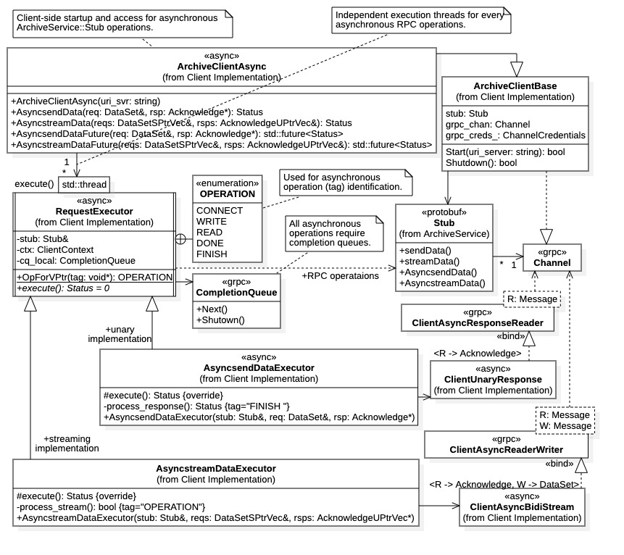

Figure 31: asynchronous client implementation

Figure 32 provides a detailed view of the request executor implementations AsyncsendDataExecutor and AsyncstreamDataExecutor. The diagram demonstrates that, after entering the execute() function, each request executor initiates the client request operation on the appropriate Stub function then defers to a class function for required completion queue management. For the unary operation completion queue management is straightforward and prescribed, requiring only one blocking action. The process_response() function issues the Finish() operation then blocks on CompletionQueue.Next() to recover the single Acknowledge message response. (The unary executor AsyncsendDataExecutor requires only the OPERATION::FINISH constant for its operation.)

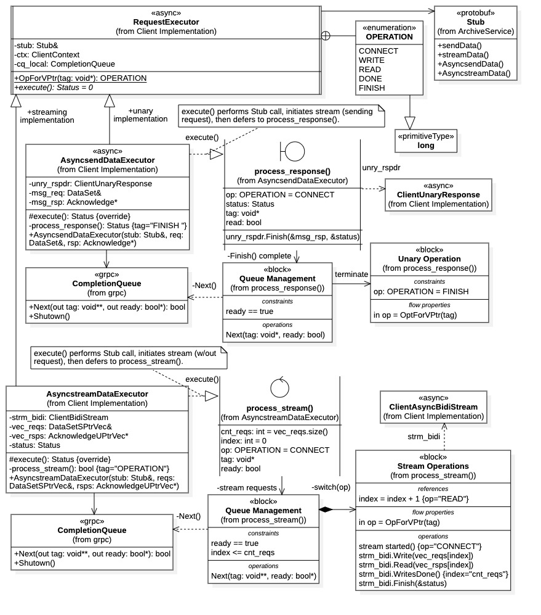

Figure 32: asynchronous client request executor implementation

For the bidirectional streaming case the situation is more involved. The process_stream() function has an extended switch block that performs streaming operations according to the recovered tag argument in the CompletionQueue.Next(void**tag, bool* read) function. Note that base class RequestExecutor contains the OPERATION enumeration used to identify stream operations for the switch statement. Base class RequestExecutor provides the static function OpForVPtr(void* tag) for converting void* tags into OPERATION enumeration values (OPERATION constants are long values, the same width as a void* pointer). Note further that the process_stream() function contains the index variable which is used as an index into the vector containers of request and response messages. It is incremented after each stream read action has completed, according to the server protocol of sending a response to each request.

A more robust implementation would maintain two vector container indices, one for writing requests and one for reading responses. Due to the asynchronous nature of the stream, strict sequencing of the request/response protocol cannot be guaranteed. Each is incremented after a write or read operation completes, respectively. When the write index achieves its boundary value, a WritesDone() signal is sent to the server. When the read index achieves its boundary value, the Finish() operation is invoked, initiating stream termination.

REFERENCES

|  |  |
| --- | --- |
| [1] | "GRPC," 2023. [Online]. Available: <https://github.com/grpc>. |
| [2] | gRPC Authors, "gRPC," gRPC Authors, 2023. [Online]. Available: <https://grpc.io/>. |
| [3] | "grpc/examples," 2023. [Online]. Available: <https://github.com/grpc/grpc/tree/master/examples>. |
| [4] | "grpc-java/examples," 2023. [Online]. Available: <https://github.com/grpc/grpc-java/tree/master/examples>. |
| [5] | "grpc-go/examples," [Online]. Available: <https://github.com/grpc/grpc-go/tree/master/examples>. |
| [6] | P. Lorins, "c++_async_stream_client," 2019. [Online]. Available: <https://gist.github.com/ppLorins/d4484b61f12b2d87ac5c8d50d0808974>. |
| [7] | P. Lorins, "bidi-server-cus.cc," 2019. [Online]. Available: <https://gist.github.com/ppLorins/6e4cc625c2c5b8fd16ced3172b1ada09>. |
| [8] | "Protocol Buffers," 2023. [Online]. Available: https:[//github.com/protocolbuffers](http://github.com/protocolbuffers). |
| [9] | Google LLC, "Protocol Buffers," Google LLC, 2023. [Online]. Available: <https://protobuf.dev/>. |
| [10] | C. K. Allen, "test-protobuf," 2023. [Online]. Available: <https://github.com/HerrDreadmiller/test-protobuf>. |
| [11] | C. K. Allen, "test-grpc-cpp," 2023. [Online]. Available: <https://github.com/HerrDreadmiller/test-grpc-cpp>. |
| [12] | C. K. Allen, G. McIntyre, M. Davidsaver, C. McChesney and L. B. Dalesio, "Machine Learning Data Platform: Phase I Research and Development Report," Osprey DCS LLC, Ocean City, Maryland, 2023. |
| [13] | "Eclipse Foundation," [Online]. Available: <https://www.eclipse.org/>. |
| [14] | Eclipse Foundation, "Eclipse CDT™," Eclipse Foundation, 2023. [Online]. Available: <https://projects.eclipse.org/projects/tools.cdt>. |
| [15] | C. McChesney, *Datastore benchmark summary and proposed changes to design and implementation,* ospreydcs.com email, July 6, 2023, 4:24 PM EDT, 2023. |
| [16] | gRPC Authors, "Performance Best Practices," 2023. [Online]. Available: <https://grpc.io/docs/guides/performance/>. |
| [17] | C. Tiller, "CompletionQueue and ServerCompletionQueue," Google, 2017. [Online]. Available: <https://groups.google.com/g/grpc-io/c/V4NAQ77PMEo>. |

APPENDIX A. Synchronous Simulations Results

Unary 100x100 Tables

---------- ---------- SCENARIO INITIALIZATION ---------- ----------

Scenario initialized and ready.

scenario name: SYNC_UNARY_100x100.

description: Synchronous, unary scenario with 100x100 double tables

scenario type: SYNC.

payload count: 100.

scenario file: src/main/resources/scenario/scenario-sync-unary-100x100.txt.

archive file(s): testing/scenario/archive/archive-binary-trunc.bin.

response file: testing/scenario/output/sync-unary-100x100-responses-2023-09-11T16;54;32.295Z.txt.

output file: testing/scenario/output/sync-unary-100x100-results-2023-09-11T16;54;32.295Z.txt.

---------- ---------- SCENARIO EXECUTION ---------- ----------

Beginning gRPC startup...

gRPC started, client and server up and running.

server address: 0.0.0.0:50051.

client address: localhost:50051.

Beginning Scenario execution...

execution completed in 0.184 seconds.

Shutting down gRPC resources...

gRPC shutdown completed in 0.000 seconds.

Scenario results checked.

Server responses saved to testing/scenario/output/sync-unary-100x100-responses-2023-09-11T16;54;32.295Z.txt.

---------- ---------- SCENARIO SUMMARY ---------- ----------

Scenario Description:

name: SYNC_UNARY_100x100

description: Synchronous, unary scenario with 100x100 double tables

execution date: 2023-09-11T16:54:32Z

synchronization: SYNC

request method: UNARY

archiver type: FILE_ARCHIVER

server compression: GRPC_COMPRESS_NONE

client compression: GRPC_COMPRESS_NONE

server message size (bytes): 4.1943e+06

client message size (bytes): 4.1943e+06

serial request size (bytes): 112611

number of gRPC calls: 100

total number of requests: 100

total payload size (bytes): 1.12616e+07

serialization compression: 0.907977

execution time: 0.184 seconds

total time: 0.370 seconds

scenario completed: TRUE

scenario errors: FALSE

---------- ---------- SCENARIO RESULTS ---------- ----------

Scenario Results:

synchronization: SYNC

request method: UNARY

scenario completed: TRUE

scenario errors: FALSE

execution time: 0.184 seconds

shutdown time: 0.000 seconds

total time: 0.370 seconds.

total requests: 100

total responses: 100

request per call: 1

serial request size (bytes): 112615

serial payload size (bytes): 1.12616e+07

number of gRPC client calls: 100

number of gRPC transmissions: 100

number of gRPC errors: 0

error rate (errors/calls): 0%

serialization efficiency (raw/serial): 1.1013

request transmission rate (reqs/sec): 542.302

data value transmission rate (vals/sec): 5.47725e+06

double value transmission rate (doubles/sec) : 8.40731e+06

RAW DATA transmission rate (bytes/sec): 6.72585e+07

RAW SERIALIZED xmission rate (bytes/sec): 6.10718e+07

DATA transmission rate w/ errors (bytes/sec): 6.72585e+07

SERIALIZED xmission rate w/ errors (bytes/sec): 6.10718e+07

Streaming 100x100 tables

---------- ---------- SCENARIO INITIALIZATION ---------- ----------

Scenario initialized and ready.

scenario name: SYNC_STREAM_100x100.

description: Synchronous, streaming scenario for 100x100 double tables

scenario type: SYNC.

payload count: 100.

scenario file: src/main/resources/scenario/scenario-sync-stream-100x100.txt.

archive file(s): testing/scenario/archive/archive-binary-trunc.bin.

response file: testing/scenario/output/sync-stream-100x100-responses-2023-09-11T17;11;45.672Z.txt.

output file: testing/scenario/output/sync-stream-100x100-results-2023-09-11T17;11;45.672Z.txt.

---------- ---------- SCENARIO EXECUTION ---------- ----------

Beginning gRPC startup...

gRPC started, client and server up and running.

server address: 0.0.0.0:50051.

client address: localhost:50051.

Beginning Scenario execution...

execution completed in 0.075 seconds.

Shutting down gRPC resources...

gRPC shutdown completed in 0.000 seconds.

Scenario results checked.

Server responses saved to testing/scenario/output/sync-stream-100x100-responses-2023-09-11T17;11;45.672Z.txt.

---------- ---------- SCENARIO SUMMARY ---------- ----------

Scenario Description:

name: SYNC_STREAM_100x100

description: Synchronous, streaming scenario for 100x100 double tables

execution date: 2023-09-11T17:11:45Z

synchronization: SYNC

request method: STREAM

archiver type: FILE_ARCHIVER

server compression: GRPC_COMPRESS_NONE

client compression: GRPC_COMPRESS_NONE

server message size (bytes): 4.1943e+06

client message size (bytes): 4.1943e+06

serial request size (bytes): 112611

number of gRPC calls: 1

total number of requests: 100

total payload size (bytes): 1.12616e+07

serialization compression: 0.907977

execution time: 0.075 seconds

total time: 0.255 seconds

scenario completed: TRUE

scenario errors: FALSE

---------- ---------- SCENARIO RESULTS ---------- ----------

Scenario Results:

synchronization: SYNC

request method: STREAM

scenario completed: TRUE

scenario errors: FALSE

execution time: 0.075 seconds

shutdown time: 0.000 seconds

total time: 0.255 seconds.

total requests: 100

total responses: 100

request per call: 100

serial request size (bytes): 112615

serial payload size (bytes): 1.12616e+07

number of gRPC client calls: 1

number of gRPC transmissions: 100

number of gRPC errors: 0

error rate (errors/calls): 0%

serialization efficiency (raw/serial): 1.1013

request transmission rate (reqs/sec): 1318.51

data value transmission rate (vals/sec): 1.3317e+07

double value transmission rate (doubles/sec) : 2.04409e+07

RAW DATA transmission rate (bytes/sec): 1.63527e+08

RAW SERIALIZED xmission rate (bytes/sec): 1.48486e+08

DATA transmission rate w/ errors (bytes/sec): 1.63527e+08

SERIALIZED xmission rate w/ errors (bytes/sec): 1.48486e+08

Unary 500x500 Tables

---------- ---------- SCENARIO INITIALIZATION ---------- ----------

Scenario initialized and ready.

scenario name: SYNC_UNARY_500x500.

description: Synchronous, unary scenario with 500x500 double tables

scenario type: SYNC.

payload count: 100.

scenario file: src/main/resources/scenario/scenario-sync-unary-500x500.txt.

archive file(s): testing/scenario/archive/archive-binary-trunc.bin.

response file: testing/scenario/output/sync-unary-500x500-responses-2023-09-11T17;26;46.642Z.txt.

output file: testing/scenario/output/sync-unary-500x500-results-2023-09-11T17;26;46.641Z.txt.

---------- ---------- SCENARIO EXECUTION ---------- ----------

Beginning gRPC startup...

gRPC started, client and server up and running.

server address: 0.0.0.0:50051.

client address: localhost:50051.

Beginning Scenario execution...

execution completed in 4.306 seconds.

Shutting down gRPC resources...

gRPC shutdown completed in 0.001 seconds.

Scenario results checked.

Server responses saved to testing/scenario/output/sync-unary-500x500-responses-2023-09-11T17;26;46.642Z.txt.

---------- ---------- SCENARIO SUMMARY ---------- ----------

Scenario Description:

name: SYNC_UNARY_500x500

description: Synchronous, unary scenario with 500x500 double tables

execution date: 2023-09-11T17:26:52Z

synchronization: SYNC

request method: UNARY

archiver type: FILE_ARCHIVER

server compression: GRPC_COMPRESS_NONE

client compression: GRPC_COMPRESS_NONE

server message size (bytes): 4.1943e+06

client message size (bytes): 4.1943e+06

serial request size (bytes): 2.76284e+06

number of gRPC calls: 100

total number of requests: 100

total payload size (bytes): 2.76285e+08

serialization compression: 0.914842

execution time: 4.306 seconds

total time: 5.979 seconds

scenario completed: TRUE

scenario errors: FALSE

---------- ---------- SCENARIO RESULTS ---------- ----------

Scenario Results:

synchronization: SYNC

request method: UNARY

scenario completed: TRUE

scenario errors: FALSE

execution time: 4.306 seconds

shutdown time: 0.001 seconds

total time: 5.979 seconds.

total requests: 100

total responses: 100

request per call: 1

serial request size (bytes): 2.76285e+06

serial payload size (bytes): 2.76285e+08

number of gRPC client calls: 100

number of gRPC transmissions: 100

number of gRPC errors: 0

error rate (errors/calls): 0%

serialization efficiency (raw/serial): 1.09308

request transmission rate (reqs/sec): 23.2189

data value transmission rate (vals/sec): 5.81633e+06

double value transmission rate (doubles/sec) : 8.76519e+06

RAW DATA transmission rate (bytes/sec): 7.01215e+07

RAW SERIALIZED xmission rate (bytes/sec): 6.41503e+07

DATA transmission rate w/ errors (bytes/sec): 7.01215e+07

SERIALIZED xmission rate w/ errors (bytes/sec): 6.41503e+07

Stream 500x500 Tables

---------- ---------- SCENARIO INITIALIZATION ---------- ----------

Scenario initialized and ready.

scenario name: SYNC_STREAM_500x500.

description: Synchronous, streaming scenario for 500x500 double tables

scenario type: SYNC.

payload count: 100.

scenario file: src/main/resources/scenario/scenario-sync-stream-500x500.txt.

archive file(s): testing/scenario/archive/archive-binary-trunc.bin.

response file: testing/scenario/output/sync-stream-500x500-responses-2023-09-11T17;44;36.262Z.txt.

output file: testing/scenario/output/sync-stream-500x500-results-2023-09-11T17;44;36.262Z.txt.

---------- ---------- SCENARIO EXECUTION ---------- ----------

Beginning gRPC startup...

gRPC started, client and server up and running.

server address: 0.0.0.0:50051.

client address: localhost:50051.

Beginning Scenario execution...

execution completed in 1.881 seconds.

Shutting down gRPC resources...

gRPC shutdown completed in 0.000 seconds.

Scenario results checked.

Server responses saved to testing/scenario/output/sync-stream-500x500-responses-2023-09-11T17;44;36.262Z.txt.

---------- ---------- SCENARIO SUMMARY ---------- ----------

Scenario Description:

name: SYNC_STREAM_500x500

description: Synchronous, streaming scenario for 500x500 double tables

execution date: 2023-09-11T17:44:39Z

synchronization: SYNC

request method: STREAM

archiver type: FILE_ARCHIVER

server compression: GRPC_COMPRESS_NONE

client compression: GRPC_COMPRESS_NONE

server message size (bytes): 4.1943e+06

client message size (bytes): 4.1943e+06

serial request size (bytes): 2.76301e+06

number of gRPC calls: 1

total number of requests: 100

total payload size (bytes): 2.7629e+08

serialization compression: 0.914897

execution time: 1.881 seconds

total time: 3.532 seconds

scenario completed: TRUE

scenario errors: FALSE

---------- ---------- SCENARIO RESULTS ---------- ----------

Scenario Results:

synchronization: SYNC

request method: STREAM

scenario completed: TRUE

scenario errors: FALSE

execution time: 1.881 seconds

shutdown time: 0.000 seconds

total time: 3.532 seconds.

total requests: 100

total responses: 100

request per call: 100

serial request size (bytes): 2.7629e+06

serial payload size (bytes): 2.7629e+08

number of gRPC client calls: 1

number of gRPC transmissions: 100

number of gRPC errors: 0

error rate (errors/calls): 0%

serialization efficiency (raw/serial): 1.09306

request transmission rate (reqs/sec): 53.1452

data value transmission rate (vals/sec): 1.33129e+07

double value transmission rate (doubles/sec) : 2.00625e+07

RAW DATA transmission rate (bytes/sec): 1.605e+08

RAW SERIALIZED xmission rate (bytes/sec): 1.46835e+08

DATA transmission rate w/ errors (bytes/sec): 1.605e+08

SERIALIZED xmission rate w/ errors (bytes/sec): 1.46835e+08

UNARY 1000x500 Tables

---------- ---------- SCENARIO INITIALIZATION ---------- ----------

Scenario initialized and ready.

scenario name: SYNC_UNARY_1000x500.

description: Synchronous, unary scenario with 1000x500 double tables

scenario type: SYNC.

payload count: 100.

scenario file: src/main/resources/scenario/scenario-sync-unary-1000x500.txt.

archive file(s): testing/scenario/archive/archive-binary-trunc.bin.

response file: testing/scenario/output/sync-unary-1000x500-responses-2023-09-11T17;52;17.465Z.txt.

output file: testing/scenario/output/sync-unary-1000x500-results-2023-09-11T17;52;17.465Z.txt.

---------- ---------- SCENARIO EXECUTION ---------- ----------

Beginning gRPC startup...

gRPC started, client and server up and running.

server address: 0.0.0.0:50051.

client address: localhost:50051.

Beginning Scenario execution...

execution completed in 8.776 seconds.

Shutting down gRPC resources...

gRPC shutdown completed in 0.002 seconds.

Scenario results checked.

Server responses saved to testing/scenario/output/sync-unary-1000x500-responses-2023-09-11T17;52;17.465Z.txt.

---------- ---------- SCENARIO SUMMARY ---------- ----------

Scenario Description:

name: SYNC_UNARY_1000x500

description: Synchronous, unary scenario with 1000x500 double tables

execution date: 2023-09-11T17:52:30Z

synchronization: SYNC

request method: UNARY

archiver type: FILE_ARCHIVER

server compression: GRPC_COMPRESS_NONE

client compression: GRPC_COMPRESS_NONE

server message size (bytes): 8.38861e+06

client message size (bytes): 8.38861e+06

serial request size (bytes): 5.51901e+06

number of gRPC calls: 100

total number of requests: 100

total payload size (bytes): 5.51888e+08

serialization compression: 0.914952

execution time: 8.776 seconds

total time: 12.360 seconds

scenario completed: TRUE

scenario errors: FALSE

---------- ---------- SCENARIO RESULTS ---------- ----------

Scenario Results:

synchronization: SYNC

request method: UNARY

scenario completed: TRUE

scenario errors: FALSE

execution time: 8.776 seconds

shutdown time: 0.002 seconds

total time: 12.360 seconds.

total requests: 100

total responses: 100

request per call: 1

serial request size (bytes): 5.51888e+06

serial payload size (bytes): 5.51888e+08

number of gRPC client calls: 100

number of gRPC transmissions: 100

number of gRPC errors: 0

error rate (errors/calls): 0%

serialization efficiency (raw/serial): 1.09298

request transmission rate (reqs/sec): 11.3943

data value transmission rate (vals/sec): 5.70283e+06

double value transmission rate (doubles/sec) : 8.59131e+06

RAW DATA transmission rate (bytes/sec): 6.87305e+07

RAW SERIALIZED xmission rate (bytes/sec): 6.28836e+07

DATA transmission rate w/ errors (bytes/sec): 6.87305e+07

SERIALIZED xmission rate w/ errors (bytes/sec): 6.28836e+07

Stream 1000x500 Tables

---------- ---------- SCENARIO INITIALIZATION ---------- ----------

Scenario initialized and ready.

scenario name: SYNC_STREAM_1000x500.

description: Synchronous, streaming scenario for 1000x500 double tables

scenario type: SYNC.

payload count: 100.

scenario file: src/main/resources/scenario/scenario-sync-stream-1000x500.txt.

archive file(s): testing/scenario/archive/archive-binary-trunc.bin.

response file: testing/scenario/output/sync-stream-1000x500-responses-2023-09-11T18;02;57.570Z.txt.

output file: testing/scenario/output/sync-stream-1000x500-results-2023-09-11T18;02;57.570Z.txt.

---------- ---------- SCENARIO EXECUTION ---------- ----------

Beginning gRPC startup...

gRPC started, client and server up and running.

server address: 0.0.0.0:50051.

client address: localhost:50051.

Beginning Scenario execution...

execution completed in 3.579 seconds.

Shutting down gRPC resources...

gRPC shutdown completed in 0.001 seconds.

Scenario results checked.

Server responses saved to testing/scenario/output/sync-stream-1000x500-responses-2023-09-11T18;02;57.570Z.txt.

---------- ---------- SCENARIO SUMMARY ---------- ----------

Scenario Description:

name: SYNC_STREAM_1000x500

description: Synchronous, streaming scenario for 1000x500 double tables

execution date: 2023-09-11T18:03:04Z

synchronization: SYNC

request method: STREAM

archiver type: FILE_ARCHIVER

server compression: GRPC_COMPRESS_NONE

client compression: GRPC_COMPRESS_NONE

server message size (bytes): 8.38861e+06

client message size (bytes): 8.38861e+06

serial request size (bytes): 5.5189e+06

number of gRPC calls: 1

total number of requests: 100

total payload size (bytes): 5.51888e+08

serialization compression: 0.914934

execution time: 3.579 seconds

total time: 6.863 seconds

scenario completed: TRUE

scenario errors: FALSE

---------- ---------- SCENARIO RESULTS ---------- ----------

Scenario Results:

synchronization: SYNC

request method: STREAM

scenario completed: TRUE

scenario errors: FALSE

execution time: 3.579 seconds

shutdown time: 0.001 seconds

total time: 6.863 seconds.

total requests: 100

total responses: 100

request per call: 100

serial request size (bytes): 5.51888e+06

serial payload size (bytes): 5.51888e+08

number of gRPC client calls: 1

number of gRPC transmissions: 100

number of gRPC errors: 0

error rate (errors/calls): 0%

serialization efficiency (raw/serial): 1.09298

request transmission rate (reqs/sec): 27.9374

data value transmission rate (vals/sec): 1.39827e+07

double value transmission rate (doubles/sec) : 2.10649e+07

RAW DATA transmission rate (bytes/sec): 1.68519e+08

RAW SERIALIZED xmission rate (bytes/sec): 1.54183e+08

DATA transmission rate w/ errors (bytes/sec): 1.68519e+08

SERIALIZED xmission rate w/ errors (bytes/sec): 1.54183e+08

Unary 1000x1000 Tables

---------- ---------- SCENARIO INITIALIZATION ---------- ----------

Scenario initialized and ready.

scenario name: SYNC_UNARY_1000x500.

description: Synchronous, unary scenario with 1000x1000 double tables

scenario type: SYNC.

payload count: 100.

scenario file: src/main/resources/scenario/scenario-sync-unary-1000x1000.txt.

archive file(s): testing/scenario/archive/archive-binary-trunc.bin.

response file: testing/scenario/output/sync-unary-1000x1000-responses-2023-09-11T18;14;51.829Z.txt.

output file: testing/scenario/output/sync-unary-1000x1000-results-2023-09-11T18;14;51.828Z.txt.

---------- ---------- SCENARIO EXECUTION ---------- ----------

Beginning gRPC startup...

gRPC started, client and server up and running.

server address: 0.0.0.0:50051.

client address: localhost:50051.

Beginning Scenario execution...

execution completed in 16.514 seconds.

Shutting down gRPC resources...

gRPC shutdown completed in 0.001 seconds.

Scenario results checked.

Server responses saved to testing/scenario/output/sync-unary-1000x1000-responses-2023-09-11T18;14;51.829Z.txt.

---------- ---------- SCENARIO SUMMARY ---------- ----------

Scenario Description:

name: SYNC_UNARY_1000x500

description: Synchronous, unary scenario with 1000x1000 double tables

execution date: 2023-09-11T18:15:15Z

synchronization: SYNC

request method: UNARY

archiver type: FILE_ARCHIVER

server compression: GRPC_COMPRESS_NONE

client compression: GRPC_COMPRESS_NONE

server message size (bytes): 1.67772e+07

client message size (bytes): 1.67772e+07

serial request size (bytes): 1.10257e+07

number of gRPC calls: 100

total number of requests: 100

total payload size (bytes): 1.10257e+09

serialization compression: 0.915757

execution time: 16.514 seconds

total time: 22.870 seconds

scenario completed: TRUE

scenario errors: FALSE

---------- ---------- SCENARIO RESULTS ---------- ----------

Scenario Results:

synchronization: SYNC

request method: UNARY

scenario completed: TRUE

scenario errors: FALSE

execution time: 16.514 seconds

shutdown time: 0.001 seconds

total time: 22.870 seconds.

total requests: 100

total responses: 100

request per call: 1

serial request size (bytes): 1.10257e+07

serial payload size (bytes): 1.10257e+09

number of gRPC client calls: 100

number of gRPC transmissions: 100

number of gRPC errors: 0

error rate (errors/calls): 0%

serialization efficiency (raw/serial): 1.09199

request transmission rate (reqs/sec): 6.05537

data value transmission rate (vals/sec): 6.06142e+06

double value transmission rate (doubles/sec) : 9.11335e+06

RAW DATA transmission rate (bytes/sec): 7.29068e+07

RAW SERIALIZED xmission rate (bytes/sec): 6.6765e+07

DATA transmission rate w/ errors (bytes/sec): 7.29068e+07

SERIALIZED xmission rate w/ errors (bytes/sec): 6.6765e+07

Stream 1000x1000 Tables

---------- ---------- SCENARIO INITIALIZATION ---------- ----------

Scenario initialized and ready.

scenario name: SYNC_STREAM_1000x1000.

description: Synchronous, streaming scenario for 1000x1000 double tables

scenario type: SYNC.

payload count: 100.

scenario file: src/main/resources/scenario/scenario-sync-stream-1000x1000.txt.

archive file(s): testing/scenario/archive/archive-binary-trunc.bin.

response file: testing/scenario/output/sync-stream-1000x1000-responses-2023-09-11T18;22;18.860Z.txt.

output file: testing/scenario/output/sync-stream-1000x1000-results-2023-09-11T18;22;18.860Z.txt.

---------- ---------- SCENARIO EXECUTION ---------- ----------

Beginning gRPC startup...

gRPC started, client and server up and running.

server address: 0.0.0.0:50051.

client address: localhost:50051.

Beginning Scenario execution...

execution completed in 7.706 seconds.

Shutting down gRPC resources...

gRPC shutdown completed in 0.002 seconds.

Scenario results checked.

Server responses saved to testing/scenario/output/sync-stream-1000x1000-responses-2023-09-11T18;22;18.860Z.txt.

---------- ---------- SCENARIO SUMMARY ---------- ----------

Scenario Description:

name: SYNC_STREAM_1000x1000

description: Synchronous, streaming scenario for 1000x1000 double tables

execution date: 2023-09-11T18:22:33Z

synchronization: SYNC

request method: STREAM

archiver type: FILE_ARCHIVER

server compression: GRPC_COMPRESS_NONE

client compression: GRPC_COMPRESS_NONE

server message size (bytes): 1.67772e+07

client message size (bytes): 1.67772e+07

serial request size (bytes): 1.10257e+07

number of gRPC calls: 1

total number of requests: 100

total payload size (bytes): 1.10257e+09

serialization compression: 0.915757

execution time: 7.706 seconds

total time: 14.473 seconds

scenario completed: TRUE

scenario errors: FALSE

---------- ---------- SCENARIO RESULTS ---------- ----------

Scenario Results:

synchronization: SYNC

request method: STREAM

scenario completed: TRUE

scenario errors: FALSE

execution time: 7.706 seconds

shutdown time: 0.002 seconds

total time: 14.473 seconds.

total requests: 100

total responses: 100

request per call: 100

serial request size (bytes): 1.10257e+07

serial payload size (bytes): 1.10257e+09

number of gRPC client calls: 1

number of gRPC transmissions: 100

number of gRPC errors: 0

error rate (errors/calls): 0%

serialization efficiency (raw/serial): 1.09199

request transmission rate (reqs/sec): 12.9766

data value transmission rate (vals/sec): 1.29896e+07

double value transmission rate (doubles/sec) : 1.95299e+07

RAW DATA transmission rate (bytes/sec): 1.56239e+08

RAW SERIALIZED xmission rate (bytes/sec): 1.43077e+08

DATA transmission rate w/ errors (bytes/sec): 1.56239e+08

SERIALIZED xmission rate w/ errors (bytes/sec): 1.43077e+08

Unary 2000x250 Tables

---------- ---------- SCENARIO INITIALIZATION ---------- ----------

Scenario initialized and ready.

scenario name: SYNC_UNARY_2000x250.

description: Synchronous, unary scenario with 2000x250 double tables

scenario type: SYNC.

payload count: 100.

scenario file: src/main/resources/scenario/scenario-sync-unary-2000x250.txt.

archive file(s): testing/scenario/archive/archive-binary-trunc.bin.

response file: testing/scenario/output/sync-unary-2000x250-responses-2023-09-12T08;28;17.459Z.txt.

output file: testing/scenario/output/sync-unary-2000x250-results-2023-09-12T08;28;17.459Z.txt.

---------- ---------- SCENARIO EXECUTION ---------- ----------

Beginning gRPC startup...

gRPC started, client and server up and running.

server address: 0.0.0.0:50051.

client address: localhost:50051.

Beginning Scenario execution...

execution completed in 8.379 seconds.

Shutting down gRPC resources...

gRPC shutdown completed in 0.001 seconds.

Scenario results checked.

Server responses saved to testing/scenario/output/sync-unary-2000x250-responses-2023-09-12T08;28;17.459Z.txt.

---------- ---------- SCENARIO SUMMARY ---------- ----------

Scenario Description:

name: SYNC_UNARY_2000x250

description: Synchronous, unary scenario with 2000x250 double tables

execution date: 2023-09-12T08:28:29Z

synchronization: SYNC

request method: UNARY

archiver type: FILE_ARCHIVER

server compression: GRPC_COMPRESS_NONE

client compression: GRPC_COMPRESS_NONE

server message size (bytes): 8.38861e+06

client message size (bytes): 8.38861e+06

serial request size (bytes): 5.52851e+06

number of gRPC calls: 100

total number of requests: 100

total payload size (bytes): 5.52845e+08

serialization compression: 0.913498

execution time: 8.379 seconds

total time: 11.682 seconds

scenario completed: TRUE

scenario errors: FALSE

---------- ---------- SCENARIO RESULTS ---------- ----------

Scenario Results:

synchronization: SYNC

request method: UNARY

scenario completed: TRUE

scenario errors: FALSE

execution time: 8.379 seconds

shutdown time: 0.001 seconds

total time: 11.682 seconds.

total requests: 100

total responses: 100

request per call: 1

serial request size (bytes): 5.52845e+06

serial payload size (bytes): 5.52845e+08

number of gRPC client calls: 100

number of gRPC transmissions: 100

number of gRPC errors: 0

error rate (errors/calls): 0%

serialization efficiency (raw/serial): 1.0947

request transmission rate (reqs/sec): 11.9338

data value transmission rate (vals/sec): 5.96989e+06

double value transmission rate (doubles/sec) : 9.02796e+06

RAW DATA transmission rate (bytes/sec): 7.22237e+07

RAW SERIALIZED xmission rate (bytes/sec): 6.59755e+07

DATA transmission rate w/ errors (bytes/sec): 7.22237e+07

SERIALIZED xmission rate w/ errors (bytes/sec): 6.59755e+07

Stream 2000x250 Tables

---------- ---------- SCENARIO INITIALIZATION ---------- ----------

Scenario initialized and ready.

scenario name: SYNC_STREAM_2000x250.

description: Synchronous, streaming scenario with 2000x250 double tables

scenario type: SYNC.

payload count: 100.

scenario file: src/main/resources/scenario/scenario-sync-stream-2000x250.txt.

archive file(s): testing/scenario/archive/archive-binary-trunc.bin.

response file: testing/scenario/output/sync-stream-2000x250-responses-2023-09-12T08;42;01.073Z.txt.

output file: testing/scenario/output/sync-stream-2000x250-results-2023-09-12T08;42;01.073Z.txt.

---------- ---------- SCENARIO EXECUTION ---------- ----------

Beginning gRPC startup...

gRPC started, client and server up and running.

server address: 0.0.0.0:50051.

client address: localhost:50051.

Beginning Scenario execution...

execution completed in 3.682 seconds.

Shutting down gRPC resources...

gRPC shutdown completed in 0.000 seconds.

Scenario results checked.

Server responses saved to testing/scenario/output/sync-stream-2000x250-responses-2023-09-12T08;42;01.073Z.txt.

---------- ---------- SCENARIO SUMMARY ---------- ----------

Scenario Description:

name: SYNC_STREAM_2000x250

description: Synchronous, streaming scenario with 2000x250 double tables

execution date: 2023-09-12T08:42:08Z

synchronization: SYNC

request method: STREAM

archiver type: FILE_ARCHIVER

server compression: GRPC_COMPRESS_NONE

client compression: GRPC_COMPRESS_NONE

server message size (bytes): 8.38861e+06

client message size (bytes): 8.38861e+06

serial request size (bytes): 5.52835e+06

number of gRPC calls: 1

total number of requests: 100

total payload size (bytes): 5.52845e+08

serialization compression: 0.913472

execution time: 3.682 seconds

total time: 6.943 seconds

scenario completed: TRUE

scenario errors: FALSE

---------- ---------- SCENARIO RESULTS ---------- ----------

Scenario Results:

synchronization: SYNC

request method: STREAM

scenario completed: TRUE

scenario errors: FALSE

execution time: 3.682 seconds

shutdown time: 0.000 seconds

total time: 6.943 seconds.

total requests: 100

total responses: 100

request per call: 100

serial request size (bytes): 5.52845e+06

serial payload size (bytes): 5.52845e+08

number of gRPC client calls: 1

number of gRPC transmissions: 100

number of gRPC errors: 0

error rate (errors/calls): 0%

serialization efficiency (raw/serial): 1.09471

request transmission rate (reqs/sec): 27.1547

data value transmission rate (vals/sec): 1.35841e+07

double value transmission rate (doubles/sec) : 2.05426e+07

RAW DATA transmission rate (bytes/sec): 1.64341e+08

RAW SERIALIZED xmission rate (bytes/sec): 1.50123e+08

DATA transmission rate w/ errors (bytes/sec): 1.64341e+08

SERIALIZED xmission rate w/ errors (bytes/sec): 1.50123e+08

Unary 2000x500 Tables

---------- ---------- SCENARIO INITIALIZATION ---------- ----------

Scenario initialized and ready.

scenario name: SYNC_UNARY_2000x500.

description: Synchronous, unary scenario with 2000x500 double tables

scenario type: SYNC.

payload count: 100.

scenario file: src/main/resources/scenario/scenario-sync-unary-2000x500.txt.

archive file(s): testing/scenario/archive/archive-binary-trunc.bin.

response file: testing/scenario/output/sync-unary-2000x500-responses-2023-09-12T08;54;40.924Z.txt.

output file: testing/scenario/output/sync-unary-2000x500-results-2023-09-12T08;54;40.924Z.txt.

---------- ---------- SCENARIO EXECUTION ---------- ----------

Beginning gRPC startup...

gRPC started, client and server up and running.

server address: 0.0.0.0:50051.

client address: localhost:50051.

Beginning Scenario execution...

execution completed in 16.560 seconds.

Shutting down gRPC resources...

gRPC shutdown completed in 0.002 seconds.

Scenario results checked.

Server responses saved to testing/scenario/output/sync-unary-2000x500-responses-2023-09-12T08;54;40.924Z.txt.

---------- ---------- SCENARIO SUMMARY ---------- ----------

Scenario Description:

name: SYNC_UNARY_2000x500

description: Synchronous, unary scenario with 2000x500 double tables

execution date: 2023-09-12T08:55:04Z

synchronization: SYNC

request method: UNARY

archiver type: FILE_ARCHIVER

server compression: GRPC_COMPRESS_NONE

client compression: GRPC_COMPRESS_NONE

server message size (bytes): 1.67772e+07

client message size (bytes): 1.67772e+07

serial request size (bytes): 1.10317e+07

number of gRPC calls: 100

total number of requests: 100

total payload size (bytes): 1.10319e+09

serialization compression: 0.91504

execution time: 16.560 seconds

total time: 23.070 seconds

scenario completed: TRUE

scenario errors: FALSE

---------- ---------- SCENARIO RESULTS ---------- ----------

Scenario Results:

synchronization: SYNC

request method: UNARY

scenario completed: TRUE

scenario errors: FALSE

execution time: 16.560 seconds

shutdown time: 0.002 seconds

total time: 23.070 seconds.

total requests: 100

total responses: 100

request per call: 1

serial request size (bytes): 1.10319e+07

serial payload size (bytes): 1.10319e+09

number of gRPC client calls: 100

number of gRPC transmissions: 100

number of gRPC errors: 0

error rate (errors/calls): 0%

serialization efficiency (raw/serial): 1.09283

request transmission rate (reqs/sec): 6.03853

data value transmission rate (vals/sec): 6.04155e+06

double value transmission rate (doubles/sec) : 9.10008e+06

RAW DATA transmission rate (bytes/sec): 7.28007e+07

RAW SERIALIZED xmission rate (bytes/sec): 6.66164e+07

DATA transmission rate w/ errors (bytes/sec): 7.28007e+07

SERIALIZED xmission rate w/ errors (bytes/sec): 6.66164e+07

Stream 2000x500 Tables

---------- ---------- SCENARIO INITIALIZATION ---------- ----------

Scenario initialized and ready.

scenario name: SYNC_STREAM_2000x500.

description: Synchronous, streaming scenario with 2000x500 double tables

scenario type: SYNC.

payload count: 100.

scenario file: src/main/resources/scenario/scenario-sync-stream-2000x500.txt.

archive file(s): testing/scenario/archive/archive-binary-trunc.bin.

response file: testing/scenario/output/sync-stream-2000x500-responses-2023-09-12T09;06;53.022Z.txt.

output file: testing/scenario/output/sync-stream-2000x500-results-2023-09-12T09;06;53.021Z.txt.

---------- ---------- SCENARIO EXECUTION ---------- ----------

Beginning gRPC startup...

gRPC started, client and server up and running.

server address: 0.0.0.0:50051.

client address: localhost:50051.

Beginning Scenario execution...

execution completed in 7.583 seconds.

Shutting down gRPC resources...

gRPC shutdown completed in 0.001 seconds.

Scenario results checked.

Server responses saved to testing/scenario/output/sync-stream-2000x500-responses-2023-09-12T09;06;53.022Z.txt.

---------- ---------- SCENARIO SUMMARY ---------- ----------

Scenario Description:

name: SYNC_STREAM_2000x500

description: Synchronous, streaming scenario with 2000x500 double tables

execution date: 2023-09-12T09:07:07Z

synchronization: SYNC

request method: STREAM

archiver type: FILE_ARCHIVER

server compression: GRPC_COMPRESS_NONE

client compression: GRPC_COMPRESS_NONE

server message size (bytes): 1.67772e+07

client message size (bytes): 1.67772e+07

serial request size (bytes): 1.10318e+07

number of gRPC calls: 1

total number of requests: 100

total payload size (bytes): 1.10319e+09

serialization compression: 0.915046

execution time: 7.583 seconds

total time: 14.262 seconds

scenario completed: TRUE

scenario errors: FALSE

---------- ---------- SCENARIO RESULTS ---------- ----------

Scenario Results:

synchronization: SYNC

request method: STREAM

scenario completed: TRUE

scenario errors: FALSE

execution time: 7.583 seconds

shutdown time: 0.001 seconds

total time: 14.262 seconds.

total requests: 100

total responses: 100

request per call: 100

serial request size (bytes): 1.10319e+07

serial payload size (bytes): 1.10319e+09

number of gRPC client calls: 1

number of gRPC transmissions: 100

number of gRPC errors: 0

error rate (errors/calls): 0%

serialization efficiency (raw/serial): 1.09283

request transmission rate (reqs/sec): 13.1868

data value transmission rate (vals/sec): 1.31934e+07

double value transmission rate (doubles/sec) : 1.98726e+07

RAW DATA transmission rate (bytes/sec): 1.58981e+08

RAW SERIALIZED xmission rate (bytes/sec): 1.45476e+08

DATA transmission rate w/ errors (bytes/sec): 1.58981e+08

SERIALIZED xmission rate w/ errors (bytes/sec): 1.45476e+08

Unary 2000x1000 Tables

---------- ---------- SCENARIO INITIALIZATION ---------- ----------

Scenario initialized and ready.

scenario name: SYNC_UNARY_2000x1000.

description: Synchronous, unary scenario with 2000x1000 double tables

scenario type: SYNC.

payload count: 100.

scenario file: src/main/resources/scenario/scenario-sync-unary-2000x1000.txt.

archive file(s): testing/scenario/archive/archive-binary-trunc.bin.

response file: testing/scenario/output/sync-unary-2000x1000-responses-2023-09-12T09;55;08.405Z.txt.

output file: testing/scenario/output/sync-unary-2000x1000-results-2023-09-12T09;55;08.405Z.txt.

---------- ---------- SCENARIO EXECUTION ---------- ----------

Beginning gRPC startup...

gRPC started, client and server up and running.

server address: 0.0.0.0:50051.

client address: localhost:50051.

Beginning Scenario execution...

execution completed in 43.805 seconds.

Shutting down gRPC resources...

gRPC shutdown completed in 0.003 seconds.

Scenario results checked.

Server responses saved to testing/scenario/output/sync-unary-2000x1000-responses-2023-09-12T09;55;08.405Z.txt.

---------- ---------- SCENARIO SUMMARY ---------- ----------

Scenario Description:

name: SYNC_UNARY_2000x1000

description: Synchronous, unary scenario with 2000x1000 double tables

execution date: 2023-09-12T09:56:22Z

synchronization: SYNC

request method: UNARY

archiver type: FILE_ARCHIVER

server compression: GRPC_COMPRESS_NONE

client compression: GRPC_COMPRESS_NONE

server message size (bytes): 3.35544e+07

client message size (bytes): 3.35544e+07

serial request size (bytes): 2.20387e+07

number of gRPC calls: 100

total number of requests: 100

total payload size (bytes): 2.20387e+09

serialization compression: 0.915838

execution time: 43.805 seconds

total time: 58.952 seconds

scenario completed: TRUE

scenario errors: FALSE

---------- ---------- SCENARIO RESULTS ---------- ----------

Scenario Results:

synchronization: SYNC

request method: UNARY

scenario completed: TRUE

scenario errors: FALSE

execution time: 43.805 seconds

shutdown time: 0.003 seconds

total time: 58.952 seconds.

total requests: 100

total responses: 100

request per call: 1

serial request size (bytes): 2.20387e+07

serial payload size (bytes): 2.20387e+09

number of gRPC client calls: 100

number of gRPC transmissions: 100

number of gRPC errors: 0

error rate (errors/calls): 0%

serialization efficiency (raw/serial): 1.0919

request transmission rate (reqs/sec): 2.28281

data value transmission rate (vals/sec): 4.5679e+06

double value transmission rate (doubles/sec) : 6.8667e+06

RAW DATA transmission rate (bytes/sec): 5.49336e+07

RAW SERIALIZED xmission rate (bytes/sec): 5.03103e+07

DATA transmission rate w/ errors (bytes/sec): 5.49336e+07

SERIALIZED xmission rate w/ errors (bytes/sec): 5.03103e+07

Stream 2000x1000 Tables

---------- ---------- SCENARIO INITIALIZATION ---------- ----------

Scenario initialized and ready.

scenario name: SYNC_STREAM_2000x1000.

description: Synchronous, streaming scenario with 2000x1000 double tables

scenario type: SYNC.

payload count: 100.

scenario file: src/main/resources/scenario/scenario-sync-stream-2000x1000.txt.

archive file(s): testing/scenario/archive/archive-binary-trunc.bin.

response file: testing/scenario/output/sync-stream-2000x1000-responses-2023-09-12T10;12;11.767Z.txt.

output file: testing/scenario/output/sync-stream-2000x1000-results-2023-09-12T10;12;11.767Z.txt.

---------- ---------- SCENARIO EXECUTION ---------- ----------

Beginning gRPC startup...

gRPC started, client and server up and running.

server address: 0.0.0.0:50051.

client address: localhost:50051.

Beginning Scenario execution...

execution completed in 23.458 seconds.

Shutting down gRPC resources...

gRPC shutdown completed in 0.002 seconds.

Scenario results checked.

Server responses saved to testing/scenario/output/sync-stream-2000x1000-responses-2023-09-12T10;12;11.767Z.txt.

---------- ---------- SCENARIO SUMMARY ---------- ----------

Scenario Description:

name: SYNC_STREAM_2000x1000

description: Synchronous, streaming scenario with 2000x1000 double tables

execution date: 2023-09-12T10:13:05Z

synchronization: SYNC

request method: STREAM

archiver type: FILE_ARCHIVER

server compression: GRPC_COMPRESS_NONE

client compression: GRPC_COMPRESS_NONE

server message size (bytes): 3.35544e+07

client message size (bytes): 3.35544e+07

serial request size (bytes): 2.20387e+07

number of gRPC calls: 1

total number of requests: 100

total payload size (bytes): 2.20387e+09

serialization compression: 0.915838

execution time: 23.458 seconds

total time: 39.029 seconds

scenario completed: TRUE

scenario errors: FALSE

---------- ---------- SCENARIO RESULTS ---------- ----------

Scenario Results:

synchronization: SYNC

request method: STREAM

scenario completed: TRUE

scenario errors: FALSE

execution time: 23.458 seconds

shutdown time: 0.002 seconds

total time: 39.029 seconds.

total requests: 100

total responses: 100

request per call: 100

serial request size (bytes): 2.20387e+07

serial payload size (bytes): 2.20387e+09

number of gRPC client calls: 1

number of gRPC transmissions: 100

number of gRPC errors: 0

error rate (errors/calls): 0%

serialization efficiency (raw/serial): 1.0919

request transmission rate (reqs/sec): 4.26282

data value transmission rate (vals/sec): 8.52991e+06

double value transmission rate (doubles/sec) : 1.28226e+07

RAW DATA transmission rate (bytes/sec): 1.02581e+08

RAW SERIALIZED xmission rate (bytes/sec): 9.39473e+07

DATA transmission rate w/ errors (bytes/sec): 1.02581e+08

SERIALIZED xmission rate w/ errors (bytes/sec): 9.39473e+07

Unary 4000x100 Tables

---------- ---------- SCENARIO INITIALIZATION ---------- ----------

Scenario initialized and ready.

scenario name: SYNC_UNARY_4000x100.

description: Synchronous, unary scenario with 4000x100 double tables

scenario type: SYNC.

payload count: 100.

scenario file: src/main/resources/scenario/scenario-sync-unary-4000x100.txt.

archive file(s): testing/scenario/archive/archive-binary-trunc.bin.

response file: testing/scenario/output/sync-unary-4000x100-responses-2023-09-12T10;35;23.028Z.txt.

output file: testing/scenario/output/sync-unary-4000x100-results-2023-09-12T10;35;23.028Z.txt.

---------- ---------- SCENARIO EXECUTION ---------- ----------

Beginning gRPC startup...

gRPC started, client and server up and running.

server address: 0.0.0.0:50051.

client address: localhost:50051.

Beginning Scenario execution...

execution completed in 7.054 seconds.

Shutting down gRPC resources...

gRPC shutdown completed in 0.000 seconds.

Scenario results checked.

Server responses saved to testing/scenario/output/sync-unary-4000x100-responses-2023-09-12T10;35;23.028Z.txt.

---------- ---------- SCENARIO SUMMARY ---------- ----------

Scenario Description:

name: SYNC_UNARY_4000x100

description: Synchronous, unary scenario with 4000x100 double tables

execution date: 2023-09-12T10:35:33Z

synchronization: SYNC

request method: UNARY

archiver type: FILE_ARCHIVER

server compression: GRPC_COMPRESS_NONE

client compression: GRPC_COMPRESS_NONE

server message size (bytes): 8.38861e+06

client message size (bytes): 8.38861e+06

serial request size (bytes): 4.45231e+06

number of gRPC calls: 100

total number of requests: 100

total payload size (bytes): 4.45239e+08

serialization compression: 0.909076

execution time: 7.054 seconds

total time: 9.939 seconds

scenario completed: TRUE

scenario errors: FALSE

---------- ---------- SCENARIO RESULTS ---------- ----------

Scenario Results:

synchronization: SYNC

request method: UNARY

scenario completed: TRUE

scenario errors: FALSE

execution time: 7.054 seconds

shutdown time: 0.000 seconds

total time: 9.939 seconds.

total requests: 100

total responses: 100

request per call: 1

serial request size (bytes): 4.45239e+06

serial payload size (bytes): 4.45239e+08

number of gRPC client calls: 100

number of gRPC transmissions: 100

number of gRPC errors: 0

error rate (errors/calls): 0%

serialization efficiency (raw/serial): 1.1

request transmission rate (reqs/sec): 14.1751

data value transmission rate (vals/sec): 5.67147e+06

double value transmission rate (doubles/sec): 8.67806e+06

RAW DATA transmission rate (bytes/sec): 6.94245e+07

RAW SERIALIZED xmission rate (bytes/sec): 6.31133e+07

DATA transmission rate w/ errors (bytes/sec): 6.94245e+07

SERIALIZED xmission rate w/ errors (bytes/sec): 6.31133e+07

Stream 4000x100 Tables

---------- ---------- SCENARIO INITIALIZATION ---------- ----------

Scenario initialized and ready.

scenario name: SYNC_STREAM_4000x100.

description: Synchronous, streaming scenario with 4000x100 double tables

scenario type: SYNC.

payload count: 100.

scenario file: src/main/resources/scenario/scenario-sync-stream-4000x100.txt.

archive file(s): testing/scenario/archive/archive-binary-trunc.bin.

response file: testing/scenario/output/sync-stream-4000x100-responses-2023-09-12T10;46;43.061Z.txt.

output file: testing/scenario/output/sync-stream-4000x100-results-2023-09-12T10;46;43.060Z.txt.

---------- ---------- SCENARIO EXECUTION ---------- ----------

Beginning gRPC startup...

gRPC started, client and server up and running.

server address: 0.0.0.0:50051.

client address: localhost:50051.

Beginning Scenario execution...

execution completed in 3.167 seconds.

Shutting down gRPC resources...

gRPC shutdown completed in 0.000 seconds.

Scenario results checked.

Server responses saved to testing/scenario/output/sync-stream-4000x100-responses-2023-09-12T10;46;43.061Z.txt.

---------- ---------- SCENARIO SUMMARY ---------- ----------

Scenario Description:

name: SYNC_STREAM_4000x100

description: Synchronous, streaming scenario with 4000x100 double tables

execution date: 2023-09-12T10:46:49Z

synchronization: SYNC

request method: STREAM

archiver type: FILE_ARCHIVER

server compression: GRPC_COMPRESS_NONE

client compression: GRPC_COMPRESS_NONE

server message size (bytes): 8.38861e+06

client message size (bytes): 8.38861e+06

serial request size (bytes): 4.45231e+06

number of gRPC calls: 1

total number of requests: 100

total payload size (bytes): 4.45239e+08

serialization compression: 0.909076

execution time: 3.167 seconds

total time: 5.974 seconds

scenario completed: TRUE

scenario errors: FALSE

---------- ---------- SCENARIO RESULTS ---------- ----------

Scenario Results:

synchronization: SYNC

request method: STREAM

scenario completed: TRUE

scenario errors: FALSE

execution time: 3.167 seconds

shutdown time: 0.000 seconds

total time: 5.974 seconds.

total requests: 100

total responses: 100

request per call: 100

serial request size (bytes): 4.45239e+06

serial payload size (bytes): 4.45239e+08

number of gRPC client calls: 1

number of gRPC transmissions: 100

number of gRPC errors: 0

error rate (errors/calls): 0%

serialization efficiency (raw/serial): 1.1

request transmission rate (reqs/sec): 31.5697

data value transmission rate (vals/sec): 1.2631e+07

double value transmission rate (doubles/sec): 1.9327e+07

RAW DATA transmission rate (bytes/sec): 1.54616e+08

RAW SERIALIZED xmission rate (bytes/sec): 1.4056e+08

DATA transmission rate w/ errors (bytes/sec): 1.54616e+08

SERIALIZED xmission rate w/ errors (bytes/sec): 1.4056e+08

Unary 4000x250 Tables

---------- ---------- SCENARIO INITIALIZATION ---------- ----------

Scenario initialized and ready.

scenario name: SYNC_UNARY_4000x250.

description: Synchronous, unary scenario with 4000x250 double tables

scenario type: SYNC.

payload count: 100.

scenario file: src/main/resources/scenario/scenario-sync-unary-4000x250.txt.

archive file(s): testing/scenario/archive/archive-binary-trunc.bin.

response file: testing/scenario/output/sync-unary-4000x250-responses-2023-09-12T10;51;30.834Z.txt.

output file: testing/scenario/output/sync-unary-4000x250-results-2023-09-12T10;51;30.834Z.txt.

---------- ---------- SCENARIO EXECUTION ---------- ----------

Beginning gRPC startup...

gRPC started, client and server up and running.

server address: 0.0.0.0:50051.

client address: localhost:50051.

Beginning Scenario execution...

execution completed in 18.572 seconds.

Shutting down gRPC resources...

gRPC shutdown completed in 0.001 seconds.

Scenario results checked.

Server responses saved to testing/scenario/output/sync-unary-4000x250-responses-2023-09-12T10;51;30.834Z.txt.

---------- ---------- SCENARIO SUMMARY ---------- ----------

Scenario Description:

name: SYNC_UNARY_4000x250

description: Synchronous, unary scenario with 4000x250 double tables

execution date: 2023-09-12T10:51:56Z

synchronization: SYNC

request method: UNARY

archiver type: FILE_ARCHIVER

server compression: GRPC_COMPRESS_NONE

client compression: GRPC_COMPRESS_NONE

server message size (bytes): 1.67772e+07

client message size (bytes): 1.67772e+07

serial request size (bytes): 1.10544e+07

number of gRPC calls: 100

total number of requests: 100

total payload size (bytes): 1.10544e+09

serialization compression: 0.913584

execution time: 18.572 seconds

total time: 25.329 seconds

scenario completed: TRUE

scenario errors: FALSE

---------- ---------- SCENARIO RESULTS ---------- ----------

Scenario Results:

synchronization: SYNC

request method: UNARY

scenario completed: TRUE

scenario errors: FALSE

execution time: 18.572 seconds

shutdown time: 0.001 seconds

total time: 25.329 seconds.

total requests: 100

total responses: 100

request per call: 1

serial request size (bytes): 1.10544e+07

serial payload size (bytes): 1.10544e+09

number of gRPC client calls: 100

number of gRPC transmissions: 100

number of gRPC errors: 0

error rate (errors/calls): 0%

serialization efficiency (raw/serial): 1.09458

request transmission rate (reqs/sec): 5.38429

data value transmission rate (vals/sec): 5.38563e+06

double value transmission rate (doubles/sec): 8.14375e+06

RAW DATA transmission rate (bytes/sec): 6.515e+07

RAW SERIALIZED xmission rate (bytes/sec): 5.95203e+07

DATA transmission rate w/ errors (bytes/sec): 6.515e+07

SERIALIZED xmission rate w/ errors (bytes/sec): 5.95203e+07

Stream 4000x250 Tables

---------- ---------- SCENARIO INITIALIZATION ---------- ----------

Scenario initialized and ready.

scenario name: SYNC_UNARY_4000x250.

description: Synchronous, streaming scenario with 4000x250 double tables

scenario type: SYNC.

payload count: 100.

scenario file: src/main/resources/scenario/scenario-sync-stream-4000x250.txt.

archive file(s): testing/scenario/archive/archive-binary-trunc.bin.

response file: testing/scenario/output/sync-stream-4000x250-responses-2023-09-12T10;57;35.071Z.txt.

output file: testing/scenario/output/sync-stream-4000x250-results-2023-09-12T10;57;35.070Z.txt.

---------- ---------- SCENARIO EXECUTION ---------- ----------

Beginning gRPC startup...

gRPC started, client and server up and running.

server address: 0.0.0.0:50051.

client address: localhost:50051.

Beginning Scenario execution...

execution completed in 7.549 seconds.

Shutting down gRPC resources...

gRPC shutdown completed in 0.001 seconds.

Scenario results checked.

Server responses saved to testing/scenario/output/sync-stream-4000x250-responses-2023-09-12T10;57;35.071Z.txt.

---------- ---------- SCENARIO SUMMARY ---------- ----------

Scenario Description:

name: SYNC_UNARY_4000x250

description: Synchronous, streaming scenario with 4000x250 double tables

execution date: 2023-09-12T10:57:49Z

synchronization: SYNC

request method: STREAM

archiver type: FILE_ARCHIVER

server compression: GRPC_COMPRESS_NONE

client compression: GRPC_COMPRESS_NONE

server message size (bytes): 1.67772e+07

client message size (bytes): 1.67772e+07

serial request size (bytes): 1.10544e+07

number of gRPC calls: 1

total number of requests: 100

total payload size (bytes): 1.10545e+09

serialization compression: 0.913581

execution time: 7.549 seconds

total time: 14.165 seconds

scenario completed: TRUE

scenario errors: FALSE

---------- ---------- SCENARIO RESULTS ---------- ----------

Scenario Results:

synchronization: SYNC

request method: STREAM

scenario completed: TRUE

scenario errors: FALSE

execution time: 7.549 seconds

shutdown time: 0.001 seconds

total time: 14.165 seconds.

total requests: 100

total responses: 100

request per call: 100

serial request size (bytes): 1.10545e+07

serial payload size (bytes): 1.10545e+09

number of gRPC client calls: 1

number of gRPC transmissions: 100

number of gRPC errors: 0

error rate (errors/calls): 0%

serialization efficiency (raw/serial): 1.09458

request transmission rate (reqs/sec): 13.2457

data value transmission rate (vals/sec): 1.3249e+07

double value transmission rate (doubles/sec): 2.00341e+07

RAW DATA transmission rate (bytes/sec): 1.60273e+08

RAW SERIALIZED xmission rate (bytes/sec): 1.46424e+08

DATA transmission rate w/ errors (bytes/sec): 1.60273e+08

SERIALIZED xmission rate w/ errors (bytes/sec): 1.46424e+08

Unary 4000x500 Tables

---------- ---------- SCENARIO INITIALIZATION ---------- ----------

Scenario initialized and ready.

scenario name: SYNC_UNARY_4000x500.

description: Synchronous, unary scenario with 4000x500 double tables

scenario type: SYNC.

payload count: 100.

scenario file: src/main/resources/scenario/scenario-sync-unary-4000x500.txt.

archive file(s): testing/scenario/archive/archive-binary-trunc.bin.

response file: testing/scenario/output/sync-unary-4000x500-responses-2023-09-12T11;03;55.021Z.txt.

output file: testing/scenario/output/sync-unary-4000x500-results-2023-09-12T11;03;55.021Z.txt.

---------- ---------- SCENARIO EXECUTION ---------- ----------

Beginning gRPC startup...

gRPC started, client and server up and running.

server address: 0.0.0.0:50051.

client address: localhost:50051.

Beginning Scenario execution...

execution completed in 44.235 seconds.

Shutting down gRPC resources...

gRPC shutdown completed in 0.002 seconds.

Scenario results checked.

Server responses saved to testing/scenario/output/sync-unary-4000x500-responses-2023-09-12T11;03;55.021Z.txt.

---------- ---------- SCENARIO SUMMARY ---------- ----------

Scenario Description:

name: SYNC_UNARY_4000x500

description: Synchronous, unary scenario with 4000x500 double tables

execution date: 2023-09-12T11:05:10Z

synchronization: SYNC

request method: UNARY

archiver type: FILE_ARCHIVER

server compression: GRPC_COMPRESS_NONE

client compression: GRPC_COMPRESS_NONE

server message size (bytes): 3.35544e+07

client message size (bytes): 3.35544e+07

serial request size (bytes): 2.20578e+07

number of gRPC calls: 100

total number of requests: 100

total payload size (bytes): 2.20579e+09

serialization compression: 0.91511

execution time: 44.235 seconds

total time: 59.927 seconds

scenario completed: TRUE

scenario errors: FALSE

---------- ---------- SCENARIO RESULTS ---------- ----------

Scenario Results:

synchronization: SYNC

request method: UNARY

scenario completed: TRUE

scenario errors: FALSE

execution time: 44.235 seconds

shutdown time: 0.002 seconds

total time: 59.927 seconds.

total requests: 100

total responses: 100

request per call: 1

serial request size (bytes): 2.20579e+07

serial payload size (bytes): 2.20579e+09

number of gRPC client calls: 100

number of gRPC transmissions: 100

number of gRPC errors: 0

error rate (errors/calls): 0%

serialization efficiency (raw/serial): 1.09276

request transmission rate (reqs/sec): 2.26062

data value transmission rate (vals/sec): 4.52236e+06

double value transmission rate (doubles/sec): 6.81125e+06

RAW DATA transmission rate (bytes/sec): 5.449e+07

RAW SERIALIZED xmission rate (bytes/sec): 4.98644e+07

DATA transmission rate w/ errors (bytes/sec): 5.449e+07

SERIALIZED xmission rate w/ errors (bytes/sec): 4.98644e+07

Stream 4000x500 Tables

---------- ---------- SCENARIO INITIALIZATION ---------- ----------

Scenario initialized and ready.

scenario name: SYNC_STREAM_4000x500.

description: Synchronous, streaming scenario with 4000x500 double tables

scenario type: SYNC.

payload count: 100.

scenario file: src/main/resources/scenario/scenario-sync-stream-4000x500.txt.

archive file(s): testing/scenario/archive/archive-binary-trunc.bin.

response file: testing/scenario/output/sync-stream-4000x500-responses-2023-09-12T11;12;50.985Z.txt.

output file: testing/scenario/output/sync-stream-4000x500-results-2023-09-12T11;12;50.985Z.txt.

---------- ---------- SCENARIO EXECUTION ---------- ----------

Beginning gRPC startup...

gRPC started, client and server up and running.

server address: 0.0.0.0:50051.

client address: localhost:50051.

Beginning Scenario execution...

execution completed in 23.357 seconds.

Shutting down gRPC resources...

gRPC shutdown completed in 0.001 seconds.

Scenario results checked.

Server responses saved to testing/scenario/output/sync-stream-4000x500-responses-2023-09-12T11;12;50.985Z.txt.

---------- ---------- SCENARIO SUMMARY ---------- ----------

Scenario Description:

name: SYNC_STREAM_4000x500

description: Synchronous, streaming scenario with 4000x500 double tables

execution date: 2023-09-12T11:13:45Z

synchronization: SYNC

request method: STREAM

archiver type: FILE_ARCHIVER

server compression: GRPC_COMPRESS_NONE

client compression: GRPC_COMPRESS_NONE

server message size (bytes): 3.35544e+07

client message size (bytes): 3.35544e+07

serial request size (bytes): 2.20578e+07

number of gRPC calls: 1

total number of requests: 100

total payload size (bytes): 2.20579e+09

serialization compression: 0.91511

execution time: 23.357 seconds

total time: 38.425 seconds

scenario completed: TRUE

scenario errors: FALSE

---------- ---------- SCENARIO RESULTS ---------- ----------

Scenario Results:

synchronization: SYNC

request method: STREAM

scenario completed: TRUE

scenario errors: FALSE

execution time: 23.357 seconds

shutdown time: 0.001 seconds

total time: 38.425 seconds.

total requests: 100

total responses: 100

request per call: 100

serial request size (bytes): 2.20579e+07

serial payload size (bytes): 2.20579e+09

number of gRPC client calls: 1

number of gRPC transmissions: 100

number of gRPC errors: 0

error rate (errors/calls): 0%

serialization efficiency (raw/serial): 1.09276

request transmission rate (reqs/sec): 4.28127

data value transmission rate (vals/sec): 8.56469e+06

double value transmission rate (doubles/sec): 1.28995e+07

RAW DATA transmission rate (bytes/sec): 1.03196e+08

RAW SERIALIZED xmission rate (bytes/sec): 9.44358e+07

DATA transmission rate w/ errors (bytes/sec): 1.03196e+08

SERIALIZED xmission rate w/ errors (bytes/sec): 9.44358e+07

Unary 4000x1000 Tables

---------- ---------- SCENARIO INITIALIZATION ---------- ----------

Scenario initialized and ready.

scenario name: SYNC_UNARY_4000x1000.

description: Synchronous, unary scenario with 4000x1000 double tables

scenario type: SYNC.

payload count: 100.

scenario file: src/main/resources/scenario/scenario-sync-unary-4000x1000.txt.

archive file(s): testing/scenario/archive/archive-binary-trunc.bin.

response file: testing/scenario/output/sync-unary-4000x1000-responses-2023-09-12T11;27;09.835Z.txt.

output file: testing/scenario/output/sync-unary-4000x1000-results-2023-09-12T11;27;09.835Z.txt.

---------- ---------- SCENARIO EXECUTION ---------- ----------

Beginning gRPC startup...

gRPC started, client and server up and running.

server address: 0.0.0.0:50051.

client address: localhost:50051.

Beginning Scenario execution...

execution completed in 111.975 seconds.

Shutting down gRPC resources...

gRPC shutdown completed in 0.003 seconds.

Scenario results checked.

Server responses saved to testing/scenario/output/sync-unary-4000x1000-responses-2023-09-12T11;27;09.835Z.txt.

---------- ---------- SCENARIO SUMMARY ---------- ----------

Scenario Description:

name: SYNC_UNARY_4000x1000

description: Synchronous, unary scenario with 4000x1000 double tables

execution date: 2023-09-12T11:30:20Z

synchronization: SYNC

request method: UNARY

archiver type: FILE_ARCHIVER

server compression: GRPC_COMPRESS_NONE

client compression: GRPC_COMPRESS_NONE

server message size (bytes): 6.71089e+07

client message size (bytes): 6.71089e+07

serial request size (bytes): 4.40647e+07

number of gRPC calls: 100

total number of requests: 100

total payload size (bytes): 4.40647e+09

serialization compression: 0.915878

execution time: 111.975 seconds

total time: 147.422 seconds

scenario completed: TRUE

scenario errors: FALSE

---------- ---------- SCENARIO RESULTS ---------- ----------

Scenario Results:

synchronization: SYNC

request method: UNARY

scenario completed: TRUE

scenario errors: FALSE

execution time: 111.975 seconds

shutdown time: 0.003 seconds

total time: 147.422 seconds.

total requests: 100

total responses: 100

request per call: 1

serial request size (bytes): 4.40647e+07

serial payload size (bytes): 4.40647e+09

number of gRPC client calls: 100

number of gRPC transmissions: 100

number of gRPC errors: 0

error rate (errors/calls): 0%

serialization efficiency (raw/serial): 1.09185

request transmission rate (reqs/sec): 0.893056

data value transmission rate (vals/sec): 3.57312e+06

double value transmission rate (doubles/sec): 5.37084e+06

RAW DATA transmission rate (bytes/sec): 4.29667e+07

RAW SERIALIZED xmission rate (bytes/sec): 3.93523e+07

DATA transmission rate w/ errors (bytes/sec): 4.29667e+07

SERIALIZED xmission rate w/ errors (bytes/sec): 3.93523e+07

Stream 4000x1000 Tables

---------- ---------- SCENARIO INITIALIZATION ---------- ----------

Scenario initialized and ready.

scenario name: SYNC_STREAM_4000x1000.

description: Synchronous, streaming scenario with 4000x1000 double tables

scenario type: SYNC.

payload count: 100.

scenario file: src/main/resources/scenario/scenario-sync-stream-4000x1000.txt.

archive file(s): testing/scenario/archive/archive-binary-trunc.bin.

response file: testing/scenario/output/sync-stream-4000x1000-responses-2023-09-12T11;47;00.254Z.txt.

output file: testing/scenario/output/sync-stream-4000x1000-results-2023-09-12T11;47;00.254Z.txt.

---------- ---------- SCENARIO EXECUTION ---------- ----------

Beginning gRPC startup...

gRPC started, client and server up and running.

server address: 0.0.0.0:50051.

client address: localhost:50051.

Beginning Scenario execution...

execution completed in 63.611 seconds.

Shutting down gRPC resources...

gRPC shutdown completed in 0.003 seconds.

Scenario results checked.

Server responses saved to testing/scenario/output/sync-stream-4000x1000-responses-2023-09-12T11;47;00.254Z.txt.

---------- ---------- SCENARIO SUMMARY ---------- ----------

Scenario Description:

name: SYNC_STREAM_4000x1000

description: Synchronous, streaming scenario with 4000x1000 double tables

execution date: 2023-09-12T11:49:38Z

synchronization: SYNC

request method: STREAM

archiver type: FILE_ARCHIVER

server compression: GRPC_COMPRESS_NONE

client compression: GRPC_COMPRESS_NONE

server message size (bytes): 6.71089e+07

client message size (bytes): 6.71089e+07

serial request size (bytes): 4.40647e+07

number of gRPC calls: 1

total number of requests: 100

total payload size (bytes): 4.40647e+09

serialization compression: 0.915878

execution time: 63.611 seconds

total time: 98.618 seconds

scenario completed: TRUE

scenario errors: FALSE

---------- ---------- SCENARIO RESULTS ---------- ----------

Scenario Results:

synchronization: SYNC

request method: STREAM

scenario completed: TRUE

scenario errors: FALSE

execution time: 63.611 seconds

shutdown time: 0.003 seconds

total time: 98.618 seconds.

total requests: 100

total responses: 100

request per call: 100

serial request size (bytes): 4.40647e+07

serial payload size (bytes): 4.40647e+09

number of gRPC client calls: 1

number of gRPC transmissions: 100

number of gRPC errors: 0

error rate (errors/calls): 0%

serialization efficiency (raw/serial): 1.09185

request transmission rate (reqs/sec): 1.57204

data value transmission rate (vals/sec): 6.28973e+06

double value transmission rate (doubles/sec): 9.45425e+06

RAW DATA transmission rate (bytes/sec): 7.5634e+07

RAW SERIALIZED xmission rate (bytes/sec): 6.92715e+07

DATA transmission rate w/ errors (bytes/sec): 7.5634e+07

SERIALIZED xmission rate w/ errors (bytes/sec): 6.92715e+07

APPENDIX B. Asynchronous Simulation Results

Unary 100x100 Tables

---------- ---------- SCENARIO INITIALIZATION ---------- ----------

Scenario initialized and ready.

scenario name: ASYNC_UNARY_100x100.

description: Asynchronous, unary scenario with 100x100 double tables

scenario type: ASYNC.

payload count: 100.

scenario file: src/main/resources/scenario/scenario-async-unary-100x100.txt.

archive file(s): testing/scenario/archive/archive-binary-trunc.bin.

response file: testing/scenario/output/async-unary-100x100-responses-2023-09-12T12;09;58.275Z.txt.

output file: testing/scenario/output/async-unary-100x100-results-2023-09-12T12;09;58.275Z.txt.

---------- ---------- SCENARIO EXECUTION ---------- ----------

Beginning gRPC startup...

gRPC started, client and server up and running.

server address: 0.0.0.0:50051.

client address: localhost:50051.

Beginning Scenario execution...

execution completed in 0.110 seconds.

Shutting down gRPC resources...

gRPC shutdown completed in 0.000 seconds.

Scenario results checked.

Server responses saved to testing/scenario/output/async-unary-100x100-responses-2023-09-12T12;09;58.275Z.txt.

---------- ---------- SCENARIO SUMMARY ---------- ----------

Scenario Description:

name: ASYNC_UNARY_100x100

description: Asynchronous, unary scenario with 100x100 double tables

execution date: 2023-09-12T12:09:58Z

synchronization: ASYNC

request method: UNARY

archiver type: FILE_ARCHIVER

server compression: GRPC_COMPRESS_NONE

client compression: GRPC_COMPRESS_NONE

server message size (bytes): 4.1943e+06

client message size (bytes): 4.1943e+06

serial request size (bytes): 112611

number of gRPC calls: 100

total number of requests: 100

total payload size (bytes): 1.12616e+07

serialization compression: 0.907977

execution time: 0.110 seconds

total time: 0.286 seconds

scenario completed: TRUE

scenario errors: FALSE

---------- ---------- SCENARIO RESULTS ---------- ----------

Scenario Results:

synchronization: ASYNC

request method: UNARY

scenario completed: TRUE

scenario errors: FALSE

execution time: 0.110 seconds

shutdown time: 0.000 seconds

total time: 0.286 seconds.

total requests: 100

total responses: 100

request per call: 1

serial request size (bytes): 112615

serial payload size (bytes): 1.12616e+07

number of gRPC client calls: 100

number of gRPC transmissions: 100

number of gRPC errors: 0

error rate (errors/calls): 0%

serialization efficiency (raw/serial): 1.1013

request transmission rate (reqs/sec): 904.331

data value transmission rate (vals/sec): 9.13374e+06

double value transmission rate (doubles/sec): 1.40198e+07

RAW DATA transmission rate (bytes/sec): 1.12159e+08

RAW SERIALIZED xmission rate (bytes/sec): 1.01842e+08

DATA transmission rate w/ errors (bytes/sec): 1.12159e+08

SERIALIZED xmission rate w/ errors (bytes/sec): 1.01842e+08

Stream 100x100 Tables

---------- ---------- SCENARIO INITIALIZATION ---------- ----------

Scenario initialized and ready.

scenario name: ASYNC_STREAM_100x100.

description: Asynchronous, streaming scenario with 100x100 double tables

scenario type: ASYNC.

payload count: 100.

scenario file: src/main/resources/scenario/scenario-async-stream-100x100.txt.

archive file(s): testing/scenario/archive/archive-binary-trunc.bin.

response file: testing/scenario/output/async-stream-100x100-responses-2023-09-12T12;17;17.167Z.txt.

output file: testing/scenario/output/async-stream-100x100-results-2023-09-12T12;17;17.166Z.txt.

---------- ---------- SCENARIO EXECUTION ---------- ----------

Beginning gRPC startup...

gRPC started, client and server up and running.

server address: 0.0.0.0:50051.

client address: localhost:50051.

Beginning Scenario execution...

execution completed in 0.066 seconds.

Shutting down gRPC resources...

gRPC shutdown completed in 0.000 seconds.

Scenario results checked.

Server responses saved to testing/scenario/output/async-stream-100x100-responses-2023-09-12T12;17;17.167Z.txt.

---------- ---------- SCENARIO SUMMARY ---------- ----------

Scenario Description:

name: ASYNC_STREAM_100x100

description: Asynchronous, streaming scenario with 100x100 double tables

execution date: 2023-09-12T12:17:17Z

synchronization: ASYNC

request method: STREAM

archiver type: FILE_ARCHIVER

server compression: GRPC_COMPRESS_NONE

client compression: GRPC_COMPRESS_NONE

server message size (bytes): 4.1943e+06

client message size (bytes): 4.1943e+06

serial request size (bytes): 112511

number of gRPC calls: 10

total number of requests: 100

total payload size (bytes): 1.12549e+07

serialization compression: 0.907171

execution time: 0.066 seconds

total time: 0.238 seconds

scenario completed: TRUE

scenario errors: FALSE

---------- ---------- SCENARIO RESULTS ---------- ----------

Scenario Results:

synchronization: ASYNC

request method: STREAM

scenario completed: TRUE

scenario errors: FALSE

execution time: 0.066 seconds

shutdown time: 0.000 seconds

total time: 0.238 seconds.

total requests: 100

total responses: 100

request per call: 10

serial request size (bytes): 112548

serial payload size (bytes): 1.12549e+07

number of gRPC client calls: 10

number of gRPC transmissions: 100

number of gRPC errors: 0

error rate (errors/calls): 0%

serialization efficiency (raw/serial): 1.10196

request transmission rate (reqs/sec): 1493.7

data value transmission rate (vals/sec): 1.50863e+07

double value transmission rate (doubles/sec): 2.31568e+07

RAW DATA transmission rate (bytes/sec): 1.85254e+08

RAW SERIALIZED xmission rate (bytes/sec): 1.68114e+08

DATA transmission rate w/ errors (bytes/sec): 1.85254e+08

SERIALIZED xmission rate w/ errors (bytes/sec): 1.68114e+08

Unary 500x500 Tables

---------- ---------- SCENARIO INITIALIZATION ---------- ----------

Scenario initialized and ready.

scenario name: ASYNC_UNARY_500x500.

description: Asynchronous, unary scenario with 500x500 double tables

scenario type: ASYNC.

payload count: 100.

scenario file: src/main/resources/scenario/scenario-async-unary-500x500.txt.

archive file(s): testing/scenario/archive/archive-binary-trunc.bin.

response file: testing/scenario/output/async-unary-500x500-responses-2023-09-12T12;32;33.598Z.txt.

output file: testing/scenario/output/async-unary-500x500-results-2023-09-12T12;32;33.598Z.txt.

---------- ---------- SCENARIO EXECUTION ---------- ----------

Beginning gRPC startup...

gRPC started, client and server up and running.

server address: 0.0.0.0:50051.

client address: localhost:50051.

Beginning Scenario execution...

execution completed in 1.896 seconds.

Shutting down gRPC resources...

gRPC shutdown completed in 0.001 seconds.

Scenario results checked.

Server responses saved to testing/scenario/output/async-unary-500x500-responses-2023-09-12T12;32;33.598Z.txt.

---------- ---------- SCENARIO SUMMARY ---------- ----------

Scenario Description:

name: ASYNC_UNARY_500x500

description: Asynchronous, unary scenario with 500x500 double tables

execution date: 2023-09-12T12:32:37Z

synchronization: ASYNC

request method: UNARY

archiver type: FILE_ARCHIVER

server compression: GRPC_COMPRESS_NONE

client compression: GRPC_COMPRESS_NONE

server message size (bytes): 4.1943e+06

client message size (bytes): 4.1943e+06

serial request size (bytes): 2.7629e+06

number of gRPC calls: 100

total number of requests: 100

total payload size (bytes): 2.76284e+08

serialization compression: 0.914859

execution time: 1.896 seconds

total time: 3.518 seconds

scenario completed: TRUE

scenario errors: FALSE

---------- ---------- SCENARIO RESULTS ---------- ----------

Scenario Results:

synchronization: ASYNC

request method: UNARY

scenario completed: TRUE

scenario errors: FALSE

execution time: 1.896 seconds

shutdown time: 0.001 seconds

total time: 3.518 seconds.

total requests: 100

total responses: 100

request per call: 1

serial request size (bytes): 2.76284e+06

serial payload size (bytes): 2.76284e+08

number of gRPC client calls: 100

number of gRPC transmissions: 100

number of gRPC errors: 0

error rate (errors/calls): 0%

serialization efficiency (raw/serial): 1.09309

request transmission rate (reqs/sec): 52.7357

data value transmission rate (vals/sec): 1.32103e+07

double value transmission rate (doubles/sec): 1.99079e+07

RAW DATA transmission rate (bytes/sec): 1.59263e+08

RAW SERIALIZED xmission rate (bytes/sec): 1.457e+08

DATA transmission rate w/ errors (bytes/sec): 1.59263e+08

SERIALIZED xmission rate w/ errors (bytes/sec): 1.457e+08

Stream 500x500 Tables

---------- ---------- SCENARIO INITIALIZATION ---------- ----------

Scenario initialized and ready.

scenario name: ASYNC_STREAM_500x500.

description: Asynchronous, streaming scenario for 500x500 double tables

scenario type: ASYNC.

payload count: 100.

scenario file: src/main/resources/scenario/scenario-async-stream-500x500.txt.

archive file(s): testing/scenario/archive/archive-binary-trunc.bin.

response file: testing/scenario/output/async-stream-500x500-responses-2023-09-12T12;45;01.069Z.txt.

output file: testing/scenario/output/async-stream-500x500-results-2023-09-12T12;45;01.069Z.txt.

---------- ---------- SCENARIO EXECUTION ---------- ----------

Beginning gRPC startup...

gRPC started, client and server up and running.

server address: 0.0.0.0:50051.

client address: localhost:50051.

Beginning Scenario execution...

execution completed in 1.483 seconds.

Shutting down gRPC resources...

gRPC shutdown completed in 0.000 seconds.

Scenario results checked.

Server responses saved to testing/scenario/output/async-stream-500x500-responses-2023-09-12T12;45;01.069Z.txt.

---------- ---------- SCENARIO SUMMARY ---------- ----------

Scenario Description:

name: ASYNC_STREAM_500x500

description: Asynchronous, streaming scenario for 500x500 double tables

execution date: 2023-09-12T12:45:04Z

synchronization: ASYNC

request method: STREAM

archiver type: FILE_ARCHIVER

server compression: GRPC_COMPRESS_NONE

client compression: GRPC_COMPRESS_NONE

server message size (bytes): 4.1943e+06

client message size (bytes): 4.1943e+06

serial request size (bytes): 2.76283e+06

number of gRPC calls: 10

total number of requests: 100

total payload size (bytes): 2.76291e+08

serialization compression: 0.914837

execution time: 1.483 seconds

total time: 3.215 seconds

scenario completed: TRUE

scenario errors: FALSE

---------- ---------- SCENARIO RESULTS ---------- ----------

Scenario Results:

synchronization: ASYNC

request method: STREAM

scenario completed: TRUE

scenario errors: FALSE

execution time: 1.483 seconds

shutdown time: 0.000 seconds

total time: 3.215 seconds.

total requests: 100

total responses: 100

request per call: 10

serial request size (bytes): 2.76291e+06

serial payload size (bytes): 2.76291e+08

number of gRPC client calls: 10

number of gRPC transmissions: 100

number of gRPC errors: 0

error rate (errors/calls): 0%

serialization efficiency (raw/serial): 1.09306

request transmission rate (reqs/sec): 67.4218

data value transmission rate (vals/sec): 1.68892e+07

double value transmission rate (doubles/sec): 2.54519e+07

RAW DATA transmission rate (bytes/sec): 2.03615e+08

RAW SERIALIZED xmission rate (bytes/sec): 1.8628e+08

DATA transmission rate w/ errors (bytes/sec): 2.03615e+08

SERIALIZED xmission rate w/ errors (bytes/sec): 1.8628e+08

Unary 1000x500 Tables

---------- ---------- SCENARIO INITIALIZATION ---------- ----------

Scenario initialized and ready.

scenario name: ASYNC_UNARY_1000x500.

description: A synchronous, unary scenario with 1000x500 double tables

scenario type: ASYNC.

payload count: 100.

scenario file: src/main/resources/scenario/scenario-async-unary-1000x500.txt.

archive file(s): testing/scenario/archive/archive-binary-trunc.bin.

response file: testing/scenario/output/async-unary-1000x500-responses-2023-09-12T13;03;12.209Z.txt.

output file: testing/scenario/output/async-unary-1000x500-results-2023-09-12T13;03;12.208Z.txt.

---------- ---------- SCENARIO EXECUTION ---------- ----------

Beginning gRPC startup...

gRPC started, client and server up and running.

server address: 0.0.0.0:50051.

client address: localhost:50051.

Beginning Scenario execution...

execution completed in 3.781 seconds.

Shutting down gRPC resources...

gRPC shutdown completed in 0.002 seconds.

Scenario results checked.

Server responses saved to testing/scenario/output/async-unary-1000x500-responses-2023-09-12T13;03;12.209Z.txt.

---------- ---------- SCENARIO SUMMARY ---------- ----------

Scenario Description:

name: ASYNC_UNARY_1000x500

description: A synchronous, unary scenario with 1000x500 double tables

execution date: 2023-09-12T13:03:19Z

synchronization: ASYNC

request method: UNARY

archiver type: FILE_ARCHIVER

server compression: GRPC_COMPRESS_NONE

client compression: GRPC_COMPRESS_NONE

server message size (bytes): 8.38861e+06

client message size (bytes): 8.38861e+06

serial request size (bytes): 5.51895e+06

number of gRPC calls: 100

total number of requests: 100

total payload size (bytes): 5.5189e+08

serialization compression: 0.914942

execution time: 3.781 seconds

total time: 7.435 seconds

scenario completed: TRUE

scenario errors: FALSE

---------- ---------- SCENARIO RESULTS ---------- ----------

Scenario Results:

synchronization: ASYNC

request method: UNARY

scenario completed: TRUE

scenario errors: FALSE

execution time: 3.781 seconds

shutdown time: 0.002 seconds

total time: 7.435 seconds.

total requests: 100

total responses: 100

request per call: 1

serial request size (bytes): 5.5189e+06

serial payload size (bytes): 5.5189e+08

number of gRPC client calls: 100

number of gRPC transmissions: 100

number of gRPC errors: 0

error rate (errors/calls): 0%

serialization efficiency (raw/serial): 1.09298

request transmission rate (reqs/sec): 26.4418

data value transmission rate (vals/sec): 1.32341e+07

double value transmission rate (doubles/sec): 1.99372e+07

RAW DATA transmission rate (bytes/sec): 1.59497e+08

RAW SERIALIZED xmission rate (bytes/sec): 1.4593e+08

DATA transmission rate w/ errors (bytes/sec): 1.59497e+08

SERIALIZED xmission rate w/ errors (bytes/sec): 1.4593e+08

Stream 1000x500 Tables

---------- ---------- SCENARIO INITIALIZATION ---------- ----------

Scenario initialized and ready.

scenario name: ASYNC_STREAM_1000x500.

description: An asynchronous, unary scenario with 1000x500 double tables

scenario type: ASYNC.

payload count: 100.

scenario file: src/main/resources/scenario/scenario-async-stream-1000x500.txt.

archive file(s): testing/scenario/archive/archive-binary-trunc.bin.

response file: testing/scenario/output/async-stream-1000x500-responses-2023-09-12T13;14;48.786Z.txt.

output file: testing/scenario/output/async-stream-1000x500-results-2023-09-12T13;14;48.786Z.txt.

---------- ---------- SCENARIO EXECUTION ---------- ----------

Beginning gRPC startup...

gRPC started, client and server up and running.

server address: 0.0.0.0:50051.

client address: localhost:50051.

Beginning Scenario execution...

execution completed in 2.659 seconds.

Shutting down gRPC resources...

gRPC shutdown completed in 0.000 seconds.

Scenario results checked.

Server responses saved to testing/scenario/output/async-stream-1000x500-responses-2023-09-12T13;14;48.786Z.txt.

---------- ---------- SCENARIO SUMMARY ---------- ----------

Scenario Description:

name: ASYNC_STREAM_1000x500

description: An asynchronous, unary scenario with 1000x500 double tables

execution date: 2023-09-12T13:14:54Z

synchronization: ASYNC

request method: STREAM

archiver type: FILE_ARCHIVER

server compression: GRPC_COMPRESS_NONE

client compression: GRPC_COMPRESS_NONE

server message size (bytes): 8.38861e+06

client message size (bytes): 8.38861e+06

serial request size (bytes): 5.51874e+06

number of gRPC calls: 10

total number of requests: 100

total payload size (bytes): 5.51888e+08

serialization compression: 0.914907

execution time: 2.659 seconds

total time: 5.863 seconds

scenario completed: TRUE

scenario errors: FALSE

---------- ---------- SCENARIO RESULTS ---------- ----------

Scenario Results:

synchronization: ASYNC

request method: STREAM

scenario completed: TRUE

scenario errors: FALSE

execution time: 2.659 seconds

shutdown time: 0.000 seconds

total time: 5.863 seconds.

total requests: 100

total responses: 100

request per call: 10

serial request size (bytes): 5.51888e+06

serial payload size (bytes): 5.51888e+08

number of gRPC client calls: 10

number of gRPC transmissions: 100

number of gRPC errors: 0

error rate (errors/calls): 0%

serialization efficiency (raw/serial): 1.09298

request transmission rate (reqs/sec): 37.6028

data value transmission rate (vals/sec): 1.88202e+07

double value transmission rate (doubles/sec): 2.83526e+07

RAW DATA transmission rate (bytes/sec): 2.26821e+08

RAW SERIALIZED xmission rate (bytes/sec): 2.07525e+08

DATA transmission rate w/ errors (bytes/sec): 2.26821e+08

SERIALIZED xmission rate w/ errors (bytes/sec): 2.07525e+08

Unary 1000x1000

---------- ---------- SCENARIO INITIALIZATION ---------- ----------

Scenario initialized and ready.

scenario name: ASYNC_UNARY_1000x1000.

description: Asynchronous, unary scenario with 1000x1000 double tables

scenario type: ASYNC.

payload count: 100.

scenario file: src/main/resources/scenario/scenario-async-unary-1000x1000.txt.

archive file(s): testing/scenario/archive/archive-binary-trunc.bin.

response file: testing/scenario/output/async-unary-1000x1000-responses-2023-09-12T13;28;13.558Z.txt.

output file: testing/scenario/output/async-unary-1000x1000-results-2023-09-12T13;28;13.557Z.txt.

---------- ---------- SCENARIO EXECUTION ---------- ----------

Beginning gRPC startup...

gRPC started, client and server up and running.

server address: 0.0.0.0:50051.

client address: localhost:50051.

Beginning Scenario execution...

execution completed in 7.570 seconds.

Shutting down gRPC resources...

gRPC shutdown completed in 0.007 seconds.

Scenario results checked.

Server responses saved to testing/scenario/output/async-unary-1000x1000-responses-2023-09-12T13;28;13.558Z.txt.

---------- ---------- SCENARIO SUMMARY ---------- ----------

Scenario Description:

name: ASYNC_UNARY_1000x1000

description: Asynchronous, unary scenario with 1000x1000 double tables

execution date: 2023-09-12T13:28:28Z

synchronization: ASYNC

request method: UNARY

archiver type: FILE_ARCHIVER

server compression: GRPC_COMPRESS_NONE

client compression: GRPC_COMPRESS_NONE

server message size (bytes): 1.67772e+07

client message size (bytes): 1.67772e+07

serial request size (bytes): 1.10257e+07

number of gRPC calls: 100

total number of requests: 100

total payload size (bytes): 1.10257e+09

serialization compression: 0.915757

execution time: 7.570 seconds

total time: 13.967 seconds

scenario completed: TRUE

scenario errors: FALSE

---------- ---------- SCENARIO RESULTS ---------- ----------

Scenario Results:

synchronization: ASYNC

request method: UNARY

scenario completed: TRUE

scenario errors: FALSE

execution time: 7.570 seconds

shutdown time: 0.007 seconds

total time: 13.967 seconds.

total requests: 100

total responses: 100

request per call: 1

serial request size (bytes): 1.10257e+07

serial payload size (bytes): 1.10257e+09

number of gRPC client calls: 100

number of gRPC transmissions: 100

number of gRPC errors: 0

error rate (errors/calls): 0%

serialization efficiency (raw/serial): 1.09199

request transmission rate (reqs/sec): 13.2089

data value transmission rate (vals/sec): 1.32221e+07

double value transmission rate (doubles/sec): 1.98794e+07

RAW DATA transmission rate (bytes/sec): 1.59035e+08

RAW SERIALIZED xmission rate (bytes/sec): 1.45638e+08

DATA transmission rate w/ errors (bytes/sec): 1.59035e+08

SERIALIZED xmission rate w/ errors (bytes/sec): 1.45638e+08

Stream 1000x1000

---------- ---------- SCENARIO INITIALIZATION ---------- ----------

Scenario initialized and ready.

scenario name: ASYNC_STREAM_1000x1000.

description: Asynchronous, streaming scenario with 1000x1000 double tables

scenario type: ASYNC.

payload count: 100.

scenario file: src/main/resources/scenario/scenario-async-stream-1000x1000.txt.

archive file(s): testing/scenario/archive/archive-binary-trunc.bin.

response file: testing/scenario/output/async-stream-1000x1000-responses-2023-09-12T13;32;36.506Z.txt.

output file: testing/scenario/output/async-stream-1000x1000-results-2023-09-12T13;32;36.505Z.txt.

---------- ---------- SCENARIO EXECUTION ---------- ----------

Beginning gRPC startup...

gRPC started, client and server up and running.

server address: 0.0.0.0:50051.

client address: localhost:50051.

Beginning Scenario execution...

execution completed in 5.507 seconds.

Shutting down gRPC resources...

gRPC shutdown completed in 0.001 seconds.

Scenario results checked.

Server responses saved to testing/scenario/output/async-stream-1000x1000-responses-2023-09-12T13;32;36.506Z.txt.

---------- ---------- SCENARIO SUMMARY ---------- ----------

Scenario Description:

name: ASYNC_STREAM_1000x1000

description: Asynchronous, streaming scenario with 1000x1000 double tables

execution date: 2023-09-12T13:32:49Z

synchronization: ASYNC

request method: STREAM

archiver type: FILE_ARCHIVER

server compression: GRPC_COMPRESS_NONE

client compression: GRPC_COMPRESS_NONE

server message size (bytes): 1.67772e+07

client message size (bytes): 1.67772e+07

serial request size (bytes): 1.10257e+07

number of gRPC calls: 10

total number of requests: 100

total payload size (bytes): 1.10257e+09

serialization compression: 0.915758

execution time: 5.507 seconds

total time: 11.934 seconds

scenario completed: TRUE

scenario errors: FALSE

---------- ---------- SCENARIO RESULTS ---------- ----------

Scenario Results:

synchronization: ASYNC

request method: STREAM

scenario completed: TRUE

scenario errors: FALSE

execution time: 5.507 seconds

shutdown time: 0.001 seconds

total time: 11.934 seconds.

total requests: 100

total responses: 100

request per call: 10

serial request size (bytes): 1.10257e+07

serial payload size (bytes): 1.10257e+09

number of gRPC client calls: 10

number of gRPC transmissions: 100

number of gRPC errors: 0

error rate (errors/calls): 0%

serialization efficiency (raw/serial): 1.09199

request transmission rate (reqs/sec): 18.1556

data value transmission rate (vals/sec): 1.81737e+07

double value transmission rate (doubles/sec): 2.73242e+07

RAW DATA transmission rate (bytes/sec): 2.18593e+08

RAW SERIALIZED xmission rate (bytes/sec): 2.00179e+08

DATA transmission rate w/ errors (bytes/sec): 2.18593e+08

SERIALIZED xmission rate w/ errors (bytes/sec): 2.00179e+08

Unary 2000x250

---------- ---------- SCENARIO INITIALIZATION ---------- ----------

Scenario initialized and ready.

scenario name: ASYNC_UNARY_2000x250.

description: Asynchronous, unary scenario with 2000x250 double tables

scenario type: ASYNC.

payload count: 100.

scenario file: src/main/resources/scenario/scenario-async-unary-2000x250.txt.

archive file(s): testing/scenario/archive/archive-binary-trunc.bin.

response file: testing/scenario/output/async-unary-2000x250-responses-2023-09-12T16;38;43.544Z.txt.

output file: testing/scenario/output/async-unary-2000x250-results-2023-09-12T16;38;43.544Z.txt.

---------- ---------- SCENARIO EXECUTION ---------- ----------

Beginning gRPC startup...

gRPC started, client and server up and running.

server address: 0.0.0.0:50051.

client address: localhost:50051.

Beginning Scenario execution...

execution completed in 3.777 seconds.

Shutting down gRPC resources...

gRPC shutdown completed in 0.002 seconds.

Scenario results checked.

Server responses saved to testing/scenario/output/async-unary-2000x250-responses-2023-09-12T16;38;43.544Z.txt.

---------- ---------- SCENARIO SUMMARY ---------- ----------

Scenario Description:

name: ASYNC_UNARY_2000x250

description: Asynchronous, unary scenario with 2000x250 double tables

execution date: 2023-09-12T16:38:50Z

synchronization: ASYNC

request method: UNARY

archiver type: FILE_ARCHIVER

server compression: GRPC_COMPRESS_NONE

client compression: GRPC_COMPRESS_NONE

server message size (bytes): 8.38861e+06

client message size (bytes): 8.38861e+06

serial request size (bytes): 5.52851e+06

number of gRPC calls: 100

total number of requests: 100

total payload size (bytes): 5.52845e+08

serialization compression: 0.913498

execution time: 3.777 seconds

total time: 6.980 seconds

scenario completed: TRUE

scenario errors: FALSE

---------- ---------- SCENARIO RESULTS ---------- ----------

Scenario Results:

synchronization: ASYNC

request method: UNARY

scenario completed: TRUE

scenario errors: FALSE

execution time: 3.777 seconds

shutdown time: 0.002 seconds

total time: 6.980 seconds.

total requests: 100

total responses: 100

request per call: 1

serial request size (bytes): 5.52845e+06

serial payload size (bytes): 5.52845e+08

number of gRPC client calls: 100

number of gRPC transmissions: 100

number of gRPC errors: 0

error rate (errors/calls): 0%

serialization efficiency (raw/serial): 1.09471

request transmission rate (reqs/sec): 26.4755

data value transmission rate (vals/sec): 1.32444e+07

double value transmission rate (doubles/sec): 2.00288e+07

RAW DATA transmission rate (bytes/sec): 1.6023e+08

RAW SERIALIZED xmission rate (bytes/sec): 1.46368e+08

DATA transmission rate w/ errors (bytes/sec): 1.6023e+08

SERIALIZED xmission rate w/ errors (bytes/sec): 1.46368e+08

Stream 2000x250

---------- ---------- SCENARIO INITIALIZATION ---------- ----------

Scenario initialized and ready.

scenario name: ASYNC_STREAM_2000x250.

description: Asynchronous, streaming scenario with 2000x250 double tables

scenario type: ASYNC.

payload count: 100.

scenario file: src/main/resources/scenario/scenario-async-stream-2000x250.txt.

archive file(s): testing/scenario/archive/archive-binary-trunc.bin.

response file: testing/scenario/output/async-stream-2000x250-responses-2023-09-12T16;42;42.204Z.txt.

output file: testing/scenario/output/async-stream-2000x250-results-2023-09-12T16;42;42.204Z.txt.

---------- ---------- SCENARIO EXECUTION ---------- ----------

Beginning gRPC startup...

gRPC started, client and server up and running.

server address: 0.0.0.0:50051.

client address: localhost:50051.

Beginning Scenario execution...

execution completed in 2.757 seconds.

Shutting down gRPC resources...

gRPC shutdown completed in 0.001 seconds.

Scenario results checked.

Server responses saved to testing/scenario/output/async-stream-2000x250-responses-2023-09-12T16;42;42.204Z.txt.

---------- ---------- SCENARIO SUMMARY ---------- ----------

Scenario Description:

name: ASYNC_STREAM_2000x250

description: Asynchronous, streaming scenario with 2000x250 double tables

execution date: 2023-09-12T16:42:48Z

synchronization: ASYNC

request method: STREAM

archiver type: FILE_ARCHIVER

server compression: GRPC_COMPRESS_NONE

client compression: GRPC_COMPRESS_NONE

server message size (bytes): 8.38861e+06

client message size (bytes): 8.38861e+06

serial request size (bytes): 5.52848e+06

number of gRPC calls: 10

total number of requests: 100

total payload size (bytes): 5.52845e+08

serialization compression: 0.913492

execution time: 2.757 seconds

total time: 6.041 seconds

scenario completed: TRUE

scenario errors: FALSE

---------- ---------- SCENARIO RESULTS ---------- ----------

Scenario Results:

synchronization: ASYNC

request method: STREAM

scenario completed: TRUE

scenario errors: FALSE

execution time: 2.757 seconds

shutdown time: 0.001 seconds

total time: 6.041 seconds.

total requests: 100

total responses: 100

request per call: 10

serial request size (bytes): 5.52845e+06

serial payload size (bytes): 5.52845e+08

number of gRPC client calls: 10

number of gRPC transmissions: 100

number of gRPC errors: 0

error rate (errors/calls): 0%

serialization efficiency (raw/serial): 1.09471

request transmission rate (reqs/sec): 36.2685

data value transmission rate (vals/sec): 1.81433e+07

double value transmission rate (doubles/sec): 2.74372e+07

RAW DATA transmission rate (bytes/sec): 2.19498e+08

RAW SERIALIZED xmission rate (bytes/sec): 2.00508e+08

DATA transmission rate w/ errors (bytes/sec): 2.19498e+08

SERIALIZED xmission rate w/ errors (bytes/sec): 2.00508e+08

Unary 2000x500

---------- ---------- SCENARIO INITIALIZATION ---------- ----------

Scenario initialized and ready.

scenario name: ASYNC_UNARY_2000x500.

description: Asynchronous, unary scenario with 2000x500 double tables

scenario type: ASYNC.

payload count: 100.

scenario file: src/main/resources/scenario/scenario-async-unary-2000x500.txt.

archive file(s): testing/scenario/archive/archive-binary-trunc.bin.

response file: testing/scenario/output/async-unary-2000x500-responses-2023-09-12T16;54;42.503Z.txt.

output file: testing/scenario/output/async-unary-2000x500-results-2023-09-12T16;54;42.503Z.txt.

---------- ---------- SCENARIO EXECUTION ---------- ----------

Beginning gRPC startup...

gRPC started, client and server up and running.

server address: 0.0.0.0:50051.

client address: localhost:50051.

Beginning Scenario execution...

execution completed in 7.518 seconds.

Shutting down gRPC resources...

gRPC shutdown completed in 0.003 seconds.

Scenario results checked.

Server responses saved to testing/scenario/output/async-unary-2000x500-responses-2023-09-12T16;54;42.503Z.txt.

---------- ---------- SCENARIO SUMMARY ---------- ----------

Scenario Description:

name: ASYNC_UNARY_2000x500

description: Asynchronous, unary scenario with 2000x500 double tables

execution date: 2023-09-12T16:54:57Z

synchronization: ASYNC

request method: UNARY

archiver type: FILE_ARCHIVER

server compression: GRPC_COMPRESS_NONE

client compression: GRPC_COMPRESS_NONE

server message size (bytes): 1.67772e+07

client message size (bytes): 1.67772e+07

serial request size (bytes): 1.1032e+07

number of gRPC calls: 100

total number of requests: 100

total payload size (bytes): 1.10319e+09

serialization compression: 0.915057

execution time: 7.518 seconds

total time: 14.020 seconds

scenario completed: TRUE

scenario errors: FALSE

---------- ---------- SCENARIO RESULTS ---------- ----------

Scenario Results:

synchronization: ASYNC

request method: UNARY

scenario completed: TRUE

scenario errors: FALSE

execution time: 7.518 seconds

shutdown time: 0.003 seconds

total time: 14.020 seconds.

total requests: 100

total responses: 100

request per call: 1

serial request size (bytes): 1.10319e+07

serial payload size (bytes): 1.10319e+09

number of gRPC client calls: 100

number of gRPC transmissions: 100

number of gRPC errors: 0

error rate (errors/calls): 0%

serialization efficiency (raw/serial): 1.09283

request transmission rate (reqs/sec): 13.3005

data value transmission rate (vals/sec): 1.33072e+07

double value transmission rate (doubles/sec): 2.00439e+07

RAW DATA transmission rate (bytes/sec): 1.60352e+08

RAW SERIALIZED xmission rate (bytes/sec): 1.4673e+08

DATA transmission rate w/ errors (bytes/sec): 1.60352e+08

SERIALIZED xmission rate w/ errors (bytes/sec): 1.4673e+08

Stream 2000x500

---------- ---------- SCENARIO INITIALIZATION ---------- ----------

Scenario initialized and ready.

scenario name: ASYNC_STREAM_2000x500.

description: Asynchronous, streaming scenario with 2000x500 double tables

scenario type: ASYNC.

payload count: 100.

scenario file: src/main/resources/scenario/scenario-async-stream-2000x500.txt.

archive file(s): testing/scenario/archive/archive-binary-trunc.bin.

response file: testing/scenario/output/async-stream-2000x500-responses-2023-09-12T17;01;25.773Z.txt.

output file: testing/scenario/output/async-stream-2000x500-results-2023-09-12T17;01;25.773Z.txt.

---------- ---------- SCENARIO EXECUTION ---------- ----------

Beginning gRPC startup...

gRPC started, client and server up and running.

server address: 0.0.0.0:50051.

client address: localhost:50051.

Beginning Scenario execution...

execution completed in 5.338 seconds.

Shutting down gRPC resources...

gRPC shutdown completed in 0.002 seconds.

Scenario results checked.

Server responses saved to testing/scenario/output/async-stream-2000x500-responses-2023-09-12T17;01;25.773Z.txt.

---------- ---------- SCENARIO SUMMARY ---------- ----------

Scenario Description:

name: ASYNC_STREAM_2000x500

description: Asynchronous, streaming scenario with 2000x500 double tables

execution date: 2023-09-12T17:01:38Z

synchronization: ASYNC

request method: STREAM

archiver type: FILE_ARCHIVER

server compression: GRPC_COMPRESS_NONE

client compression: GRPC_COMPRESS_NONE

server message size (bytes): 1.67772e+07

client message size (bytes): 1.67772e+07

serial request size (bytes): 1.10317e+07

number of gRPC calls: 10

total number of requests: 100

total payload size (bytes): 1.10319e+09

serialization compression: 0.91504

execution time: 5.338 seconds

total time: 11.725 seconds

scenario completed: TRUE

scenario errors: FALSE

---------- ---------- SCENARIO RESULTS ---------- ----------

Scenario Results:

synchronization: ASYNC

request method: STREAM

scenario completed: TRUE

scenario errors: FALSE

execution time: 5.338 seconds

shutdown time: 0.002 seconds

total time: 11.725 seconds.

total requests: 100

total responses: 100

request per call: 10

serial request size (bytes): 1.10319e+07

serial payload size (bytes): 1.10319e+09

number of gRPC client calls: 10

number of gRPC transmissions: 100

number of gRPC errors: 0

error rate (errors/calls): 0%

serialization efficiency (raw/serial): 1.09284

request transmission rate (reqs/sec): 18.7334

data value transmission rate (vals/sec): 1.87428e+07

double value transmission rate (doubles/sec): 2.82313e+07

RAW DATA transmission rate (bytes/sec): 2.2585e+08

RAW SERIALIZED xmission rate (bytes/sec): 2.06665e+08

DATA transmission rate w/ errors (bytes/sec): 2.2585e+08

SERIALIZED xmission rate w/ errors (bytes/sec): 2.06665e+08

Unary 2000x1000

---------- ---------- SCENARIO INITIALIZATION ---------- ----------

Scenario initialized and ready.

scenario name: ASYNC_UNARY_2000x1000.

description: Asynchronous, unary scenario with 2000x1000 double tables

scenario type: ASYNC.

payload count: 100.

scenario file: src/main/resources/scenario/scenario-async-unary-2000x1000.txt.

archive file(s): testing/scenario/archive/archive-binary-trunc.bin.

response file: testing/scenario/output/async-unary-2000x1000-responses-2023-09-12T17;09;14.096Z.txt.

output file: testing/scenario/output/async-unary-2000x1000-results-2023-09-12T17;09;14.096Z.txt.

---------- ---------- SCENARIO EXECUTION ---------- ----------

Beginning gRPC startup...

gRPC started, client and server up and running.

server address: 0.0.0.0:50051.

client address: localhost:50051.

Beginning Scenario execution...

execution completed in 18.667 seconds.

Shutting down gRPC resources...

gRPC shutdown completed in 0.003 seconds.

Scenario results checked.

Server responses saved to testing/scenario/output/async-unary-2000x1000-responses-2023-09-12T17;09;14.096Z.txt.

---------- ---------- SCENARIO SUMMARY ---------- ----------

Scenario Description:

name: ASYNC_UNARY_2000x1000

description: Asynchronous, unary scenario with 2000x1000 double tables

execution date: 2023-09-12T17:10:05Z

synchronization: ASYNC

request method: UNARY

archiver type: FILE_ARCHIVER

server compression: GRPC_COMPRESS_NONE

client compression: GRPC_COMPRESS_NONE

server message size (bytes): 3.35544e+07

client message size (bytes): 3.35544e+07

serial request size (bytes): 2.20387e+07

number of gRPC calls: 100

total number of requests: 100

total payload size (bytes): 2.20387e+09

serialization compression: 0.915838

execution time: 18.667 seconds

total time: 33.213 seconds

scenario completed: TRUE

scenario errors: FALSE

---------- ---------- SCENARIO RESULTS ---------- ----------

Scenario Results:

synchronization: ASYNC

request method: UNARY

scenario completed: TRUE

scenario errors: FALSE

execution time: 18.667 seconds

shutdown time: 0.003 seconds

total time: 33.213 seconds.

total requests: 100

total responses: 100

request per call: 1

serial request size (bytes): 2.20387e+07

serial payload size (bytes): 2.20387e+09

number of gRPC client calls: 100

number of gRPC transmissions: 100

number of gRPC errors: 0

error rate (errors/calls): 0%

serialization efficiency (raw/serial): 1.0919

request transmission rate (reqs/sec): 5.3568

data value transmission rate (vals/sec): 1.07189e+07

double value transmission rate (doubles/sec): 1.61133e+07

RAW DATA transmission rate (bytes/sec): 1.28906e+08

RAW SERIALIZED xmission rate (bytes/sec): 1.18057e+08

DATA transmission rate w/ errors (bytes/sec): 1.28906e+08

SERIALIZED xmission rate w/ errors (bytes/sec): 1.18057e+08

Stream 2000x1000

---------- ---------- SCENARIO INITIALIZATION ---------- ----------

Scenario initialized and ready.

scenario name: ASYNC_STREAM_2000x1000.

description: Asynchronous, streaming scenario with 2000x1000 double tables

scenario type: ASYNC.

payload count: 100.

scenario file: src/main/resources/scenario/scenario-async-stream-2000x1000.txt.

archive file(s): testing/scenario/archive/archive-binary-trunc.bin.

response file: testing/scenario/output/async-stream-2000x1000-responses-2023-09-12T17;17;06.401Z.txt.

output file: testing/scenario/output/async-stream-2000x1000-results-2023-09-12T17;17;06.401Z.txt.

---------- ---------- SCENARIO EXECUTION ---------- ----------

Beginning gRPC startup...

gRPC started, client and server up and running.

server address: 0.0.0.0:50051.

client address: localhost:50051.

Beginning Scenario execution...

execution completed in 15.428 seconds.

Shutting down gRPC resources...

gRPC shutdown completed in 0.004 seconds.

Scenario results checked.

Server responses saved to testing/scenario/output/async-stream-2000x1000-responses-2023-09-12T17;17;06.401Z.txt.

---------- ---------- SCENARIO SUMMARY ---------- ----------

Scenario Description:

name: ASYNC_STREAM_2000x1000

description: Asynchronous, streaming scenario with 2000x1000 double tables

execution date: 2023-09-12T17:18:01Z

synchronization: ASYNC

request method: STREAM

archiver type: FILE_ARCHIVER

server compression: GRPC_COMPRESS_NONE

client compression: GRPC_COMPRESS_NONE

server message size (bytes): 3.35544e+07

client message size (bytes): 3.35544e+07

serial request size (bytes): 2.20387e+07

number of gRPC calls: 10

total number of requests: 100

total payload size (bytes): 2.20387e+09

serialization compression: 0.915838

execution time: 15.428 seconds

total time: 30.599 seconds

scenario completed: TRUE

scenario errors: FALSE

---------- ---------- SCENARIO RESULTS ---------- ----------

Scenario Results:

synchronization: ASYNC

request method: STREAM

scenario completed: TRUE

scenario errors: FALSE

execution time: 15.428 seconds

shutdown time: 0.004 seconds

total time: 30.599 seconds.

total requests: 100

total responses: 100

request per call: 10

serial request size (bytes): 2.20387e+07

serial payload size (bytes): 2.20387e+09

number of gRPC client calls: 10

number of gRPC transmissions: 100

number of gRPC errors: 0

error rate (errors/calls): 0%

serialization efficiency (raw/serial): 1.0919

request transmission rate (reqs/sec): 6.48156

data value transmission rate (vals/sec): 1.29696e+07

double value transmission rate (doubles/sec): 1.94966e+07

RAW DATA transmission rate (bytes/sec): 1.55972e+08

RAW SERIALIZED xmission rate (bytes/sec): 1.42846e+08

DATA transmission rate w/ errors (bytes/sec): 1.55972e+08

SERIALIZED xmission rate w/ errors (bytes/sec): 1.42846e+08

Unary 4000x100

---------- ---------- SCENARIO INITIALIZATION ---------- ----------

Scenario initialized and ready.

scenario name: ASYNC_UNARY_4000x100.

description: Asynchronous, unary scenario with 4000x100 double tables

scenario type: ASYNC.

payload count: 100.

scenario file: src/main/resources/scenario/scenario-async-unary-4000x100.txt.

archive file(s): testing/scenario/archive/archive-binary-trunc.bin.

response file: testing/scenario/output/async-unary-4000x100-responses-2023-09-12T17;27;23.641Z.txt.

output file: testing/scenario/output/async-unary-4000x100-results-2023-09-12T17;27;23.641Z.txt.

---------- ---------- SCENARIO EXECUTION ---------- ----------

Beginning gRPC startup...

gRPC started, client and server up and running.

server address: 0.0.0.0:50051.

client address: localhost:50051.

Beginning Scenario execution...

execution completed in 3.448 seconds.

Shutting down gRPC resources...

gRPC shutdown completed in 0.001 seconds.

Scenario results checked.

Server responses saved to testing/scenario/output/async-unary-4000x100-responses-2023-09-12T17;27;23.641Z.txt.

---------- ---------- SCENARIO SUMMARY ---------- ----------

Scenario Description:

name: ASYNC_UNARY_4000x100

description: Asynchronous, unary scenario with 4000x100 double tables

execution date: 2023-09-12T17:27:30Z

synchronization: ASYNC

request method: UNARY

archiver type: FILE_ARCHIVER

server compression: GRPC_COMPRESS_NONE

client compression: GRPC_COMPRESS_NONE

server message size (bytes): 8.38861e+06

client message size (bytes): 8.38861e+06

serial request size (bytes): 4.45241e+06

number of gRPC calls: 100

total number of requests: 100

total payload size (bytes): 4.45239e+08

serialization compression: 0.909096

execution time: 3.448 seconds

total time: 6.517 seconds

scenario completed: TRUE

scenario errors: FALSE

---------- ---------- SCENARIO RESULTS ---------- ----------

Scenario Results:

synchronization: ASYNC

request method: UNARY

scenario completed: TRUE

scenario errors: FALSE

execution time: 3.448 seconds

shutdown time: 0.001 seconds

total time: 6.517 seconds.

total requests: 100

total responses: 100

request per call: 1

serial request size (bytes): 4.45239e+06

serial payload size (bytes): 4.45239e+08

number of gRPC client calls: 100

number of gRPC transmissions: 100

number of gRPC errors: 0

error rate (errors/calls): 0%

serialization efficiency (raw/serial): 1.1

request transmission rate (reqs/sec): 28.9945

data value transmission rate (vals/sec): 1.16007e+07

double value transmission rate (doubles/sec): 1.77505e+07

RAW DATA transmission rate (bytes/sec): 1.42004e+08

RAW SERIALIZED xmission rate (bytes/sec): 1.29095e+08

DATA transmission rate w/ errors (bytes/sec): 1.42004e+08

SERIALIZED xmission rate w/ errors (bytes/sec): 1.29095e+08

Stream 4000x100

---------- ---------- SCENARIO INITIALIZATION ---------- ----------

Scenario initialized and ready.

scenario name: ASYNC_STREAM_4000x100.

description: Asynchronous, streaming scenario with 4000x100 double tables

scenario type: ASYNC.

payload count: 100.

scenario file: src/main/resources/scenario/scenario-async-stream-4000x100.txt.

archive file(s): testing/scenario/archive/archive-binary-trunc.bin.

response file: testing/scenario/output/async-stream-4000x100-responses-2023-09-12T17;32;07.517Z.txt.

output file: testing/scenario/output/async-stream-4000x100-results-2023-09-12T17;32;07.516Z.txt.

---------- ---------- SCENARIO EXECUTION ---------- ----------

Beginning gRPC startup...

gRPC started, client and server up and running.

server address: 0.0.0.0:50051.

client address: localhost:50051.

Beginning Scenario execution...

execution completed in 2.136 seconds.

Shutting down gRPC resources...

gRPC shutdown completed in 0.001 seconds.

Scenario results checked.

Server responses saved to testing/scenario/output/async-stream-4000x100-responses-2023-09-12T17;32;07.517Z.txt.

---------- ---------- SCENARIO SUMMARY ---------- ----------

Scenario Description:

name: ASYNC_STREAM_4000x100

description: Asynchronous, streaming scenario with 4000x100 double tables

execution date: 2023-09-12T17:32:12Z

synchronization: ASYNC

request method: STREAM

archiver type: FILE_ARCHIVER

server compression: GRPC_COMPRESS_NONE

client compression: GRPC_COMPRESS_NONE

server message size (bytes): 8.38861e+06

client message size (bytes): 8.38861e+06

serial request size (bytes): 4.45241e+06

number of gRPC calls: 10

total number of requests: 100

total payload size (bytes): 4.45239e+08

serialization compression: 0.909096

execution time: 2.136 seconds

total time: 4.888 seconds

scenario completed: TRUE

scenario errors: FALSE

---------- ---------- SCENARIO RESULTS ---------- ----------

Scenario Results:

synchronization: ASYNC

request method: STREAM

scenario completed: TRUE

scenario errors: FALSE

execution time: 2.136 seconds

shutdown time: 0.001 seconds

total time: 4.888 seconds.

total requests: 100

total responses: 100

request per call: 10

serial request size (bytes): 4.45239e+06

serial payload size (bytes): 4.45239e+08

number of gRPC client calls: 10

number of gRPC transmissions: 100

number of gRPC errors: 0

error rate (errors/calls): 0%

serialization efficiency (raw/serial): 1.1

request transmission rate (reqs/sec): 46.8086

data value transmission rate (vals/sec): 1.87281e+07

double value transmission rate (doubles/sec): 2.86564e+07

RAW DATA transmission rate (bytes/sec): 2.29251e+08

RAW SERIALIZED xmission rate (bytes/sec): 2.0841e+08

DATA transmission rate w/ errors (bytes/sec): 2.29251e+08

SERIALIZED xmission rate w/ errors (bytes/sec): 2.0841e+08

Unary 4000x250

---------- ---------- SCENARIO INITIALIZATION ---------- ----------

Scenario initialized and ready.

scenario name: ASYNC_UNARY_4000x250.

description: Asynchronous, unary scenario with 4000x250 double tables

scenario type: ASYNC.

payload count: 100.

scenario file: src/main/resources/scenario/scenario-async-unary-4000x250.txt.

archive file(s): testing/scenario/archive/archive-binary-trunc.bin.

response file: testing/scenario/output/async-unary-4000x250-responses-2023-09-12T17;43;59.596Z.txt.

output file: testing/scenario/output/async-unary-4000x250-results-2023-09-12T17;43;59.595Z.txt.

---------- ---------- SCENARIO EXECUTION ---------- ----------

Beginning gRPC startup...

gRPC started, client and server up and running.

server address: 0.0.0.0:50051.

client address: localhost:50051.

Beginning Scenario execution...

execution completed in 7.618 seconds.

Shutting down gRPC resources...

gRPC shutdown completed in 0.003 seconds.

Scenario results checked.

Server responses saved to testing/scenario/output/async-unary-4000x250-responses-2023-09-12T17;43;59.596Z.txt.

---------- ---------- SCENARIO SUMMARY ---------- ----------

Scenario Description:

name: ASYNC_UNARY_4000x250

description: Asynchronous, unary scenario with 4000x250 double tables

execution date: 2023-09-12T17:44:14Z

synchronization: ASYNC

request method: UNARY

archiver type: FILE_ARCHIVER

server compression: GRPC_COMPRESS_NONE

client compression: GRPC_COMPRESS_NONE

server message size (bytes): 1.67772e+07

client message size (bytes): 1.67772e+07

serial request size (bytes): 1.10545e+07

number of gRPC calls: 100

total number of requests: 100

total payload size (bytes): 1.10545e+09

serialization compression: 0.913594

execution time: 7.618 seconds

total time: 14.048 seconds

scenario completed: TRUE

scenario errors: FALSE

---------- ---------- SCENARIO RESULTS ---------- ----------

Scenario Results:

synchronization: ASYNC

request method: UNARY

scenario completed: TRUE

scenario errors: FALSE

execution time: 7.618 seconds

shutdown time: 0.003 seconds

total time: 14.048 seconds.

total requests: 100

total responses: 100

request per call: 1

serial request size (bytes): 1.10545e+07

serial payload size (bytes): 1.10545e+09

number of gRPC client calls: 100

number of gRPC transmissions: 100

number of gRPC errors: 0

error rate (errors/calls): 0%

serialization efficiency (raw/serial): 1.09458

request transmission rate (reqs/sec): 13.1266

data value transmission rate (vals/sec): 1.31299e+07

double value transmission rate (doubles/sec): 1.98541e+07

RAW DATA transmission rate (bytes/sec): 1.58832e+08

RAW SERIALIZED xmission rate (bytes/sec): 1.45108e+08

DATA transmission rate w/ errors (bytes/sec): 1.58832e+08

SERIALIZED xmission rate w/ errors (bytes/sec): 1.45108e+08

Stream 4000x250

---------- ---------- SCENARIO INITIALIZATION ---------- ----------

Scenario initialized and ready.

scenario name: ASYNC_STREAM_4000x250.

description: Asynchronous, streaming scenario with 4000x250 double tables

scenario type: ASYNC.

payload count: 100.

scenario file: src/main/resources/scenario/scenario-async-stream-4000x250.txt.

archive file(s): testing/scenario/archive/archive-binary-trunc.bin.

response file: testing/scenario/output/async-stream-4000x250-responses-2023-09-12T17;49;11.655Z.txt.

output file: testing/scenario/output/async-stream-4000x250-results-2023-09-12T17;49;11.654Z.txt.

---------- ---------- SCENARIO EXECUTION ---------- ----------

Beginning gRPC startup...

gRPC started, client and server up and running.

server address: 0.0.0.0:50051.

client address: localhost:50051.

Beginning Scenario execution...

execution completed in 5.628 seconds.

Shutting down gRPC resources...

gRPC shutdown completed in 0.002 seconds.

Scenario results checked.

Server responses saved to testing/scenario/output/async-stream-4000x250-responses-2023-09-12T17;49;11.655Z.txt.

---------- ---------- SCENARIO SUMMARY ---------- ----------

Scenario Description:

name: ASYNC_STREAM_4000x250

description: Asynchronous, streaming scenario with 4000x250 double tables

execution date: 2023-09-12T17:49:24Z

synchronization: ASYNC

request method: STREAM

archiver type: FILE_ARCHIVER

server compression: GRPC_COMPRESS_NONE

client compression: GRPC_COMPRESS_NONE

server message size (bytes): 1.67772e+07

client message size (bytes): 1.67772e+07

serial request size (bytes): 1.10545e+07

number of gRPC calls: 10

total number of requests: 100

total payload size (bytes): 1.10544e+09

serialization compression: 0.913594

execution time: 5.628 seconds

total time: 12.339 seconds

scenario completed: TRUE

scenario errors: FALSE

---------- ---------- SCENARIO RESULTS ---------- ----------

Scenario Results:

synchronization: ASYNC

request method: STREAM

scenario completed: TRUE

scenario errors: FALSE

execution time: 5.628 seconds

shutdown time: 0.002 seconds

total time: 12.339 seconds.

total requests: 100

total responses: 100

request per call: 10

serial request size (bytes): 1.10544e+07

serial payload size (bytes): 1.10544e+09

number of gRPC client calls: 10

number of gRPC transmissions: 100

number of gRPC errors: 0

error rate (errors/calls): 0%

serialization efficiency (raw/serial): 1.09458

request transmission rate (reqs/sec): 17.7678

data value transmission rate (vals/sec): 1.77722e+07

double value transmission rate (doubles/sec): 2.68739e+07

RAW DATA transmission rate (bytes/sec): 2.14991e+08

RAW SERIALIZED xmission rate (bytes/sec): 1.96413e+08

DATA transmission rate w/ errors (bytes/sec): 2.14991e+08

SERIALIZED xmission rate w/ errors (bytes/sec): 1.96413e+08

Unary 4000x500

---------- ---------- SCENARIO INITIALIZATION ---------- ----------

Scenario initialized and ready.

scenario name: ASYNC_UNARY_4000x500.

description: Asynchronous, unary scenario with 4000x500 double tables

scenario type: ASYNC.

payload count: 100.

scenario file: src/main/resources/scenario/scenario-async-unary-4000x500.txt.

archive file(s): testing/scenario/archive/archive-binary-trunc.bin.

response file: testing/scenario/output/async-unary-4000x500-responses-2023-09-12T17;53;40.656Z.txt.

output file: testing/scenario/output/async-unary-4000x500-results-2023-09-12T17;53;40.656Z.txt.

---------- ---------- SCENARIO EXECUTION ---------- ----------

Beginning gRPC startup...

gRPC started, client and server up and running.

server address: 0.0.0.0:50051.

client address: localhost:50051.

Beginning Scenario execution...

execution completed in 18.177 seconds.

Shutting down gRPC resources...

gRPC shutdown completed in 0.007 seconds.

Scenario results checked.

Server responses saved to testing/scenario/output/async-unary-4000x500-responses-2023-09-12T17;53;40.656Z.txt.

---------- ---------- SCENARIO SUMMARY ---------- ----------

Scenario Description:

name: ASYNC_UNARY_4000x500

description: Asynchronous, unary scenario with 4000x500 double tables

execution date: 2023-09-12T17:54:28Z

synchronization: ASYNC

request method: UNARY

archiver type: FILE_ARCHIVER

server compression: GRPC_COMPRESS_NONE

client compression: GRPC_COMPRESS_NONE

server message size (bytes): 3.35544e+07

client message size (bytes): 3.35544e+07

serial request size (bytes): 2.20578e+07

number of gRPC calls: 100

total number of requests: 100

total payload size (bytes): 2.20579e+09

serialization compression: 0.915111

execution time: 18.177 seconds

total time: 33.433 seconds

scenario completed: TRUE

scenario errors: FALSE

---------- ---------- SCENARIO RESULTS ---------- ----------

Scenario Results:

synchronization: ASYNC

request method: UNARY

scenario completed: TRUE

scenario errors: FALSE

execution time: 18.177 seconds

shutdown time: 0.007 seconds

total time: 33.433 seconds.

total requests: 100

total responses: 100

request per call: 1

serial request size (bytes): 2.20579e+07

serial payload size (bytes): 2.20579e+09

number of gRPC client calls: 100

number of gRPC transmissions: 100

number of gRPC errors: 0

error rate (errors/calls): 0%

serialization efficiency (raw/serial): 1.09276

request transmission rate (reqs/sec): 5.50119

data value transmission rate (vals/sec): 1.10051e+07

double value transmission rate (doubles/sec): 1.65751e+07

RAW DATA transmission rate (bytes/sec): 1.32601e+08

RAW SERIALIZED xmission rate (bytes/sec): 1.21345e+08

DATA transmission rate w/ errors (bytes/sec): 1.32601e+08

SERIALIZED xmission rate w/ errors (bytes/sec): 1.21345e+08

Stream 4000x500

---------- ---------- SCENARIO INITIALIZATION ---------- ----------

Scenario initialized and ready.

scenario name: ASYNC_STREAM_4000x500.

description: Asynchronous, streaming scenario with 4000x500 double tables

scenario type: ASYNC.

payload count: 100.

scenario file: src/main/resources/scenario/scenario-async-stream-4000x500.txt.

archive file(s): testing/scenario/archive/archive-binary-trunc.bin.

response file: testing/scenario/output/async-stream-4000x500-responses-2023-09-12T18;07;09.346Z.txt.

output file: testing/scenario/output/async-stream-4000x500-results-2023-09-12T18;07;09.346Z.txt.

---------- ---------- SCENARIO EXECUTION ---------- ----------

Beginning gRPC startup...

gRPC started, client and server up and running.

server address: 0.0.0.0:50051.

client address: localhost:50051.

Beginning Scenario execution...

execution completed in 14.268 seconds.

Shutting down gRPC resources...

gRPC shutdown completed in 0.002 seconds.

Scenario results checked.

Server responses saved to testing/scenario/output/async-stream-4000x500-responses-2023-09-12T18;07;09.346Z.txt.

---------- ---------- SCENARIO SUMMARY ---------- ----------

Scenario Description:

name: ASYNC_STREAM_4000x500

description: Asynchronous, streaming scenario with 4000x500 double tables

execution date: 2023-09-12T18:07:58Z

synchronization: ASYNC

request method: STREAM

archiver type: FILE_ARCHIVER

server compression: GRPC_COMPRESS_NONE

client compression: GRPC_COMPRESS_NONE

server message size (bytes): 3.35544e+07

client message size (bytes): 3.35544e+07

serial request size (bytes): 2.2058e+07

number of gRPC calls: 10

total number of requests: 100

total payload size (bytes): 2.20579e+09

serialization compression: 0.915117

execution time: 14.268 seconds

total time: 29.072 seconds

scenario completed: TRUE

scenario errors: FALSE

---------- ---------- SCENARIO RESULTS ---------- ----------

Scenario Results:

synchronization: ASYNC

request method: STREAM

scenario completed: TRUE

scenario errors: FALSE

execution time: 14.268 seconds

shutdown time: 0.002 seconds

total time: 29.072 seconds.

total requests: 100

total responses: 100

request per call: 10

serial request size (bytes): 2.20579e+07

serial payload size (bytes): 2.20579e+09

number of gRPC client calls: 10

number of gRPC transmissions: 100

number of gRPC errors: 0

error rate (errors/calls): 0%

serialization efficiency (raw/serial): 1.09276

request transmission rate (reqs/sec): 7.00835

data value transmission rate (vals/sec): 1.40202e+07

double value transmission rate (doubles/sec): 2.11162e+07

RAW DATA transmission rate (bytes/sec): 1.68929e+08

RAW SERIALIZED xmission rate (bytes/sec): 1.54589e+08

DATA transmission rate w/ errors (bytes/sec): 1.68929e+08

SERIALIZED xmission rate w/ errors (bytes/sec): 1.54589e+08

Unary 4000x1000

---------- ---------- SCENARIO INITIALIZATION ---------- ----------

Scenario initialized and ready.

scenario name: ASYNC_UNARY_4000x1000.

description: Asynchronous, unary scenario with 4000x1000 double tables

scenario type: ASYNC.

payload count: 100.

scenario file: src/main/resources/scenario/scenario-async-unary-4000x1000.txt.

archive file(s): testing/scenario/archive/archive-binary-trunc.bin.

response file: testing/scenario/output/async-unary-4000x1000-responses-2023-09-12T18;21;30.284Z.txt.

output file: testing/scenario/output/async-unary-4000x1000-results-2023-09-12T18;21;30.283Z.txt.

---------- ---------- SCENARIO EXECUTION ---------- ----------

Beginning gRPC startup...

gRPC started, client and server up and running.

server address: 0.0.0.0:50051.

client address: localhost:50051.

Beginning Scenario execution...

execution completed in 41.346 seconds.

Shutting down gRPC resources...

gRPC shutdown completed in 0.009 seconds.

Scenario results checked.

Server responses saved to testing/scenario/output/async-unary-4000x1000-responses-2023-09-12T18;21;30.284Z.txt.

---------- ---------- SCENARIO SUMMARY ---------- ----------

Scenario Description:

name: ASYNC_UNARY_4000x1000

description: Asynchronous, unary scenario with 4000x1000 double tables

execution date: 2023-09-12T18:23:35Z

synchronization: ASYNC

request method: UNARY

archiver type: FILE_ARCHIVER

server compression: GRPC_COMPRESS_NONE

client compression: GRPC_COMPRESS_NONE

server message size (bytes): 6.71089e+07

client message size (bytes): 6.71089e+07

serial request size (bytes): 4.40647e+07

number of gRPC calls: 100

total number of requests: 100

total payload size (bytes): 4.40647e+09

serialization compression: 0.915878

execution time: 41.346 seconds

total time: 76.098 seconds

scenario completed: TRUE

scenario errors: FALSE

---------- ---------- SCENARIO RESULTS ---------- ----------

Scenario Results:

synchronization: ASYNC

request method: UNARY

scenario completed: TRUE

scenario errors: FALSE

execution time: 41.346 seconds

shutdown time: 0.009 seconds

total time: 76.098 seconds.

total requests: 100

total responses: 100

request per call: 1

serial request size (bytes): 4.40647e+07

serial payload size (bytes): 4.40647e+09

number of gRPC client calls: 100

number of gRPC transmissions: 100

number of gRPC errors: 0

error rate (errors/calls): 0%

serialization efficiency (raw/serial): 1.09185

request transmission rate (reqs/sec): 2.41856

data value transmission rate (vals/sec): 9.67666e+06

double value transmission rate (doubles/sec): 1.45452e+07

RAW DATA transmission rate (bytes/sec): 1.16362e+08

RAW SERIALIZED xmission rate (bytes/sec): 1.06573e+08

DATA transmission rate w/ errors (bytes/sec): 1.16362e+08

SERIALIZED xmission rate w/ errors (bytes/sec): 1.06573e+08

Stream 4000x1000

---------- ---------- SCENARIO INITIALIZATION ---------- ----------

Scenario initialized and ready.

scenario name: ASYNC_STREAM_4000x1000.

description: Asynchronous, streaming scenario with 4000x1000 double tables

scenario type: ASYNC.

payload count: 100.

scenario file: src/main/resources/scenario/scenario-async-stream-4000x1000.txt.

archive file(s): testing/scenario/archive/archive-binary-trunc.bin.

response file: testing/scenario/output/async-stream-4000x1000-responses-2023-09-12T18;43;12.202Z.txt.

output file: testing/scenario/output/async-stream-4000x1000-results-2023-09-12T18;43;12.202Z.txt.

---------- ---------- SCENARIO EXECUTION ---------- ----------

Beginning gRPC startup...

gRPC started, client and server up and running.

server address: 0.0.0.0:50051.

client address: localhost:50051.

Beginning Scenario execution...

execution completed in 33.558 seconds.

Shutting down gRPC resources...

gRPC shutdown completed in 0.005 seconds.

Scenario results checked.

Server responses saved to testing/scenario/output/async-stream-4000x1000-responses-2023-09-12T18;43;12.202Z.txt.

---------- ---------- SCENARIO SUMMARY ---------- ----------

Scenario Description:

name: ASYNC_STREAM_4000x1000

description: Asynchronous, streaming scenario with 4000x1000 double tables

execution date: 2023-09-12T18:45:13Z

synchronization: ASYNC

request method: STREAM

archiver type: FILE_ARCHIVER

server compression: GRPC_COMPRESS_NONE

client compression: GRPC_COMPRESS_NONE

server message size (bytes): 6.71089e+07

client message size (bytes): 6.71089e+07

serial request size (bytes): 4.40647e+07

number of gRPC calls: 10

total number of requests: 100

total payload size (bytes): 4.40647e+09

serialization compression: 0.915878

execution time: 33.558 seconds

total time: 68.197 seconds

scenario completed: TRUE

scenario errors: FALSE

---------- ---------- SCENARIO RESULTS ---------- ----------

Scenario Results:

synchronization: ASYNC

request method: STREAM

scenario completed: TRUE

scenario errors: FALSE

execution time: 33.558 seconds

shutdown time: 0.005 seconds

total time: 68.197 seconds.

total requests: 100

total responses: 100

request per call: 10

serial request size (bytes): 4.40647e+07

serial payload size (bytes): 4.40647e+09

number of gRPC client calls: 10

number of gRPC transmissions: 100

number of gRPC errors: 0

error rate (errors/calls): 0%

serialization efficiency (raw/serial): 1.09185

request transmission rate (reqs/sec): 2.97984

data value transmission rate (vals/sec): 1.19224e+07

double value transmission rate (doubles/sec): 1.79208e+07

RAW DATA transmission rate (bytes/sec): 1.43366e+08

RAW SERIALIZED xmission rate (bytes/sec): 1.31306e+08

DATA transmission rate w/ errors (bytes/sec): 1.43366e+08

SERIALIZED xmission rate w/ errors (bytes/sec): 1.31306e+08

1. Work performed under the auspices of the U.S. Department of Energy with funding by the Office of High Energy Physics SBIR Grant DE-SC0022583.
2. Technical Note: ServerContext and ClientContext instances needed for registration should never be used more than once, otherwise unpredictable behavior is possible. Always create new instances of these classes.